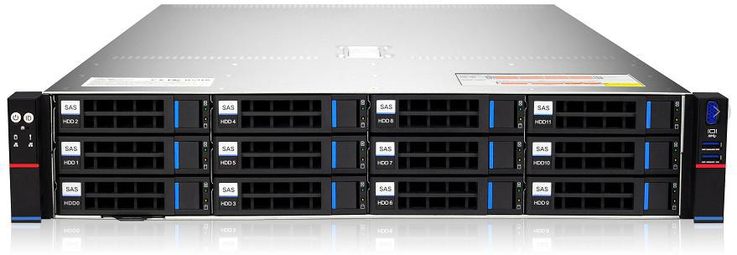
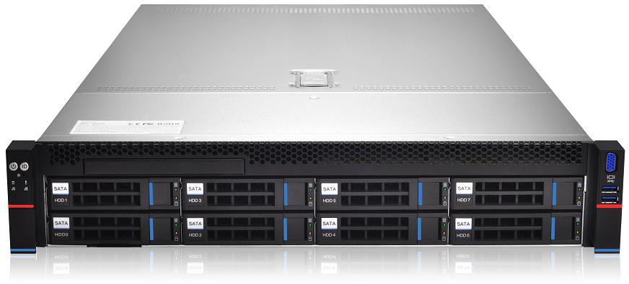
Purley platform 2U two-way L-shaped server barebones

Preface
This manual is the product technical manual of Purley 2U dual-channel cabinet server. It mainly introduces and explains the technical characteristics, system architecture, installation method, and basic operation of this product. Purley 2U dual-channel server is divided into 2U8 bays and 2U12 bays. This product has the characteristics of low energy consumption, flexible expansion, high reliability, easy management and easy deployment.
This manual is for reference research by professional system integrators and personal computer technicians. This product should only be installed and maintained by experienced technicians.

Manual structure
Chapter 1 Security Statement
This chapter describes some environmental conditions, precautions and instructions related to this product that need to be paid attention to when using this product.
Chapter 2 Product Introduction
This chapter provides the specifications of the main components of the system and describes the main features of each model of the Purley 2U dual cabinet server series.
Chapter 3 Installing System Components
This chapter describes the installation methods and main precautions of various main system components using Purley 2U dual-channel cabinet server.
Chapter 4 System cabinet Installation
This chapter describes the installation steps and precautions of using the rails provided with Purley 2U dual-channel cabinet server.
Chapter 5 BIOS parameter setting description
This chapter mainly introduces the parameter settings and main functions of the system BIOS.
Chapter 6 RAID Setting Instructions
This chapter mainly introduces how to set up RAID.
Chapter 7 IPMI Rapid Deployment
This chapter mainly describes how to quickly deploy IPMI.
Chapter 8 Product Technical Specifications
This chapter focuses on the main technical specifications of Purley 2U dual-socket cabinet server products.

Statement
Copyright statement
©QTECH LLC. All rights reserved.
All information contained in this user manual, including but not limited to it, is protected by copyright law. Without the permission of QTECH LLC (hereinafter referred to as QTECH), no copying, copying, or excerpting is allowed. , Re-issuance, or other use.

Disclaimer
QTECH provides this user manual "as is". Within the scope of the law, it does not provide any express or implied guarantees and guarantees, including but not limited to commercial marketability, applicability for specific purposes, non-infringement of the rights of any other person, and any The guarantee of using this user manual or the inability to use this user manual, and QTECH does not provide guarantees and guarantees for the accuracy or reliability of the results obtained from using this user manual or any information obtained through this user manual.
Due to product version upgrades or other reasons, the contents of this user manual will be updated from time to time. Unless otherwise agreed, this user manual is only used as a guide, and the user shall bear all risks of using this user manual.

Trademark statement
Intel and Xeon are trademarks of Intel Corporation in the United States and other countries. Microsoft and Windows are trademarks of companies in the Microsoft group.
Linux is a registered trademark of Linus Torvalds.
Aspeed is a trademark of Xinhua Technology.
The ownership of other trademarks belongs to their respective owners.
Product name: Purley platform 2U dual-channel L-shaped server barebone system manual version: V1.0
Publication date: May 2021
Glossary:
noun | Paraphrase
Intel® Xeon® Scalable  Processors | Intel Xeon Scalable Processor
Platinum efficiency power supply | Platinum certified power supply is "80 PLUS Platinum" standard, that is, the conversion rate of 20% load is above 90%, the conversion rate of 50% load is above 94%, and the conversion rate is 100%.  Rate above 91%
M.2 | M.2 interface is a new generation interface standard tailored for Ultrabook.  It is a new interface specification introduced by Intel®to replace mSATA
C621/C622 | Intel®Chipset
RJ45 | Common name for standard 8-bit modular interface
AST2500 | Aspeed®BMC chip
Socket P | One of the Intel®processor interface types
-F CPU | Refers to CPUs supporting Intel®Omni-Path Host Fabric interface, Omni-Path  High-speed optical cable interconnection technology, which can support up to 100Gbps end-to-end interconnection
8038 fan | Fan with size 80x80x38mm
LGA3647 | The full name Land Grid Array, grid array package, LGA3647 represents 3647  Contacts
CR2032 | It is a 3V CR2032 lithium manganese battery, shaped like a button, referred to as button battery or lithium manganese button  battery
RS-232 | One of the communication interfaces on the computer is the asynchronous transmission standard interface, called COM port
Jtag | Joint Test Action Group, a joint test working group, mainly used for internal chip testing  test
NC Pin | Empty pin
XDP | Extend Debug Port, Intel®CPU debugging interface
Abbreviations
Explain the abbreviations used in this article, and provide the full English name and Chinese explanation of each abbreviation, as shown in the following table:

Abbreviations | original | Chinese meaning
PCH | Platform Controller Hub | It was previously collectively referred to as "South Bridge"
GbE | Gigabit Ethernet | Gigabit Ethernet
BMC | Baseboard Management Controller | Baseboard management controller
IPMI | Intelligent Platform Management  Interface | Intelligent platform management interface
CPU | Central Processing Unit | CPU
SATA | Serial Advanced Technology  Attachment | Serial ATA interface specification
SAS | Serial Attached SCSI | Serial SCSI
sSATA | secondary SATA | Expansion SATA interface
LAN | Local Area Network | local area network
VGA | Video Graphics Array | Video transmission standard
MB | Mother Board | Motherboard
MIB | Motherboard Interface Board | Motherboard adapter board/side board
BP | Backplane | Backplane
PDB | Power Distribution Board | Power distribution board
FIB | Fan Interface Board | Fan adapter board
PCIE | Peripheral Component Interconnect  Express | High-speed serial computer expansion bus standard
USB | Universal Serial Bus | Universal Serial Bus
FW | Firmware | firmware
TPM | Trusted Platform Module | Trusted Platform Module
IO | Input/Output | input Output
BIOS | Basic Input-Output System | Basic Input Output System
CMOS | Complementary Metal Oxide Semiconductor | Complementary metal oxide semiconductor
ME | Management Engine | Management engine
DDR4 | Double Data Rate 4 SDRAM | The fourth generation double data rate synchronous dynamic  Random access memory
DIMM | Dual-Inline-Memory-Modules | Dual in-line storage module
RDIMM | Registered DIMM | Registered two-wire memory module
LRDIMM | Load-Reduced DIMM | Low load DIMM
AEP | Apache Pass | Intel®Optane DDR4 memory code name
MEZZ  CONN | Mezzanine Connector | Mezzanine/buckle card
KVM | Keyboard Video Mouse | Can access and control computing by directly connecting keyboard, video, and mouse ports  machine
CPLD | Complex Programmable Logic Device | Complex programmable logic device
ECC | Error Correcting Code | Error checking and correction
CFM | Cubic Feet Per Minute | Cubic feet per minute
RPM | Revolution Per Minute | Rpm
Symbol convention:
Note: It is used to transmit equipment or environmental safety warning messages. If not avoided, it may cause equipment replacement, data loss, equipment performance degradation or other unpredictable results.
Warning: Used to warn of potentially dangerous situations, which, if unavoidable, may cause death or serious personal injury.
Red arrow: means pointing to a certain position.

Blue arrow: represents the action of pulling out or inserting downward or tilting.
Hollow arrow: represents the next action or result.
Dark blue rotating arrow 1: represents the action of turning the screw clockwise or pulling out.
Dark blue rotating arrow 2: represents the action of turning the screw counterclockwise or buckling inward

Table of Contents
Preface 2
Manual structure 2
Statement 3
1 Security Statement 12
1.1 General safety matters 12
1.2 Product name and content identification table of toxic and hazardous substances or elements 13
1.3 Warning notice 16
1.4 Climate and environmental requirements 16
1.5 Other important description 17
2 Product Introduction 18
2.1 System introduction 18
2.2 System Configuration 18
2.2.1 System parameters 18
2.2.2 System structure 19
2.3 System model specification introduction 21
2.4 System component introduction 25
2.4.1 Front panel components 25
2.4.2 Rear panel components 29
2.4.3 Motherboard components 32
2.4.4 Hard disk backplane assembly 34
2.4.5 DIMM slot location 42
2.4.6 Hard disk label 43
2.4.7 Hard Disk Indicator 43
2.4.8 System fan 44
3 Installing System Components 45
3.1 CPU installation 45
3.2 Radiator installation 46
3.3 Memory installation 46
3.4 Hard disk installation 48
3.5 Front hard disk backplane installation. 50
3.6 M.2 SSD installation 52
3.7 PCI-E module installation 53
3.8 Rear hard disk module backplane installation 54
3.9 Rear hard disk module installation 55
3.10 Power supply module installation 58
3.11 PCI-E expansion card installation 59
3.12 Fan module installation 61
3.13 Installation of air duct 62
3.14 CD-ROM installation 63
3.15 Installation of the upper cover of the chassis 65
4 System cabinet Installation 66
4.1 Rail installation 66
4.2 Install the outer rail to cabinet 68
4.3 Install server to cabinet 69
5 BIOS parameter setting description 71
5.1 Enter the BIOS Setup interface 71
5.2 Setup menu parameter description 71
5.2.1 Navigation key description 71
5.2.2 Main menu description 72
5.2.3 Advanced menu description 74
5.2.4 Trusted Computing 76
5.2.5 Serial Port Console Redirection 77
5.2.6 Console Redirection Settings 78
5.2.7 SIO Configuration 80
5.2.8 [*Active*] Serial Port 81
5.2.9 Option ROM Dispatch Policy 82
5.2.10 PCI Subsystem Settings 84
5.2.11 CSM Configuration 85
5.2.12 NVMe Configuration 86
5.2.13 Network Stack Configuration 88
5.2.14 iSCSI Configuration 90
5.2.15 Platform Configuration menu 91
5.2.16 PCH SATA Configuration 92
5.2.17 PCH sSATA Configuration 94
5.2.18 USB Configuration 95
5.2.19 Miscellaneous Configuration 96
5.2.20 Server ME Configuration 97
5.2.21 Runtime Error Logging 97
5.2.22 Socket Configuration menu 98
5.2.23 Processor Configuration 99
5.2.24 Common RefCode Configuration 103
5.2.25 UPI Configuration 104
5.2.26 Memory Configuration 106
5.2.27 Memory Topology 109
5.2.28 Memory Map 110
5.2.29 Memory RAS Configuration 112
5.2.30 IIO Configuration 114
5.2.31 Advanced Power Management Configuration 116
5.2.32 CPU P State Control 117
5.2.33 Hardware PM State Control 118
5.2.34 CPU C State Control 119
5.2.35 Package C State Control 120
5.2.36 CPU-Advanced PM Tuning 121
5.2.37 Energy Perf BIAS 122
5.2.38 Server Mgmt menu 123
5.2.39 System Event Log menu 125
5.2.40 BMC network configuration menu 127
5.2.41 View System Event Log menu 130
5.2.42 BMC User Setting 131
5.2.43 Add User 132
5.2.44 Delete User 133
5.2.45 Change User Setting 134
5.2.46 Security menu 136
5.2.47 Boot menu 137
5.2.48 Save & Exit menu 139
5.3 User operation reminder 141
6 RAID Setting Instructions 142
6.1 PCH group RAID 142
6.1.1 Configure RAID in UEFI boot mode 142
6.1.2 Configure RAID in Legacy Boot Mode 149
6.1.3 Delete RAID: 155
6.2 LSI 9361-8i group RAID 156
6.2.1 Configure RAID in UEFI boot mode 156
6.2.2 Create RAID: 159
6.2.3 Configure hot spare disk: 167
6.2.4 Delete RAID: 170
6.2.5 Erase disk data: 185
6.2.6 Migrate RAID level: 191
6.2.7 Clear disk RAID information: 197
6.3 Configure RAID in Legacy Boot Mode 200
6.4 Configure hot spare disk: 205
6.5 Delete RAID: 207
6.6 Locate the disk location: 209
6.7 Initialize the logical disk: 210
6.8 Erase disk data: 212
6.9 Clear disk RAID information: 215
7 IPMI Rapid Deployment 216
7.1 Rapid deployment of IPMI process 216
7.1.1 Make sure the motherboard supports IPMI function 216
7.1.2 Enter BIOS to set IPMI function 216
7.1.3 IPMI interface configuration Static mode 219
7.1.4 IPMI configuration Java SOL 219
7.2 IPMI function quick start instructions 220
7.2.1 Enter the operation interface 220
7.2.2 Default username and password 221
7.2.3 IPMI management system content 221
7.2.4 Introduction to KVM remote management 224
7.2.5 KVM page introduction 224
7.2.6 Remote control quick operation 226
7.2.7 Introduction to SOL 226
7.3 Other ways to connect to IPMI 228
7.3.1 IPMI driver 228
7.3.2 IPMI tools and other open source software 228
8 Product Technical Specifications 229
8.1 Technical specifications 229

Security Statement

General safety matters
To prevent the risk of major personal and property losses, please follow the following recommendations.
Please do not open the system cover by yourself, and should be operated by professionally trained maintenance technicians. There may be high voltage or electric shock on the triangular mark with lightning symbol, please do not touch it.
Remember: Disconnect all cables before performing maintenance. (There may be more than one cable) It is strictly forbidden to perform live operations such as starting the machine before the cover is closed.
When it is necessary to open the cover, please wait for the internal equipment to cool down before performing it, otherwise it is easy to burn you.
Do not use this device in a humid environment.
If an extension cable needs to be used, please use a three-wire cable and make sure it is properly grounded.
Ensure that the computer is well grounded. Different grounding methods can be used, but it must be actually connected to the ground. If you are not sure whether the grounding protection has been secured, please contact the corresponding agency or electrician for confirmation. If you need twisting table cable wiring, please contact QTECH to provide suggestions.
Please use a three-core power cord and socket with grounding protection. Improper grounding may cause leakage, burns, explosions and even personal injury.
Please make sure that the power socket and the power interface can be in close contact, loose contact may cause a fire hazard.
Please use your computer under 220V AC voltage. Working at an improper voltage will cause electric shock, fire and computer damage.
The computer is required to be well ventilated and far away from heat and fire sources, and do not block the cooling fan, otherwise the computer may cause smoke, fire or other dangers due to overheating.
If you smell or see smoke from your computer, please turn off the computer immediately and unplug the power cord.
It is required to be able to easily plug and unplug the power cord from the power source and the power socket. Please keep the power cord and plug clean and intact, otherwise there may be a risk of electric shock or fire.
Note: If the battery is replaced incorrectly, there is a danger of explosion. Only use the same or equivalent type of replacement recommended by the manufacturer. The used battery will pollute the environment. Please follow the relevant instructions for the replacement of the old battery.
Keep the computer away from electromagnetic fields.
Keep away from electronic noise caused by high-frequency safety equipment such as air-conditioning, large fans, large motors, radio and television transmission towers.
Please do not plug or unplug the backplane cable or move the computer while the computer is running, otherwise it may cause the computer to crash or damage the components.
Please try to avoid frequent restarting or switching on and off to extend the life of the computer.
Please keep the environment clean and avoid dust. The working environment temperature of the equipment is 10℃~35℃, and the humidity is 35%~80%.
Users are requested to back up important data in time. QTECH is not responsible for data loss caused by any circumstances.
The optical drive used in this product is a Class 1 laser device.
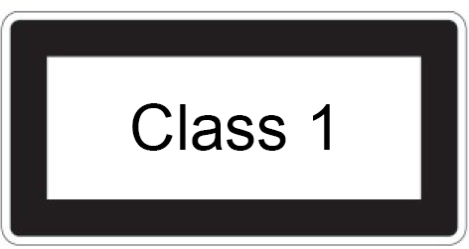
Figure 6-1

Product name and content identification table of toxic and hazardous substances or elements
Within the 10-year environmental protection use period, the toxic and hazardous substances or elements contained in the product will not leak or mutate under normal use conditions, and the use of electronic information products by users of electronic information products will not cause serious pollution to the environment or affect them. Cause serious damage to person and property.
Part Name | Harmful Substance
 | Lead (Pb) | Mercury (Hg) | Cadmium (Cd) | Hexavalent Chromium (Cr VI) | Polybrominated biphenyls (PBB) | Polybrominated Diphenyl Ether (PBDE)
Chassis/Baffle | X | O | O | O | O | O
Mechanical components (fans, radiators, motors, etc.) | X | O | O | O | O | O
Printed Circuit Components-PCA* | X | O | O | O | O | O
Cable/wire/connector | X | O | O | O | O | O
Hard disk drive | X | O | O | O | O | O
Table 1-1

Part Name | Harmful Substance
 | Lead (Pb) | Mercury (Hg) | Cadmium (Cd) | Hexavalent Chromium (Cr VI) | Polybrominated biphenyls (PBB) | Polybrominated Diphenyl Ether (PBDE)
Media reading/storage device (CD, etc.) | X | O | O | O | O | O
Power supply/power adapter | X | O | O | O | O | O
power cable | X | O | O | O | O | O
Pointing device (mouse, etc.) | X | O | O | O | O | O
keyboard | X | O | O | O | O | O
UPS | X | O | O | O | O | O
Complete cabinet/rail products | X | X | O | O | O | O
Table 1- 2
O - It means that the content of this toxic and hazardous substance in all homogeneous materials of this part is below the limit requirement stipulated in GB/T26572-2011 "Limit Requirements for Restricted Substances in Electronic and Electrical Products".
X - Indicates that the content of the toxic and hazardous substance in at least one of the homogeneous materials of the part exceeds the limit requirement specified in GB/T26572-2011 "Limited Requirements for Restricted Substances in Electronic and Electrical Products". But it complies with the EU RoHS directive (including its exemption clauses).

Note: This table shows the status of toxic and hazardous substances contained in all components that may be used in QTECH server, storage and workstation products. Customers can check the status of toxic and hazardous substances contained in each component of the purchased product based on this table.

Warning notice

This product complies with EMC Class A standards.

Climate and environmental requirements

- The best working temperature of the equipment is 10°C—35°C; the highest indoor ambient temperature of the equipment is 40°C.
- System battery: 3 V CR2032 lithium battery.

Note: Some configurations have been tested for performance at 45°C temperature and 90% (29°C maximum dew point) humidity.
Temperature
Operating temperature | 10°C to 35°C (50°F to 95°F), the maximum temperature gradient is  Hour 10°C
Continuous operating temperature range (under the sea  (At 950 meters or 3117 feet) | In the case of equipment without direct light, 10°C to 35°C (50°F to  95°F)
Storage temperature range | -40°C to 65°C (-40°F to 149°F)
Humidity
storage | When the maximum dew point is 33°C (91°F), the relative humidity is 5% to  95%. The air must never condense.
Continuous operating humidity percentage range | When the maximum dew point is 26°C (78.8°F), the relative humidity is 10% to  80%
Table 1-3
- If the computer use environment has poor or no lightning protection facilities, please shut down during a thunderstorm and unplug the power cord, network cable, telephone line, etc. connected to the computer.
- Please use genuine operating system and software, and configure it correctly. QTECH assumes no maintenance responsibility for server failures caused by operating systems and software.
- Please do not disassemble the case and increase or decrease the server hardware configuration by yourself. QTECH is not responsible for the hardware and data damage caused by this.
- When the server fails, please first check the "Troubleshooting" section of this manual to determine and eliminate common failures. If you are not sure of the cause of the failure, please contact the technical support department of QTECH for help.
- Choosing a suitable environment for the computer is helpful for the stable operation of the computer and can extend the service life of the computer.
QTECH reserves the right of final interpretation of the above terms

Other important description

"If the equipment is marked with a logo, it means that the equipment with the logo is only fully designed and evaluated at an altitude of 2000m. Therefore, it is only suitable for safe use below 2000m and in the sea.
When used at a distance of more than 2000m, there may be safety hazards."
"If the device is marked with this logo, it means that the device with the logo is only designed and evaluated for safety in non-tropical climatic conditions. Therefore, it is only suitable for safe use under non-tropical climatic conditions.
When used in tropical climates, there may be safety hazards."

Product Introduction

System introduction

Purley 2U dual-channel L-type server is a new generation of 2U dual-channel cabinet server with a wide range of uses that QTECH has launched for the needs of the Internet, IDC (Internet Data Center), cloud computing, enterprise market and telecom business applications. It is suitable for IT core business, cloud computing virtualization, high-performance computing, distributed storage, big data processing, enterprise or telecom business applications and other complex workloads. The server has the advantages of low energy consumption, strong scalability, high reliability, easy management, and easy deployment.

System Configuration

Nebulas 2 Purley 2U dual-channel L-shaped server products include 2U8 (3.5” hard disk) disk bays, 2U12
(3.5” hard disk) The two models have the same specifications except for the hard disk connection method and the maximum number of compatible hard disks.

System parameters
Features | Technical specifications
Series models | 2U8 (3.5" hard disk) bay, 2U12 (3.5" hard disk) bay
size | 2U cabinet type, 748*433.4*87.6mm
processor | 1st and 2nd generation Intel® Xeon® Scalable processors  Maximum support 205W
RAM | Support DDR4 LRDIMM/RDIMM/NV-DIMM ECC memory  Memory frequency support 2133/2400/2666/2933MHz  A single CPU supports 6 DDR4 Channels, with 2 slots per Channel, and a total of 24 DDR4 slots for CPU0/CPU1  Support a single capacity of 8GB, 16GB, 32GB, 64GB, 128G
Storage controller | Internal storage: 2 SATA ports (7Pin), 2 PCIe 3.0 X2 M.2  Interface, 3 minisas 8643 interfaces, 2 slimline x8 interfaces
driver | The front panel supports up to 8/12/hot-plug 3.5/2.5 inch SAS/SATA (HDD/SSD)  The rear supports 4*2.5" and 4*3.5" hard disks or 8*2.5"
power supply | Platinum 550W, 800W, 1200W, 1600W hot-swappable redundant power  Source (adapted according to actual power)
External port&PCIE | Front port: 1 VGA; 2 USB3.0  Rear: 1 VGA, 1 DB-9COM port, 2 USB3.0, 1 RJ45 Gigabit management network port, 2 Gigabit/10 Gigabit RJ45 network ports  PCIE expansion: supports up to 11 PCIe3.0 slots
System fan | N+1 hot-swappable redundant fans
The internet | 2 Gigabit/10 Gigabit RJ45 network ports
safety | Support TPM module  Chassis opening intrusion detection
management | The onboard iBMC management module supports IPMI, SOL, KVM Over IP,  Management features such as virtual media
Table 1-4

System structure
The dual-socket L-shaped server uses the Intel Purley platform with Intel® Xeon® scalable processors; supports DDR4 LRDIMM/RDIMM/NV-DIMM ECC server memory, and the memory frequency supports 2133/2400/2666/2933MHz; a single CPU supports 6 Two channels, each channel supports 2 DIMMs; two CPUs support a total of 24 DDR4 slots; supports a single capacity of 8GB, 16GB, 32GB, 64GB, 128GB.
The main board features are as follows:
- The CPU adopts the first and second generation Intel® Xeon® scalable processors, LGA3647 socket, TDP power consumption 205W;
- Each CPU supports six-channel DDR4, each channel has 2 DIMM strips, RDIMM/LRDIMM. And each CPU supports a maximum capacity of 1.5TB;
- DDR4 type: DDR4-2133/2400/2666/2933ECC-RDI, ECC-LRDIMM;
- There are 3 PCIE RISER slots on the board, of which: RISER1 24 PCIE LANEs are all from CPU0, 24 PCIE LANEs of Riser2, of which 8 PCIE LANEs are from CPU0, 16 PCIE LANEs are from CPU1, 16 PCIE LANEs of Riser3 Also from CPU1;
- The G3DCL-B motherboard provides 2 M.2 Key M SSD slots, supports 2280 size, and only supports PCIe X2 signals;
- Two Gigabit Ethernet ports are integrated on the motherboard, using 88E1512 chip, from PCH;
- Southbridge PCH uses INTEL LEWISBURG C621/C622 series chipset;
- PCH leads to 14 SATA Ports, the highest rate: 6Gb/s, compatible with SATA 1.5Gb/s, 3.0Gb/s; SATA Controller provides 8 SATA PORTs, and SSATA provides 6 SATA PORTs, of which SATA PORT 8 PORT, according to Two SFF8643 connectors are introduced in order, and the first four PORTs of SSATA are introduced into one SFF8643 connector, and the latter two PORTs are introduced into the 7PIN SATA connector for access to SATA DOM and DVD;
- The BMC chip in this single board uses ASPEED's AST2500 control chip to
Do IPMI remote management. VGA output port, dedicated Gigabit RJ45 management network port, and connected to PCH through RMII/NCSI.

The main board block diagram of the system architecture is as follows:
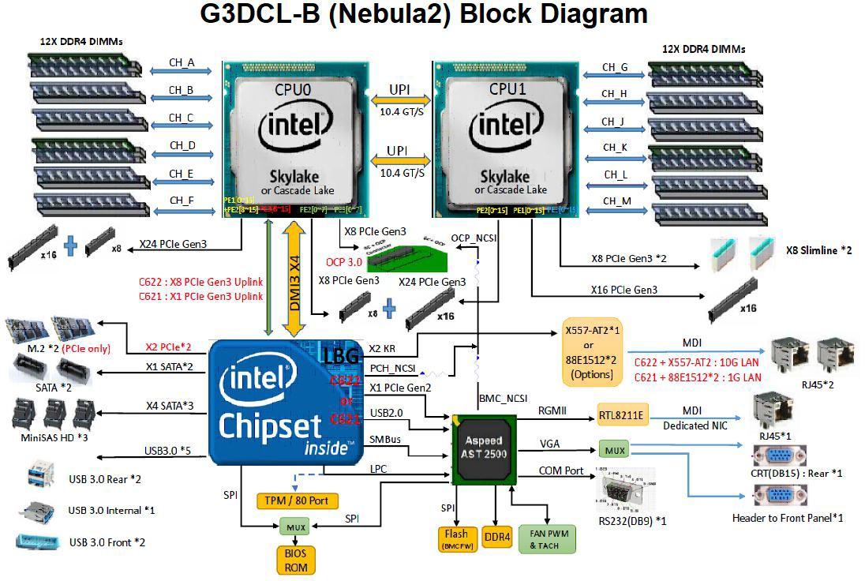
Figure 2-1

System model specification introduction

- 2U8 disk bay 3.5 inch disk model
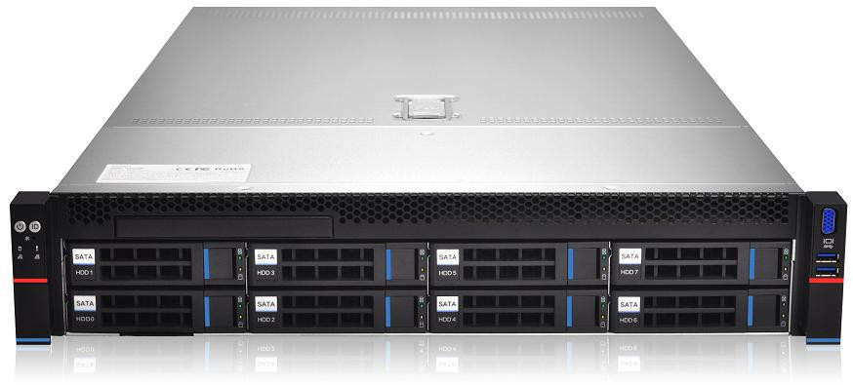
Figure 2-2

Product name | 2U8 (3.5” hard disk)
processor | Support 1 or 2 Intel Xeon Scalable series processors  Maximum support 205W
Motherboard model | G3DCL-B/G3DCL-TB
chipset | Intel® C621/C622 series server dedicated chipset
RAM (system) | Support DDR4 LRDIMM/RDIMM/NV-DIMM ECC memory  Memory frequency support 2133/2400/2666/2933MHz  A single CPU supports 6 DDR4 Channels, each Channel has 2 slots, CPU0/CPU1 totals 24 DDR4 slots  Support a single capacity of 8GB, 16GB, 32GB, 64GB, 128G
Expansion Card | 1.(Left) PCI-Express 3.0 X24 slot comes from CPU0;  2.(Middle) PCI-Express 3.0 X24 slot comes from CPU0 / CPU1;  3.(Right) PCI-Express 3.0 X16 slot comes from CPU1;
hard disk | Supports up to 8 front 3.5-inch/2.5-inch SAS/SATA (HDD/SSD)  The rear can support 4 2.5-inch SAS/SATA (HDD/SSD), 4 rear 3.5/2.5-inch SAS/SATA (HDD/SSD)  Onboard 3*8643 interface, 2*SATA DOM
Optical drive | Support 1 optical drive;
M.2 SSD | 2 M.2 PCIE X2 (2280)
LAN | Onboard 2 Gigabit RJ45 data network ports (optional 2 Gigabit RJ45 data  Network port)
External port | Front port: VGA, 2 USB3.0  Rear: VGA, 2 USB3.0, 1 management network port, 2 RJ45  Data network port, 1 DB-9 COM port
management | The onboard iBMC management module supports IPMI, SOL, KVM Over IP,  Management features such as virtual media
System fan | 4 8038 brand fans (optional 4 8056 brand fans)
power supply | Standard platinum 550W, optional 800W, 1200W, 1600W hot-swappable redundant power supply (CRPS)
Dimensions | 2U cabinet type, 748x433.4x87.6mm
Table 1-5
- 2U12 disk bay 3.5 inch disk model
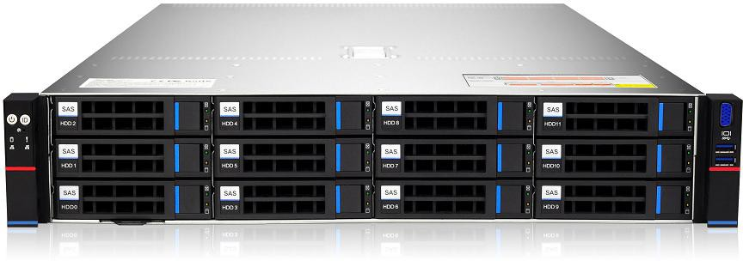
Figure 2-3

Product name | 2U12 (3.5” hard disk)
processor | Support 1 or 2 Intel Xeon Scalable series processors, maximum support 205W
Motherboard model | G3DCL-B/G3DCL-TB
chipset | Intel® C621/C622 series server dedicated chipset
RAM (system) | Support DDR4 LRDIMM/RDIMM/NV-DIMM ECC memory  Memory frequency support 2133/2400/2666/2933MHz  A single CPU supports 6 DDR4 Channels, each Channel has 2 slots, CPU0/CPU1 totals 24 DDR4 slots  Support a single capacity of 8GB, 16GB, 32GB, 64GB, 128G
Expansion Card | 1.(Left) PCI-Express 3.0 X24 slot comes from CPU0;  2.(Middle) PCI-Express 3.0 X24 slot comes from CPU0 / CPU1;  3.(Right) PCI-Express 3.0 X16 slot comes from CPU1;
hard disk | Support up to 12 front 3.5-inch/2.5-inch SAS/SATA (HDD/SSD)  The rear can support 4 2.5-inch SAS/SATA (HDD/SSD) and 4 rear 3.5/2.5-inch SAS/SATA (HDD/SSD)  Onboard 3*8643 interface, 2*SATA DOM
Optical drive | Support 1 optical drive;
M.2 SSD | 2 M.2 PCIE X2 (2280)
LAN | Onboard 2 Gigabit RJ45 data network ports (optional 2 Gigabit RJ45 data network ports)
External port | Front port: VGA, 2 USB3.0  Rear: VGA, 2 USB3.0, 1 management network port, 2 RJ45  Data network port, 1 DB-9 COM port
management | The onboard iBMC management module supports management features such as IPMI, SOL, KVM Over IP, and virtual media
System fan | 4 8038 brand fans (optional 4 8056 brand fans)
Power supply | Standard platinum 550W, optional 800W, 1200W, 1600W hot-swappable redundant power supply (CRPS)
Dimensions | 2U cabinet type, 748x433.4x87.6mm
Table 1-6

- 2U25 disk position 2.5 inch disk model

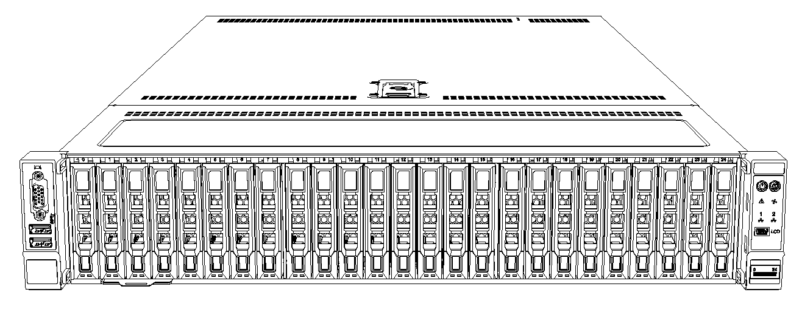
Product name | 2U25 (2.5” hard disk)
processor | Support 1 or 2 Intel Xeon Scalable series processors, maximum support 205W
Motherboard model | G3DCL-B/G3DCL-TB
chipset | Intel® C621/C622 series server dedicated chipset
RAM (system) | Support DDR4 LRDIMM/RDIMM/NV-DIMM ECC memory  Memory frequency support 2133/2400/2666/2933MHz  A single CPU supports 6 DDR4 Channels, each Channel has 2 slots, CPU0/CPU1 totals 24 DDR4 slots  Support a single capacity of 8GB, 16GB, 32GB, 64GB, 128G
Expansion Card | 1.(Left) PCI-Express 3.0 X24 slot comes from CPU0;  2.(Middle) PCI-Express 3.0 X24 slot comes from CPU0 / CPU1;  3.(Right) PCI-Express 3.0 X16 slot comes from CPU1;
hard disk | Support up to 25 3.5-inch/2.5-inch SAS/SATA (HDD/SSD)  The rear can support 4 2.5-inch SAS/SATA (HDD/SSD) and 4 rear 3.5/2.5-inch SAS/SATA (HDD/SSD)  Onboard 3*8643 interface, 2*SATA DOM
Optical drive | Support 1 optical drive;
M.2 SSD | 2 M.2 PCIE X2 (2280)
LAN | Onboard 2 Gigabit RJ45 data network ports (optional 2 Gigabit RJ45 data network ports)
External port | Front port: VGA, 2 USB3.0  Rear: VGA, 2 USB3.0, 1 management network port, 2 RJ45  Data network port, 1 DB-9 COM port
management | The onboard iBMC management module supports management features such as IPMI, SOL, KVM Over IP, and virtual media
System fan | 4 8038 brand fans (optional 4 8056 brand fans)
Power supply | Standard platinum 550W, optional 800W, 1200W, 1600W hot-swappable redundant power supply (CRPS)
Dimensions | 2U cabinet type, 748x433.4x87.6mm

System component introduction

Front panel components
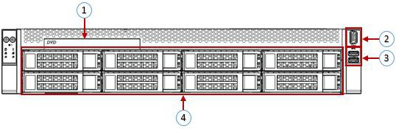
Figure 2- 4
- 2U8 disk bay 3.5 inch disk model

Serial number | name | Serial number | name
1 | Built-in DVD drive | 3 | USB3.0 interface
2 | VGA interface | 4 | 3.5 inch hard drive
Table 1- 7

- 2U12 disk bay 3.5 inch disk model

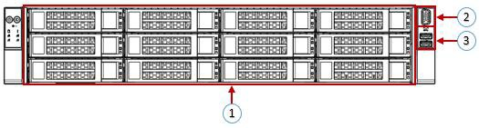
Figure 2-5

Serial number | name | Serial number | name
1 | hard disk | 3 | USB3.0 interface
2 | VGA interface
Table 1- 8

- Front panel interface description

name | Types of | Description
VGA interface | DB15 | Used to connect a display terminal, such as a monitor or KVM.
USB interface | USB 3.0 | Provide an outgoing USB interface, through which USB devices can be connected.  note:When using an external USB device, please make sure that the USB device is in good condition, otherwise it may cause the server to work  abnormal.
Table 1- 9

- Description of front panel indicators and buttons

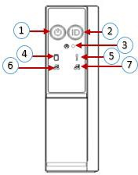

Figure 2- 6

Serial number | Indicator light/button | Serial number | Indicator light/button
1 | Power switch button/indicator | 5 | System alarm indicator
2 | UID button/indicator | 6 | Network port 1 connection status indicator
3 | Reset button | 7 | Network port 2 connection status indicator
4 | Hard Disk Indicator
Table 1-10

LED status description
Logo | Indicator light/button | State description
Power indicator description:
Green (steady light): indicates that the device has been powered on normally. Green (flashing): indicates that the device is in standby.
Green off: The device is not powered on. Power button description:
Short press this button in the boot state, the OS will shut down normally.
Press and hold this button for 6 seconds in the power-on state to force the server to power off.
Short press the button when it is to be powered on, you can
Turn on.
 | UID button/indicator | The UID button/indicator is used to conveniently locate the server to be operated. You can manually press the UID button or BMC command to remotely control the lamp to turn off or on.  UID indicator description:  Blue (steady light/flashing): indicates that the server is located.  Off: The server is not located.  UID button description: short press this button to  Turn on/off the positioning light.
 | Reset button | Press to restart the server
 | Hard Disk Indicator | Green light flashes: the hard disk is operating normally
 | System alarm indicator | System alarm indicator. Including system alarm, fan alarm, power supply alarm, etc.  IPMI management software view
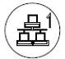 | Network port connection status indicator | Corresponding to the Ethernet port indicator of the network card. Green (steady light): indicates that the network port is connected normally. Off: indicates that the network port is not in use or is faulty.  Note: Corresponding to two 1GE network ports on the motherboard.
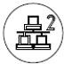 | Network port connection status indicator | Corresponding to the Ethernet port indicator of the network card. Green (steady light): indicates that the network port is connected normally. Off: indicates that the network port is not in use or is faulty.  Note: Corresponding to two 1GE network ports on the motherboard.
Table 1-11

Rear panel components
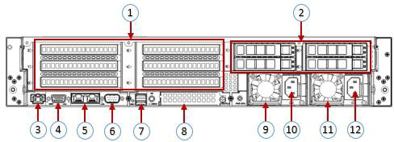
Figure 2-7

Serial number | name | Serial number | name
1 | Rise module | 7 | USB 3.0 interface
2 | Hard Disk Module | 8 | OCP3.0 interface
3 | Management network port | 9 | Power module 1
4 | VGA interface | 10 | Power module 1 AC interface
5 | RJ45 Gigabit Ethernet port | 11 | Power module 2
6 | COM port | 12 | Power module 2 AC interface
Table 1-12

- Description:

Both 1 and 2 can be equipped with rear hard disk modules or riser modules. This picture is for reference only, and the actual configuration shall prevail.
- Rear panel interface description
name | Types of | Quantity | Description
VGA interface | DB15 | 1 | Used to connect a display terminal, such as a monitor or  KVM。
Management network port | GE BASE-T | 1 | Provide an outgoing 1000Mbit/s Ethernet port. The server can be managed through this interface.
USB interface | USB 3.0 | 2 | Provide an outgoing USB interface, through which USB devices can be connected.  note:  When using an external USB device, make sure that the USB device is in good condition, otherwise it may cause the server to malfunction.  Make an exception.
RJ45 Gigabit Ethernet port | GEBASE-T | 2 | Server service network port.
Power module AC interface | / | 1 or 2 | You can choose the number of power supplies according to your actual needs, but you must ensure that the rated power of the power supply is large  It is the rated power of the whole machine.
COM port |  | 1 | Serial communication port
OCP3.0 interface  mouth |  | 1 | Install OCP3.0 network card
Table 1-13

- Description of indicators and buttons on the rear panel

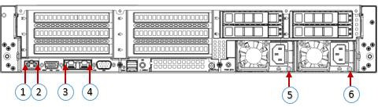
Figure 2-8

Serial number | name | Serial number | name
1 | Connection status indicator | 4 | Data transmission status indicator
2 | Data transmission status indicator | 5 | Power module indicator
3 | Connection status indicator | 6 | Power module indicator
Table 1-14

Indicator light/button | State description
Power module indicator | Green (steady light): It indicates that the input and output are normal.  Red (steady light): It means that the input is normal, power supply over-temperature protection, power supply output over-current/short circuit, output over-voltage, short-circuit protection, device failure (excluding all device failures) and other reasons cause no output.  Green (1Hz/flashing): It indicates that the input is normal, and the power supply has turned off the output due to power-on or in-position; input overvoltage or undervoltage.  Green (4Hz/flashing): indicates that the firmware is being upgraded online.  Off: There is no AC power input.
Connection status indicator | Steady green: It means Gigabit Link. Long orange light: It means 100M Link.  Extinguished: Ten trillion Link.
Data transmission status indicator  Indicator light | Yellow (flashing): indicates that data is being transmitted.  Off: No data is being transmitted.
Table 1-15

Motherboard components
- All models share motherboard components, and the interface description is as follows
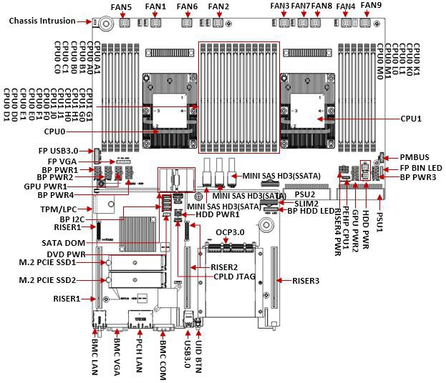
Figure 2-9

Hard disk backplane assembly
- 2U12 expansion backplane as shown
TOP noodles
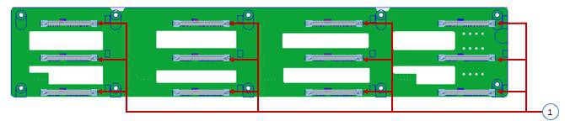
Figure 2-10
Serial number | description | Features
1 | SAS/SATA hard disk connector | Maximum support 12G/b SAS hard disk;  Maximum support 6G/b SATA hard disk;  Supports hot swap of SAS/SATA hard disks.
Table 1-16

Bottom surface
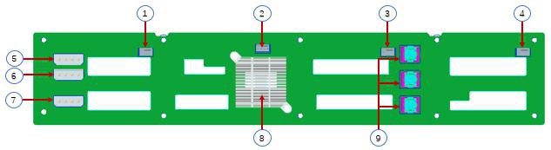
Figure 2- 11
Serial number | description | Features
1, 2, 3, 4 | Temperature control fan socket | For 12G/b SAS or 6G/b SATA  Number transmission.
5, 6, 7 | Power connector | Backplane power transmission connector for 12V power supply  Transmission.
8 | EXPANDER chip | PM8043 SXP 24Sx12G  24-port 12G SAS Expander
9 | MINI SAS HD high  Fast connector | Used for 12G/b SAS or 6G/b SATA signal transmission.
10 | PMBUS connector | The backplane power management bus is used to connect and communicate between the backplane and the motherboard.
Table 1-17

- 2U8 expansion backplane as shown
TOP noodles
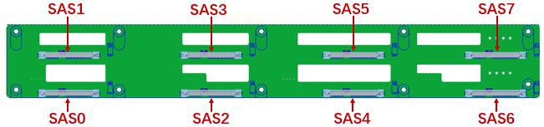
Figure 2-12

Serial number | description | Features
SAS0~7 | SAS/SATA hard disk connector | Maximum support 12G/b SAS hard disk;  Maximum support 6G/b SATA hard disk;  Supports hot swap of SAS/SATA hard disks.
Table 1- 18

Bottom surface
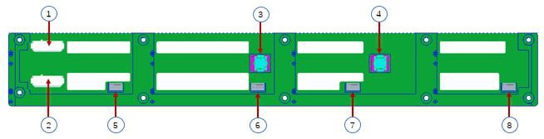
Figure 2-13

Serial number | description | Features
1, 2 | ATX power input | Backplane power transmission connector for 12V power transmission
3, 4 | SFF-8643 12Gb SAS interface | Backplane bay signal interface
5, 6, 7, 8 | Temperature control fan socket | For 4pin fan interface
Table 1- 19

- SAS/SATA backplane as shown

- 2U25 2.5” expansion backplane as shown

TOP surface:
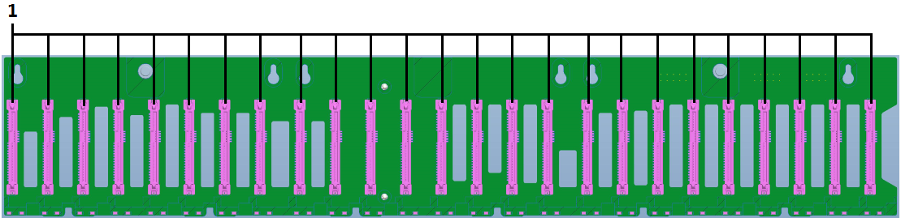

Numbering | Device description | Functional description | Bit number
1 | SAS/SATA hard disk connector | 1. Maximum support 12G/b SAS hard drive;  2. Maximum support 6G/b SATA hard disk;  3. Support SAS/SATA hard disk hot swap. | J10,J11,J12,J13,J14,J15,J16,J17,J18,J19,J20,J21,J22,J23,J24,J25,J26,J27,  J28,J29,J30,J31,J32,J33,J34

BOTTOM face:
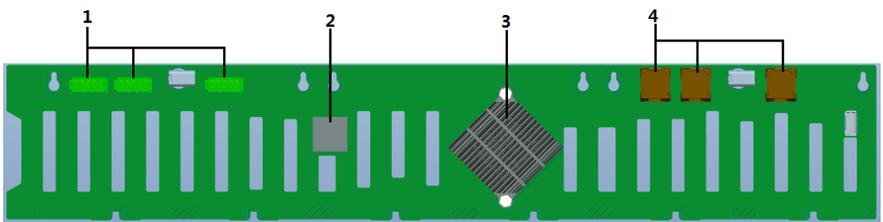

Numbering | Device description | Functional description | Bit number
1 | Power connector | Backplane power transfer connector for transmission of 12V power. | J6,J7,J8
2 | CPLD chip | Decode SGPIO to control the status indicator of the hard disk | U16
3 | PM8044 | 12G SAS Expander IC | U1
4 | MINI SAS HD High Speed ​​Connector | Used for transmission of 12G/b SAS or 6G/b SATA signals. | J2,J4,J5

TOP noodles
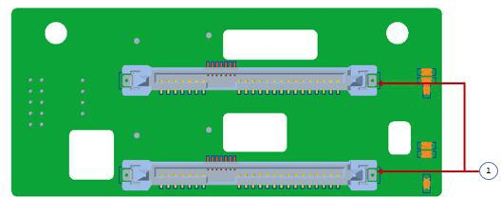
Figure 2- 14

Serial number | description | Features
1 | SAS/SATA connector | Maximum support 12G/b SAS hard disk;  Maximum support 6G/b SATA hard disk;  Supports hot swap of SAS/SATA hard disks.
Table 1-20
Bottom surface
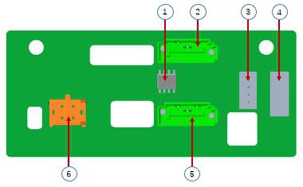
Figure 2-15
Serial number | description | Features
1 | Temperature sensor IC | Temperature sensor chip
2, 5 | 7PIN SATA interface | SATA disk signal line interface
3 | I2C interface | For I2C signal interface
4 | SGPIO lighting signal | Used for hard disk LED positioning and fault LED indication  Features.
6 | Power connector | Backplane power transmission connector for 12V power transmission  lose
Table 1- 21
- U.2 backplane as shown
TOP noodles

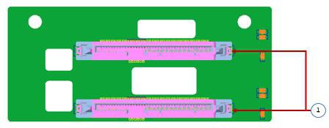
Figure 2-16

Serial number | description | Features
1 | SFF-8639 connector | Support PCIe×4 U.2 interface, used to connect NVME SSD
Table 1-22

Bottom surface
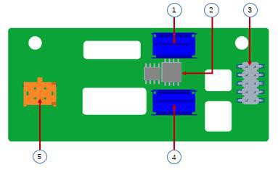
Figure 2-17
Serial number | description | Features
1, 5 | Slimline 4i Connector | Provide PCIe×4 interface to connect CPU and NVME SSD1 (including CPU PEHP  I2C and BMC I2C signal)
2 | CPLD chip | For data logic processing
3 | JATG debug interface | JTAG debugging interface, used to edit CPLD  Process and version upgrade
4 | Power outlet | 4 Pin power socket, used to dock PSU or  Docking MB 4 Pin plug to power the board
Table 1-23

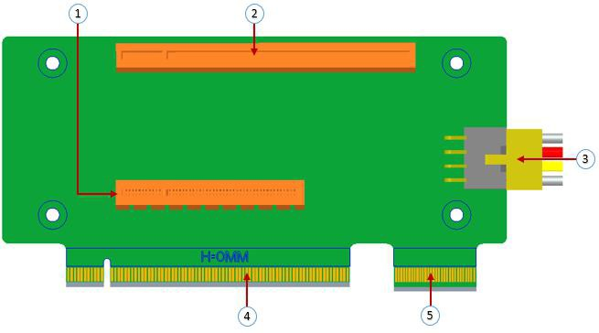
Figure 2- 18

Serial number | description | Features
1 | PCIE 3.0 X8 Slot | Used for PCIe 3.0 X8 devices.
2 | PCIE 3.0 X16  Slot | Used for PCIe 3.0 X16 devices.
3 | RISER POWER | Riser card power transmission connector for 12V power supply  Transmission
4 | PCIE X16 specification gold  finger | For QTECH G3DCL motherboard PCIe X16 X8  interface
5 | PCIE X8 specification gold hand  Means | For QTECH G3DCL motherboard PCIe X16 X8  interface
Table 1-24

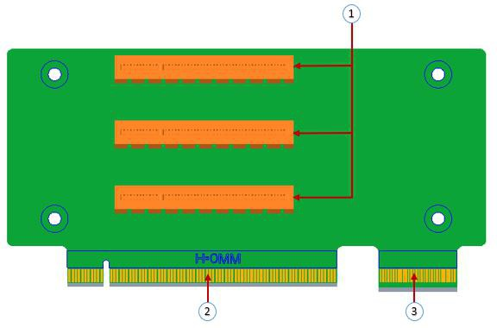
Figure 2-19
Serial number | description | Features
1 | PCIE 3.0 X8 Slot | Used for PCIe 3.0 X8 devices.
2 | PCIE X16 gold finger | For QTECH G3DCL motherboard PCIe X16 X8  interface
3 | PCIE X8 gold finger | For QTECH G3DCL motherboard PCIe X16 X8  interface
Table 1-25

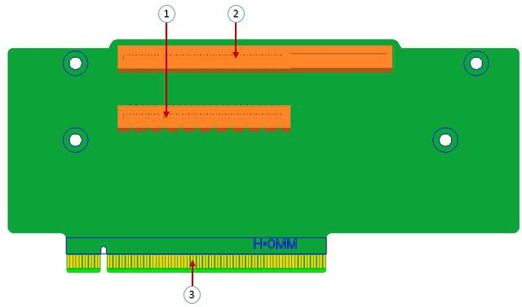
Figure 2-20
Serial number | description | Features
1 | PCIE X16 Slot | Used for PCIe 3.0 X16 devices.
2 | PCIE X8 Slot | Used for PCIe 3.0 X8 devices.
3 | PCIE X16 specification gold  finger | For motherboard PCIe X16 interface
Table 1-26
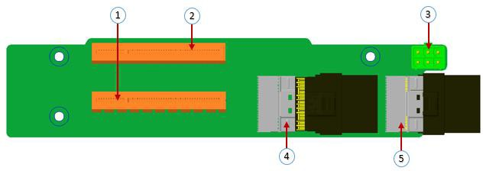
Figure 2-21
Serial number | description | Features
1 | PCIE X16 Slot | Used for PCIe 3.0 X16 devices.
2 | PCIE X8 Slot | Used for PCIe 3.0 X8 devices.
3 | Power connector | Riser card power transmission connector for 12V power supply  Transmission
4, 5 | Slimline interface | For Slimline cable interface
Table 1-27

DIMM slot location
The motherboard uses the Intel Purley platform, with Intel Xeon SkyLake CPU, supports 12 DDR4 Channels, 24 DDR4 slots (when only one memory is inserted, the plastic color of the slot on the slot board in the red box in the figure below is preferred) , Supports DDR4 ECC RDIMMs/LRDIMMs server memory, memory frequency supports 2133/2400/2666/2933MHz; the location is shown in the figure below:
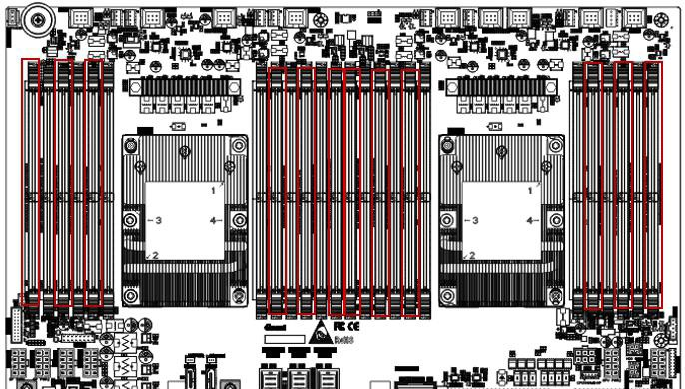
Figure 2-22

Hard disk label
- 2U8 disk bay 3.5 inch disk model
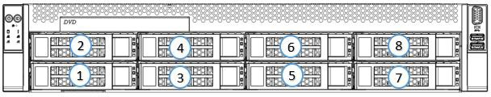
Figure 2- 23

- 2U12 disk bay 3.5 inch disk model
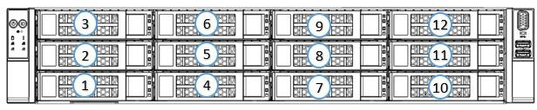
Figure 2-24

Hard Disk Indicator
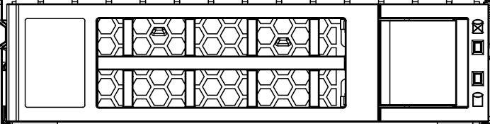 | Fault LED  StatusLED  Act LED

Figure 2-25

Features | Act LED | Fault LED | Status LED
Hard drive in place | Chang Liang | OFF | OFF
Hard drive activity | Flashing 4Hz/sec | OFF | OFF
Hard disk positioning | Chang Liang | Flashing 4Hz/sec | OFF
Hard disk error | Chang Liang | OFF | Chang Liang
RAID reconstruction | Chang Liang | OFF | Flashing 1Hz/sec
Table 1-28

System fan
The server supports variable fan speeds. Generally, the fan rotates at the lowest speed. If the server temperature rises, the fan will increase the speed to cool down.
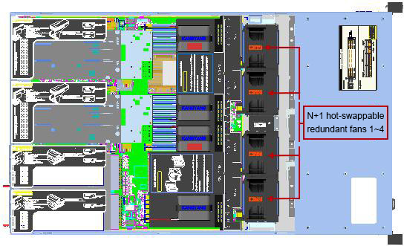
Figure 2-27

Installing System Components

CPU installation

- Install the processor:
Step 1: CPU installation
- Tilt the CPU angle as shown in the figure, the A1 corner (triangular mark) is aligned, and it is stuck on one end of the clamping piece.
- Direction, press the other end of the clamp to fix the CPU to the clamp.

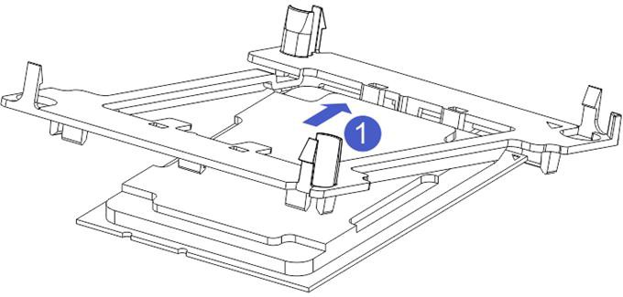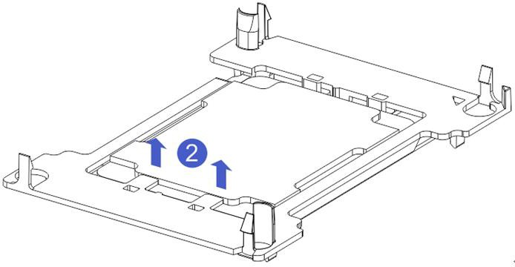
Figure 3-1 Figure 3-2
Step 2: Install the CPU on the radiator to ensure that the surfaces of the CPU and the radiator are clean and free of oil and foreign matter. (As shown below)
- Apply approximately 0.4ml thermal grease on the CPU and smooth it evenly.
- Align the A1 corner (triangular mark) and buckle the CPU on the heat sink.
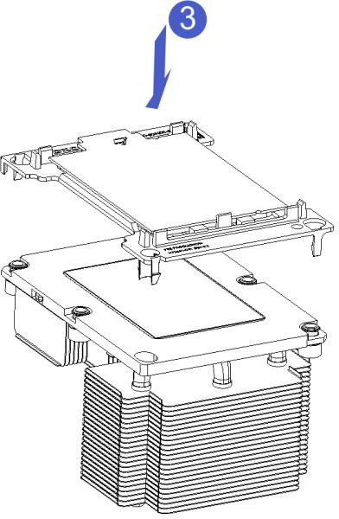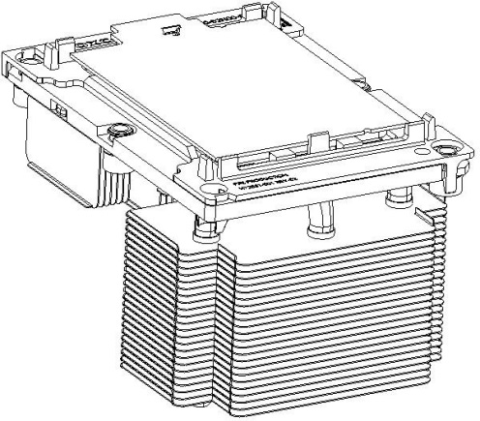
Figure 3-3 Figure 3-4

Radiator installation

- installation steps:
- Remove the processor blank (as shown below)
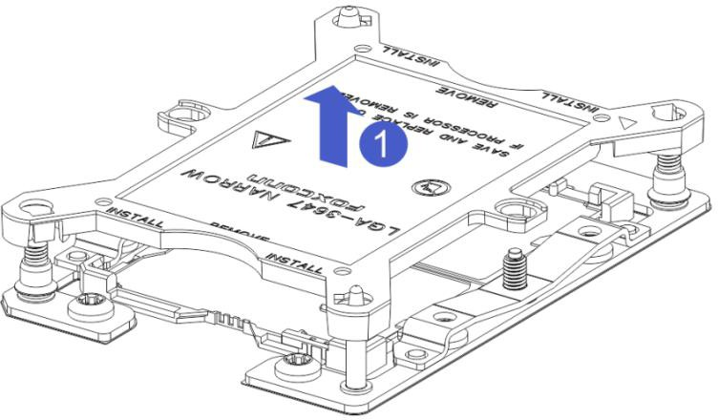
Figure 3-3
- Align the heat sink with the heat sink fixing studs on the CPU base, and tighten the fixing screws of the heat sink in sequence according to the instructions. (As shown below)
Note: The pins on the motherboard are extremely fragile and easily damaged. To avoid damage to the motherboard, do not touch the processor or processor socket contacts.

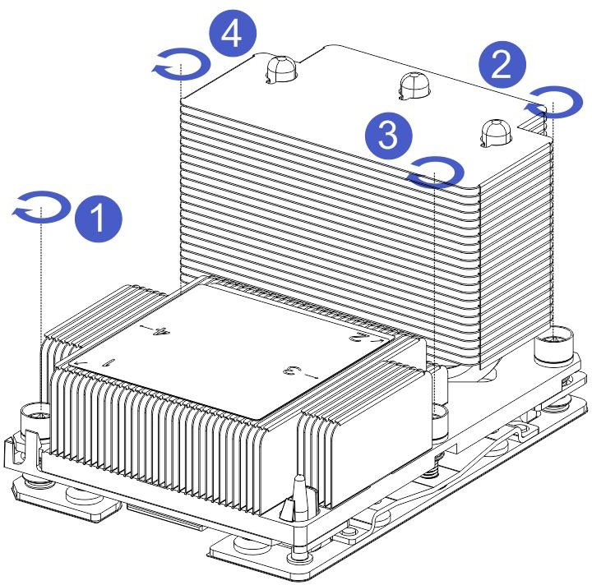
Figure 3-4

Memory installation

The 8 memory slots controlled by the motherboard CPU 1 are: DIMMA1, A2, DIMMB1, B2, DIMM C1, C2 and DIMM D1, D2; The 8 memory slots controlled by CPU 2 are: DIMME1, E2, DIMMF1, F2, DIMMG1, G2 and DIMMH1, H2,
Note that the notch of the memory is consistent with the notch of the DIMM slot, and each DIMM module is vertically snapped in place to prevent incorrect installation.
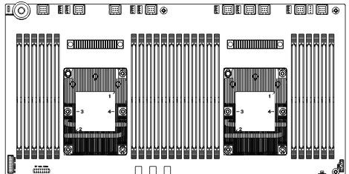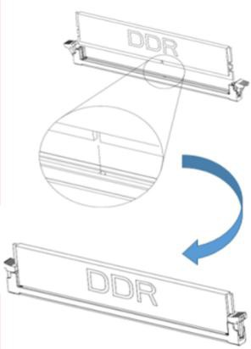
Figure 3-5

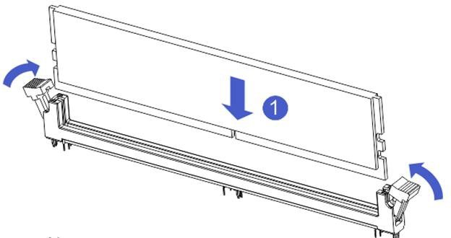

Figure 3- 6

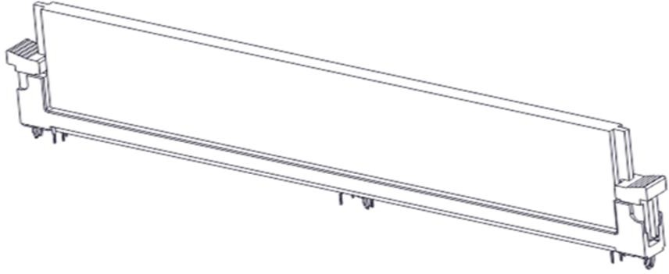
Figure 3-7

Hard disk installation

- Install 3.5 inch hard disk:
- Place the hard drive in the tray
- There are a total of 4 countersunk screws on the left and right sides to lock the hard drive (the screw heads must not protrude from the surface of the slide rails on both sides of the tray)

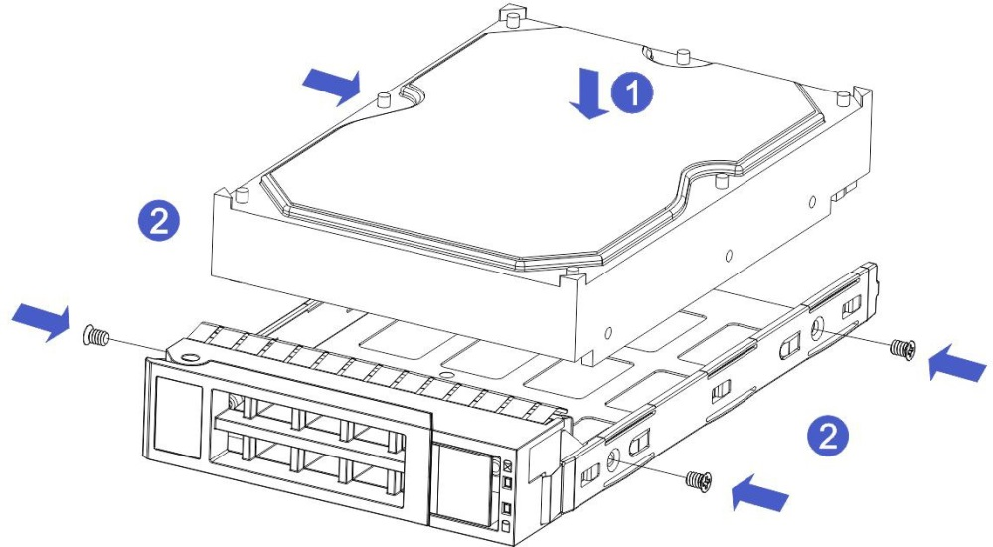

Figure 3-8

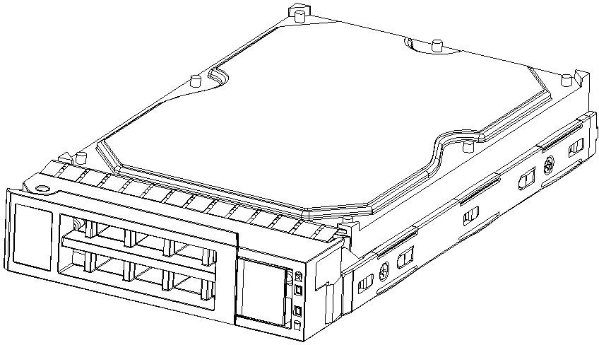

Figure 3-9
- Install 2.5 inch hard drive
- Place the hard drive in the tray
- 4 countersunk screws at the bottom to lock the hard drive (the screw heads protrude from the bottom of the tray)

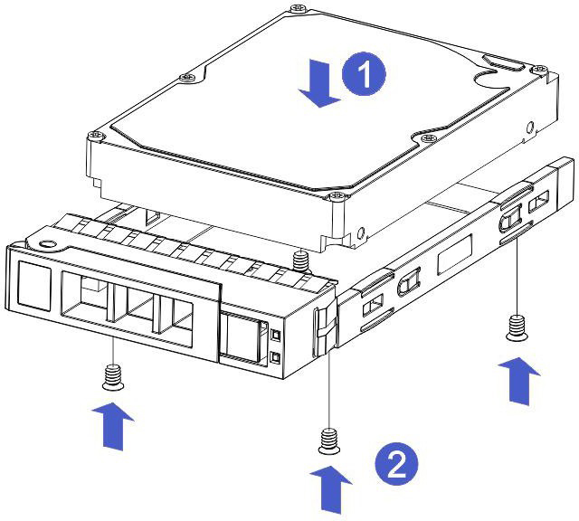
Figure 3-10

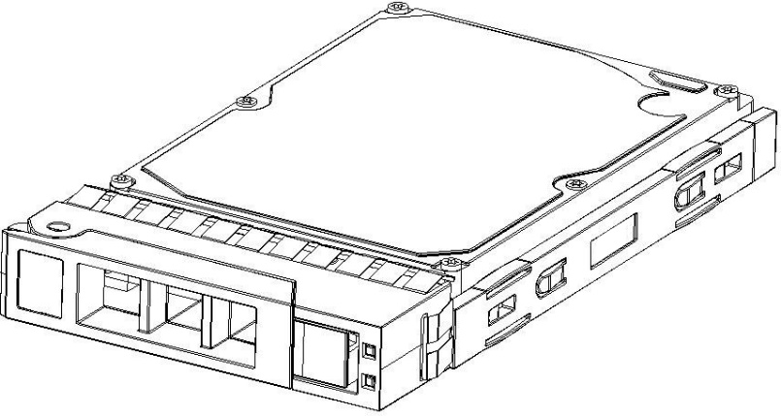

Figure 3-11

Install the hard drive tray assembly into the chassis
- With the hard drive wrench open, push it into the chassis
- When the hard disk golden finger touches the backplane device, turn the wrench in the direction of the arrow
- Schematic diagram of hard disk installation in place

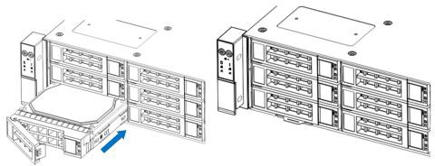

Figure 3-12

Front hard disk backplane installation.

- Front hard disk backplane installation:
- Align the gourd holes and hanging holes on the left and right sides of the hard disk backplane with the hanging nails of the hard disk frame and push in the direction of the arrow
- After the hard disk backplane is pushed into place, press the backplane down until the gourd nails and hanging holes on both sides are all in place
- Turn over the fixing parts on the left and right sides of the hard disk backplane and lay the fixing parts flat.

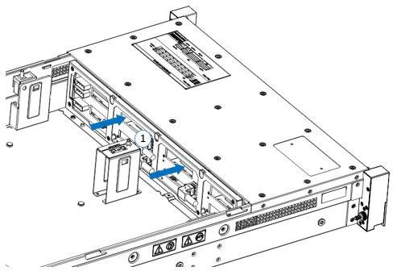
Figure 3-13

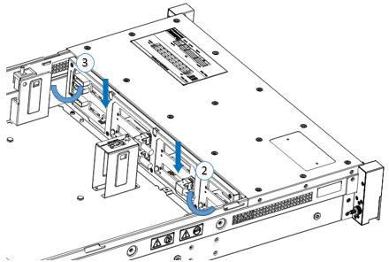

Figure 3-14

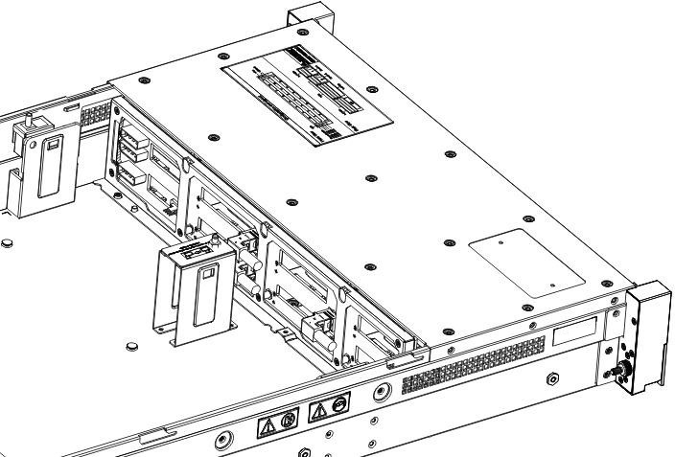

Figure 3-15

M.2 SSD installation

Step 1: Install the positioning studs according to the length of the M.2 card to be installed.

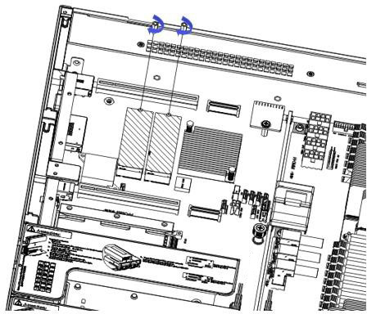
Figure 3-16

Step 2: install M.2 card
- Insert the M.2 card connector end into the motherboard connector as shown in the figure.
- Press the other end of the M.2 card to the plane of the positioning stud in step 1.

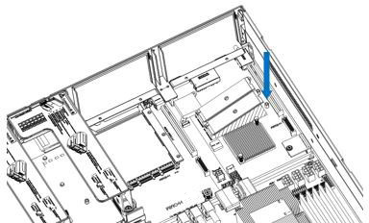
Figure 3-17

Step 3: Install the fixing screws of the M.2 card.
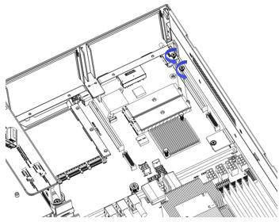
Figure 3- 18

PCI-E module installation

Riser1-3 module installation steps: the rear window PCIE components, vertically downward-align the PCIE slot, align the positioning holes, and place it flush with the rear window.
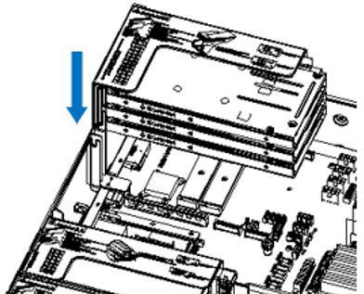
Figure 3-19

Riser4 module installation steps: rear window PCIE components, placed vertically downward-align the PCIE slot, align the positioning holes, place it flush with the rear window, and then tighten the side screws.

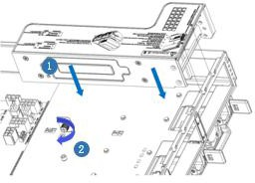
Figure 3-20

Rear hard disk module backplane installation

Step 1: Install the rear hard disk module backplane
- Pull the back plate limiting shrapnel outward with your hand, and hold the shrapnel with your hand-keep the shrapnel open
- Align the nail holes of the hard disk backplane with the nails of the hard disk module bracket and push it forward, and then place it down in place, release the hard disk limit shrapnel, and the shrapnel automatically springs back to the original position;
- Turn over the fixing parts on the hard disk backplane, as shown in the figure-the fixing parts can be placed flat.

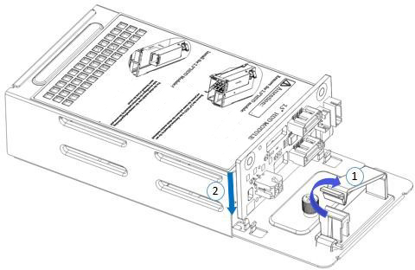

Figure 3-21

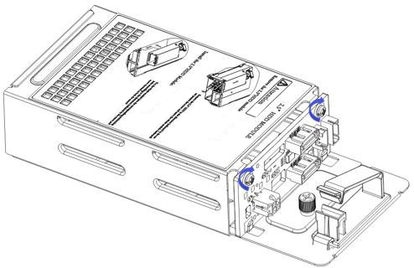

Figure 3-22

Rear hard disk module installation

- Rear 3.5 inch HDD tray installation
Step 1. Place the HDD tray vertically downward and flush with the rear window
Step 2. Fix the rear HDD tray component
Step 3. Lock a captive screw

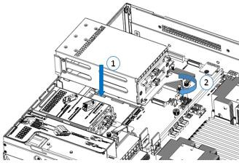
Figure 3-23

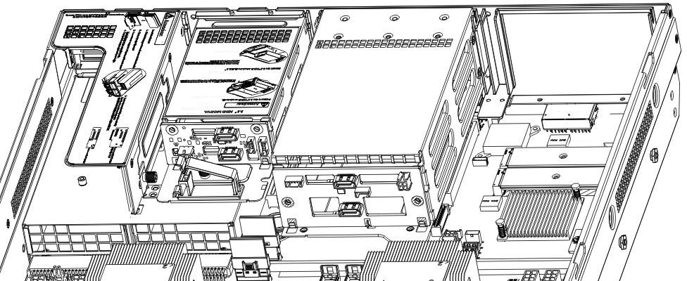
Figure 3-24

- Rear 2.5 inch HDD tray installation
- Place vertically downward, aiming at the guide pin at the lower end
- After placing it flat, push it to the end in the direction of the arrow,
- Lock the captive screws

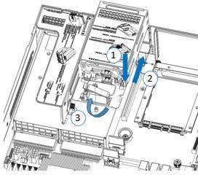

Figure 3-25

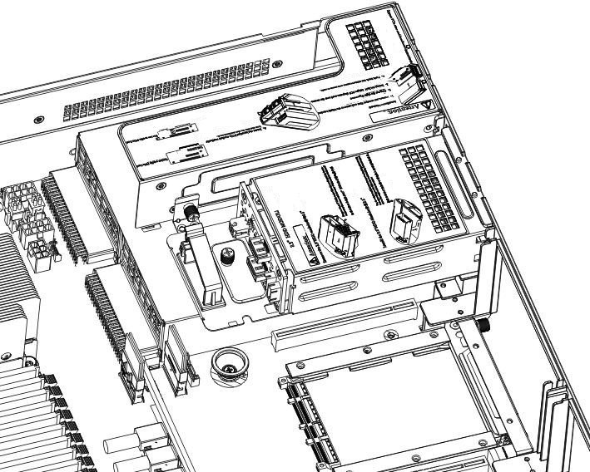
Figure 3-26

Power supply module installation

Step: Push the power supply in the direction of the arrow to the end, and the shrapnel wrench on the right makes a clicking sound, indicating that it is installed in place;

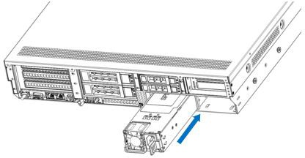

Figure 3-27

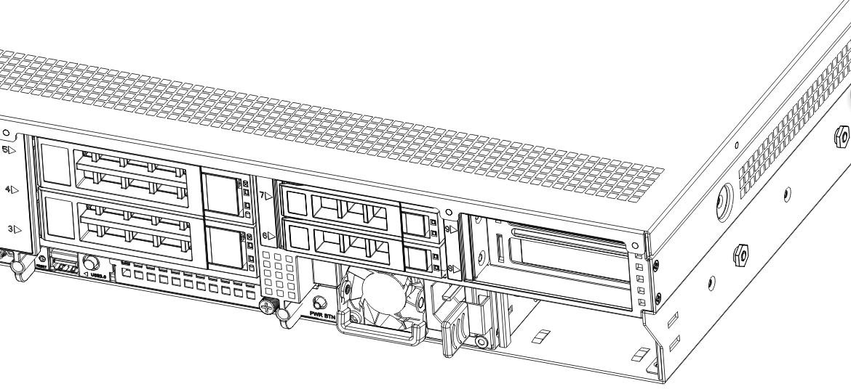

Figure 3-28

PCI-E expansion card installation

Steps: install PCIE card
- Install the PCIE card in the direction indicated in the figure
- Rotate the PCIE card lock
- Follow the arrow scheme to lock the PCIE card lock

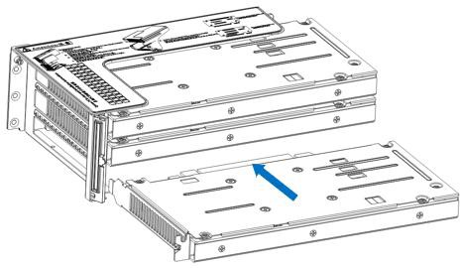

Figure 3- 29

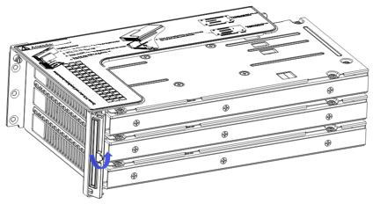

Figure 3-30

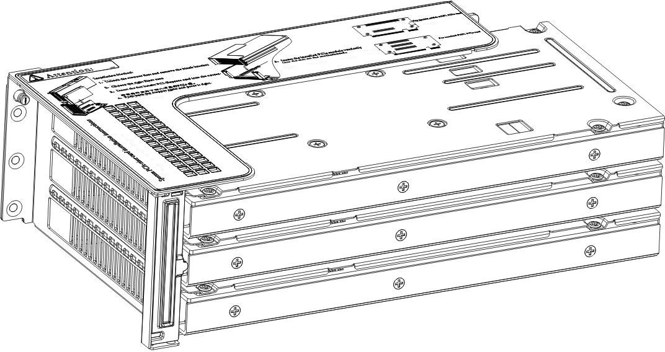

Figure 3-31

Fan module installation

Steps: The fan module is placed vertically downward in the direction of the arrow (note the direction of the fan module).
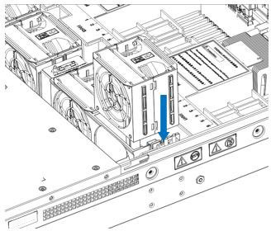

Figure 3-32

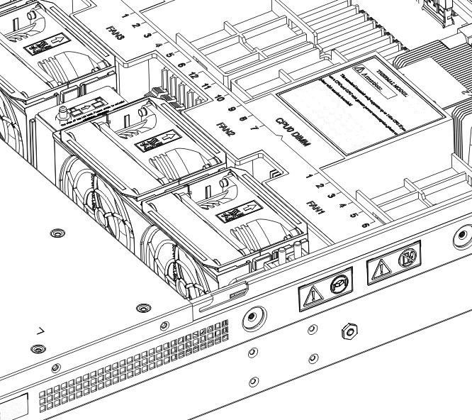

Figure 3-33

Installation of air duct

Steps: align the air baffle module with the hanging points on the left and right sides and place it vertically downward-the height is lower than the height of the cabinet

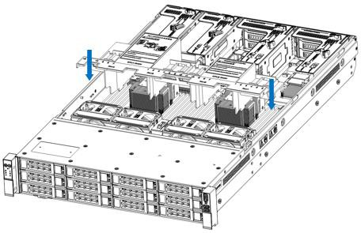

Figure 3- 34

CD-ROM installation

Step: install the optical drive
- The optical drive is as shown in Figure 3-34:

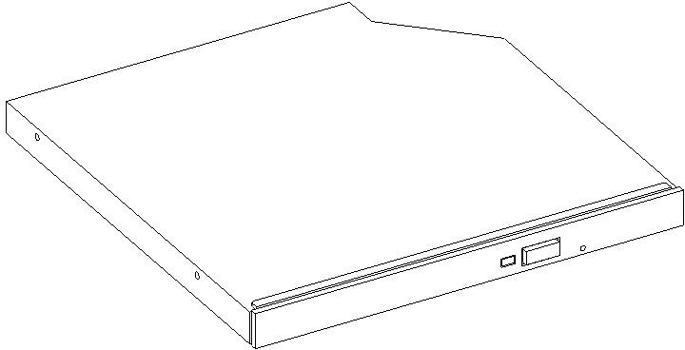

Figure 3-35

- Align the opening of the optical drive on the chassis, and push the optical drive in the direction of the arrow until the fixing part is automatically locked.

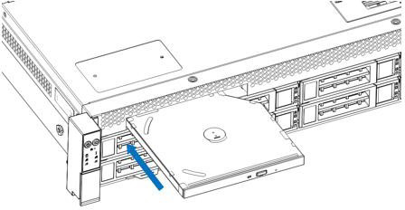

Figure 3- 36

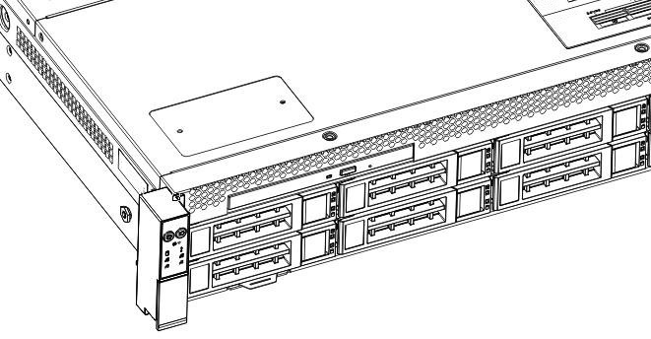

Figure 3-37

Installation of the upper cover of the chassis

Step 1: Install the back cover of the chassis
- Align the top cover with the opening position of the box and place it down
- Rotate the upper cover lock in the direction of the arrow to lock it in place

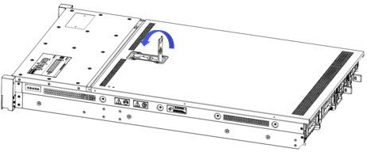
Figure 3-38

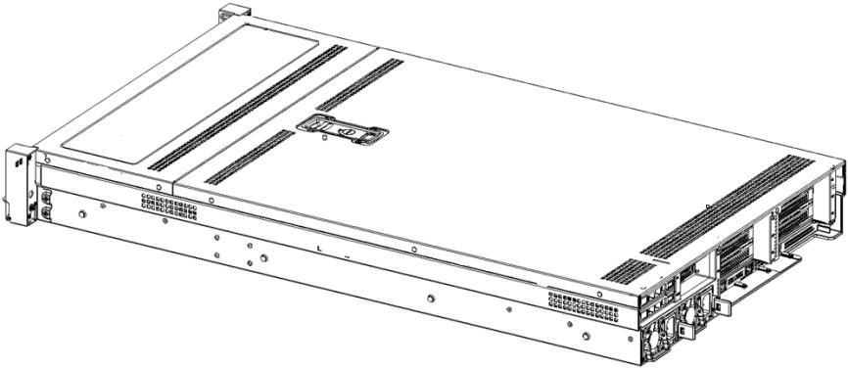
Figure 3-39

System cabinet Installation

Rail installation

Step 1. Prepare two sliding rail frames and draw out the inner rail.
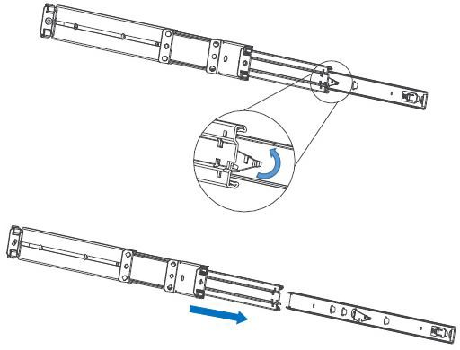
Figure 4-1

Step 2. Fix the inner rails on both sides of the chassis.

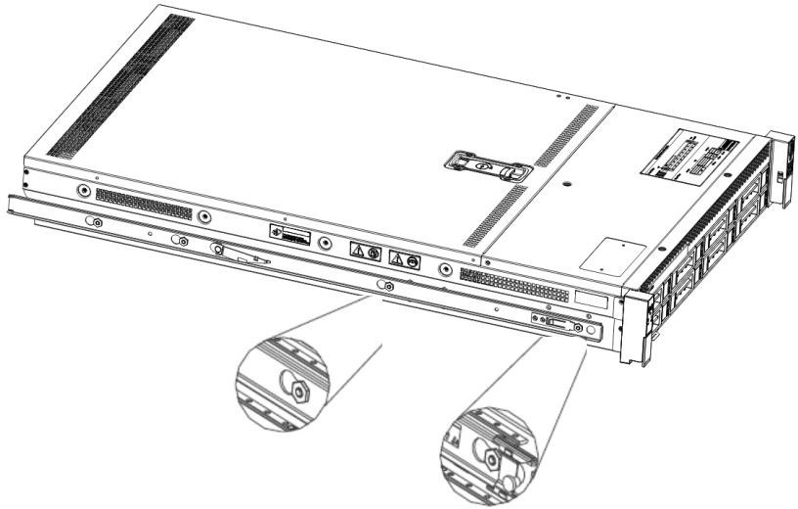

Figure 4-2

Install the outer rail to cabinet

Step 3. Install the outer rail on the cabinet bracket and tighten the screws.
Note: When installing the guide rail, you need to align the U mark, and install it in place with a snapping sound. Use M5 screws to secure it.

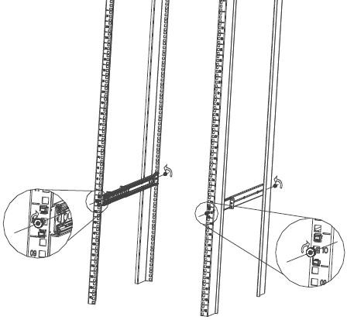
Figure 4-3

Install server to cabinet
Step 4. Align the cabinet with the inner rail to the outer rail for installation.
Note: When you push the chassis forward, you hear a pop. If you can't push it, you need to pull the inner rail buckle down to continue pushing the chassis gently.

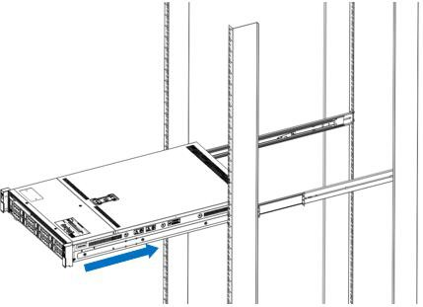

Figure 4-4

Step 5. When the chassis is pushed forward and cannot slide, the screws are installed firmly.
Note: When the equipment is maintained, it is necessary to loosen the panel screws and gently pull the chassis. Do not push and pull the chassis at will, so as not to damage the equipment.

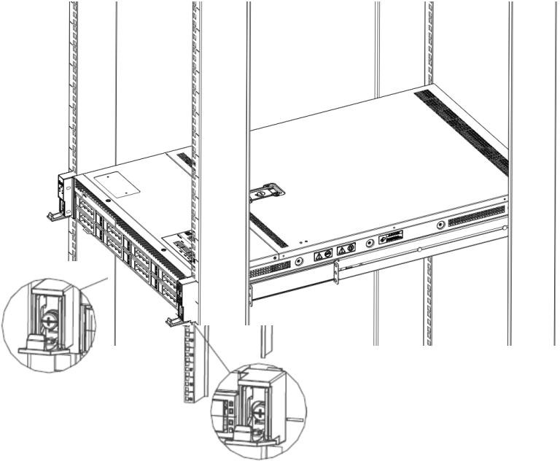

Figure 4-5

BIOS parameter setting description

Enter the BIOS Setup interface

Steps:
- Power on the server motherboard and connect the keyboard;
- During the POST process, pay attention to the prompt to enter the BIOS Setup interface at the bottom left of the Logo screen, "Press <DEL> or <ESC> to enter setup, <F7> to enter Boot Menu.";
- Press the keyboard <DEL> or <ESC> key to prepare to enter the BIOS Setup interface;

Setup menu parameter description

Navigation key description

→←: Menu switch (Select Screen)
↑↓: Select Item
Enter: OK (Select)
+/-: Change Opt. (Change Opt.)
F1: General Help
F2: Previous Values
F3: Optimized Defaults
F4: Save changes and restart the system (Save & Reset)
ESC: Exit

Main menu description

The Main interface contains the basic information of the BIOS system, such as the BIOS version number, CPU model, memory capacity, and the system time can be set.
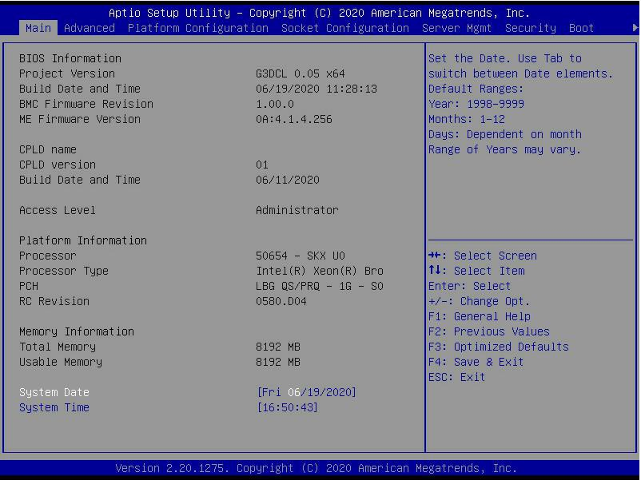
Figure 5-1

BIOS Information Project Version:
Display the BIOS version information of the board.

Build Date and Time:
Display the compilation date and time of the board BIOS.

BMC Firmware Revision:
Display the BMC version information of the board.

ME Firmware Version:
Display the version information of the board ME.

CPLD Name:
Display the CPLD name information of the board.

CPLD Version:
Display the CPLD version information of the board.

Build Date and Time:
Display the compilation date and time of the CPLD of the board.

Access Level:
Display the current user rights of the board.

Platform Information Processor:
CPUID and step information.

Processor Type:
CPU model information.

PCH:
PCH SKU and step information.

RC Revision:
Display the RC version information of the board.

Memory information Total Memory:
Display the total capacity of system memory.

Usable Memory:
Display the available memory capacity of the system.

System Language:
Select the current system language.

System Date:
Display and set the current system date. The format of the system date is "week month/day/year". Press "Enter" to switch between month, day, and year. You can change the value in the following ways:
- Press "+": the value increases by 1.
- Press "-": the value decreases by 1.
- Press the number keys: directly change the value.

System Time:
Display and set the current system time. The system time is in 24-hour format and the format is "hour:minute:second". Press "Enter" to switch between hour, minute, and second. You can change the value in the following ways:
- Press "+": the value increases by 1.
- Press "-": the value decreases by 1.
- Press the number keys: directly change the value.

Advanced menu description

The Advanced interface contains advanced configuration items of the BIOS system.
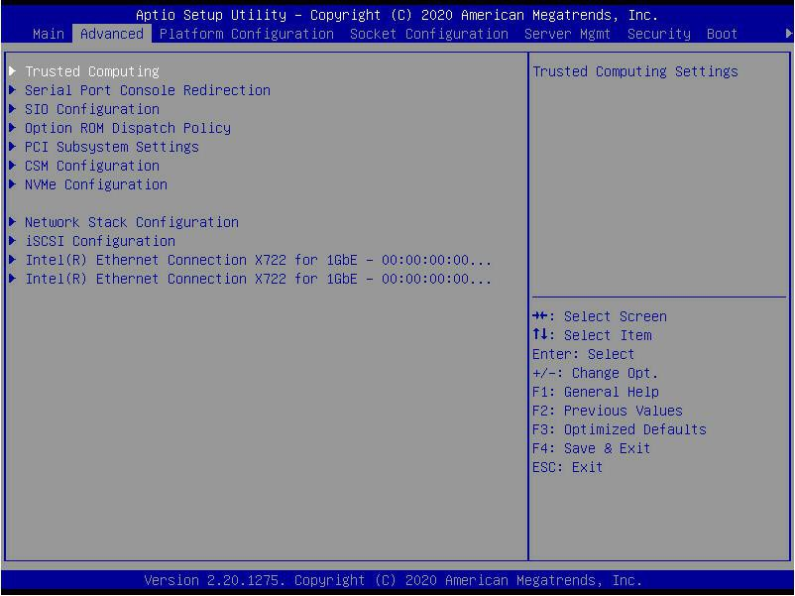
Figure 5-2

- Trusted Computing
Trusted execution module configuration.
- Serial Port Console Redirection
Serial port redirection configuration.
- SIO Configuration
SIO configuration.
- Option ROM Dispatch Policy
Option ROM call policy.
- PCI Subsystem Settings
PCI Subsystem Settings.
- CSM Configuration
CSM configuration.
- NVMe Configuration
NVMe configuration.
- Network Stack Configuration
Network Stack Configuration.
- iSCSI Configuration
iSCSI configuration.
- Intel Enthernet Connection X722 for xGbE-XX:XX:XX:XX:XX:XX
Intel xG network card UEFI OPROM configuration

Trusted Computing

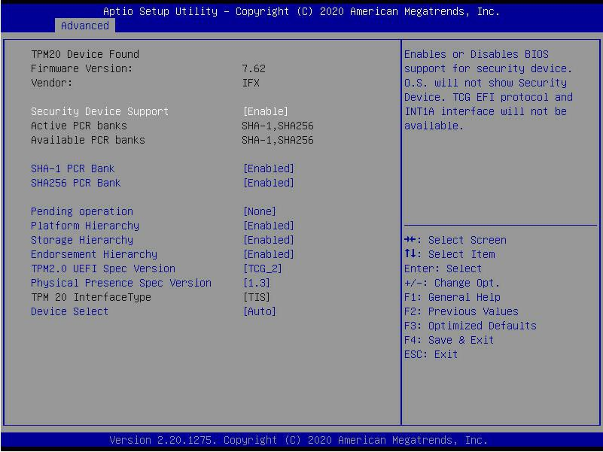
Figure 5-3

Display and set the TCM/TPM module information. Different module options have different settings. The user can set according to the Setup help instructions.

Serial Port Console Redirection

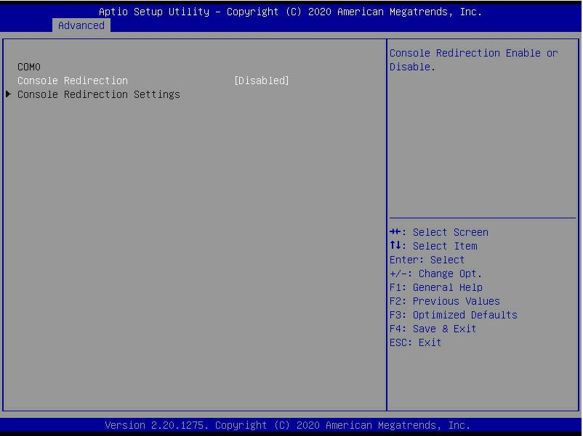
Figure 5-4

Console Redirection
The console redirection function switch redirects the information output from the console (such as a graphics card) to the display to the serial port.
- Disabled: Turn off the redirection function.
- Enabled: Enable the redirection function.
- Default value: Disabled

Console Redirection Settings

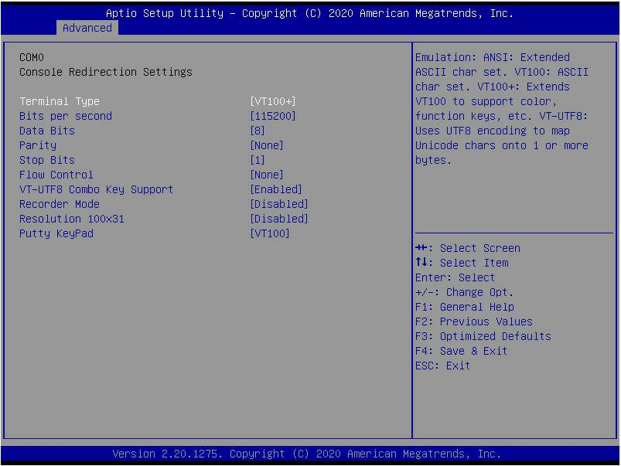

Terminal Type
Figure 5- 5

The emulation type can be selected through this option, and the BIOS emulation type must match the mode selected in the terminal program. The menu options are:
- VT100
- VT100+
- VT-UTF8
- ANSI
Default value: VT100+
Bits per second
Serial port redirection rate, the value range is 9600~115200
Default value: 115200
Data Bits
Serial port redirection data bit length, the menu options are:
- 8
- 7

Default value: 8

Parity
Serial port redirection check switch, the menu options are:
- None: No verification
- Even: Even parity
- Odd: odd parity
- Mark: The check digit is always 1
- Space: Check digit is always 0
- Default value: None
Mark and Space checks are not allowed to detect errors.
Stop Bits
Serial port data packet end flag, the menu options are:
- 1
- 2
Default value: 1

Flow Control
Serial port redirection control flow selection switch, the menu options are:
- None: Close the serial port redirection control flow
- Hardware RTS/CTS: Request to send/Clear to send
- Default value: None

VT-UTF8 Combo key support
ANSI/VT100 terminal VT-UTF8 key combination supports switch, the menu options are:
- Disabled: Disable ANSI/VT100 terminal VT-UTF8 key combination support
- Enabled: Enable ANSI/VT100 terminal VT-UTF8 key combination support
- Default value: Enabled

Recorder Mode
Record mode switch, turn on this function, only text messages will be sent, the menu options are:

- Enabled: open
- Disabled: Closed
- Default value: Disabled

SIO Configuration

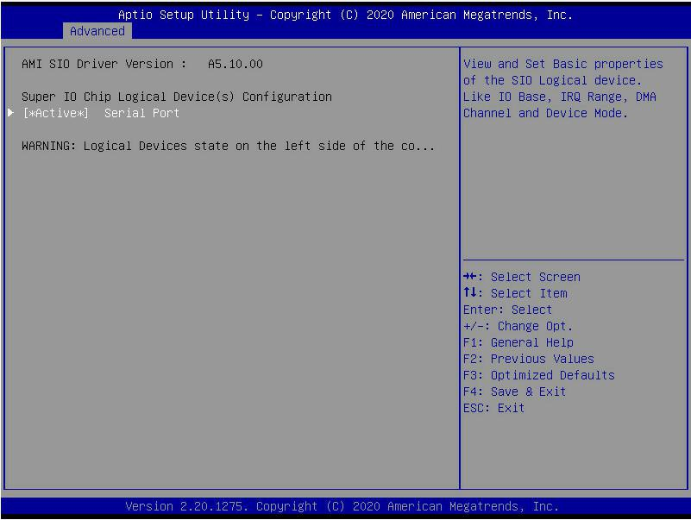
Figure 5-6

[*Active*] Serial Port

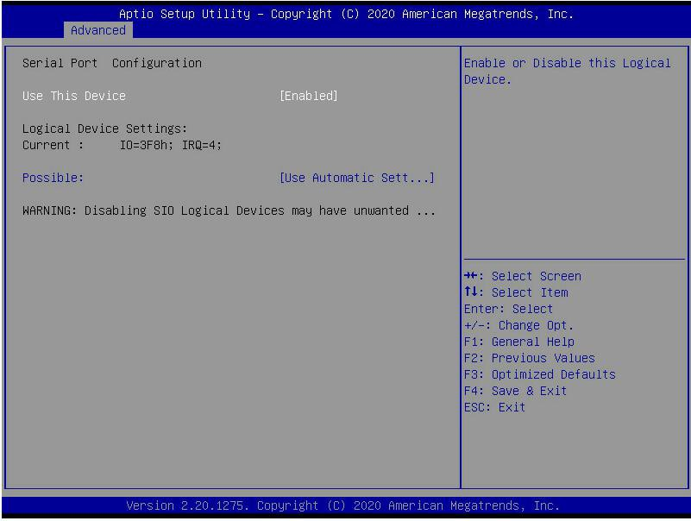
Figure 5-7
Use This Device
With this device, the menu options are:
- Enabled: open
- Disabled: Closed
- Default value: Enabled

Possible
Choose the optimal settings for the serial port according to your needs, the menu options are:
- Use Automatic Settings
- IO=3F8h; IRQ=4; DMA;
- IO=3F8h; IRQ=3,4,5,7,9,10,11,12; DMA;
- IO=2F8h; IRQ=3,4,5,7,9,10,11,12; DMA;

- IO=3E8h; IRQ=3,4,5,7,9,10,11,12; DMA;
- IO=2E8h; IRQ=3,4,5,7,9,10,11,12; DMA;
Default value: Use Automatic Settings

Option ROM Dispatch Policy

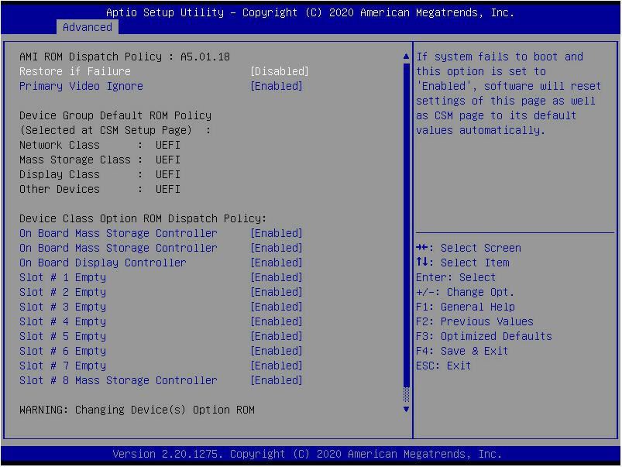
Figure 5-8
Manage Option ROM call strategy Restore if Failure
When the fault is restored, the menu options are:
- Enabled: open
- Disabled: Closed
- Default value: Disabled

Primary Video Ignore
Ignore the basic graphics card, the menu options are:
- Enabled: open
- Disabled: Closed
- Default value: Enabled

On Board Mass Storage Controller Onboard or external device controller, the menu options are:
- Enabled: open
- Disabled: Closed
- Default value: Enabled
On Board Mass Storage Controller
Onboard or external device controller, the menu options are:
- Enabled: open
- Disabled: Closed
- Default value: Enabled

On Board Display Controller
Onboard or external device controller, the menu options are:
- Enabled: open
- Disabled: Closed
- Default value: Enabled

Slot # 1 Empty
Onboard or external device controller, the menu options are:
- Enabled: open
- Disabled: Closed
- Default value: Enabled
…
Slot # 8 Empty
Onboard or external device controller, the menu options are:
- Enabled: open
- Disabled: Closed
- Default value: Enabled

PCI Subsystem Settings

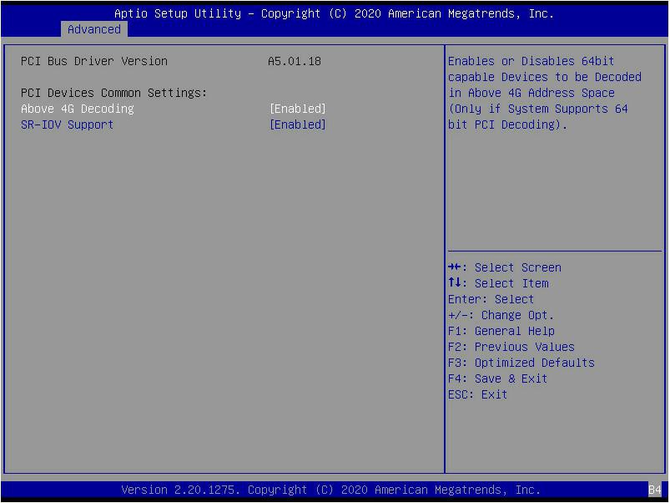
Figure 5-9

Above 4G Decoding
Figure 5- 9

Memory space resource decoding control switch above 4G, the menu options are:
- Enabled: open
- Disabled: Closed
- Default value: Enabled

SR-IOV Support
SR-IOV supports switch settings, the menu options are:
- Enabled: open
- Disabled: Closed
- Default value: Enabled

CSM Configuration

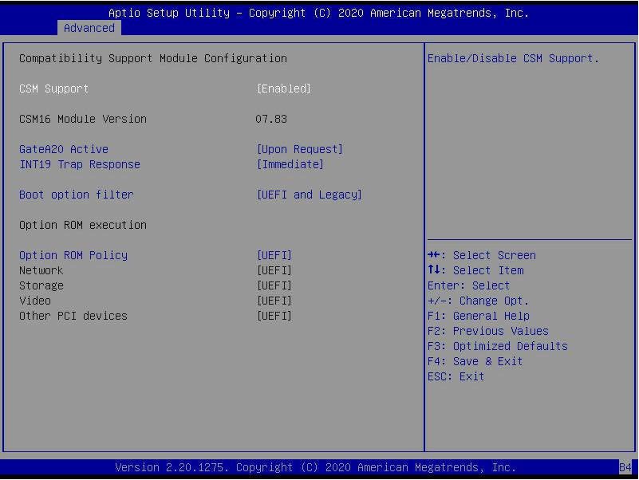
Figure 5-10

CSM Support
Figure 5- 10

To enable or disable the compatible support module, the menu options are:
- Disabled:shut down
- Enabled: Open
- Default value: Enabled

GateA20 Active
A20 address line control mode setting, the menu options are:
- Upon Request:If needed
- Always:always
- Default value: Upon Request
INT19 Trap Response
Interrupt and capture signal response settings, the menu options are:
- Immediate:Respond immediately
- Postponed:Delayed response

Default value: Immediate

Boot option filter
Start option control switch, the menu options are:
- UEFI and Legacy: UEFI and Legacy startup items
- UEFI only: UEFI boot item
- Legacy only: Legacy boot item
- Default value: UEFI and Legacy

Option ROM Policy
Select Option ROM execution mode, the menu options are:
- UEFI: UEFI mode
- Legacy: Legacy mode
- Default value: UEFI

NVMe Configuration

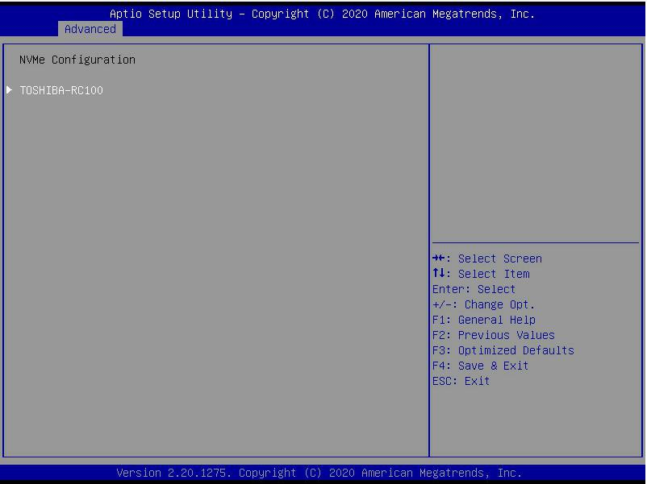
Figure 5-11

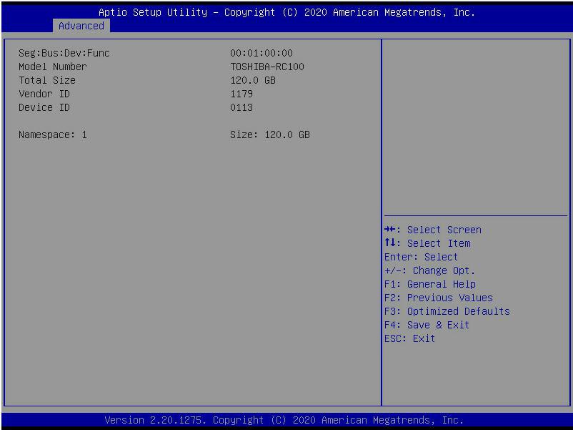
Figure 5-11

Display the detailed information of the NVMe hard disk.

Network Stack Configuration

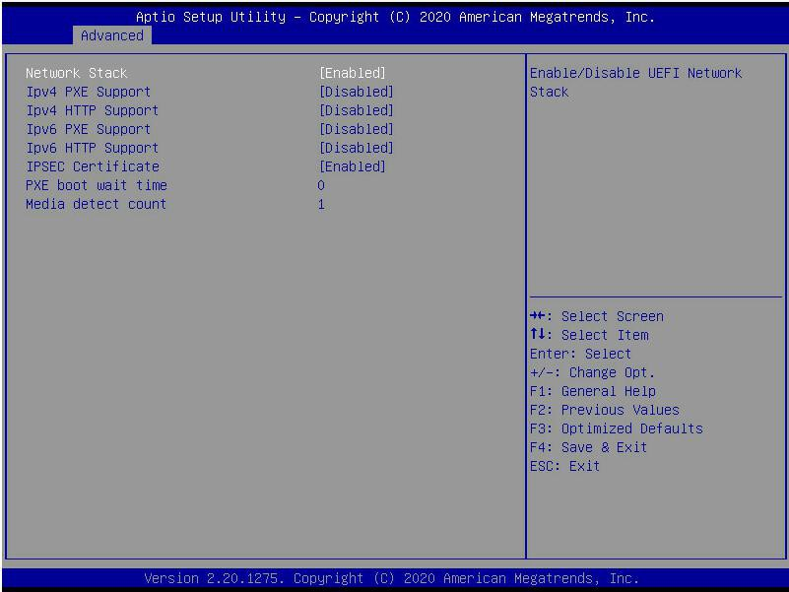
Figure 5-13

Network Stack
Network stack control switch, the menu options are:
- Enabled: open
- Disabled: Closed
- Default value: Disabled

Ipv4 PXE Support
Ipv4 UEFI PXE function control switch, the menu options are:
- Enabled: open
- Disabled: Closed
- Default value: Disabled

Ipv4 HTTP Support
Ipv4 HTTP function control switch, the menu options are:
- Enabled: open
- Disabled: Closed
- Default value: Disabled

Ipv6 PXE Support
Ipv6 UEFI PXE function control switch, the menu options are:
- Enabled: open
- Disabled: Closed
- Default value: Disabled

Ipv6 HTTP Support
Ipv6 HTTP function control switch, the menu options are:
- Enabled: open
- Disabled: Closed
- Default value: Disabled

PXE boot wait time
PXE startup waiting time, the user can enter the PXE startup waiting time, the waiting process can press "ESC"
Give up PXE boot, the default is 0.

Media detect count
The number of device detection times, the user can enter the number of device network card device detection times, the default is 1.

iSCSI Configuration

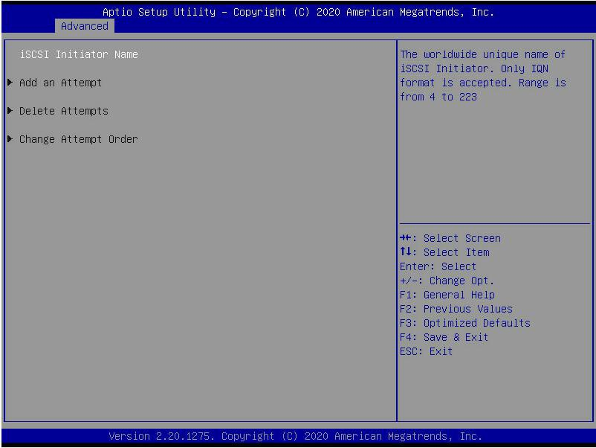
Figure 5-14

iSCSI configuration

Platform Configuration menu

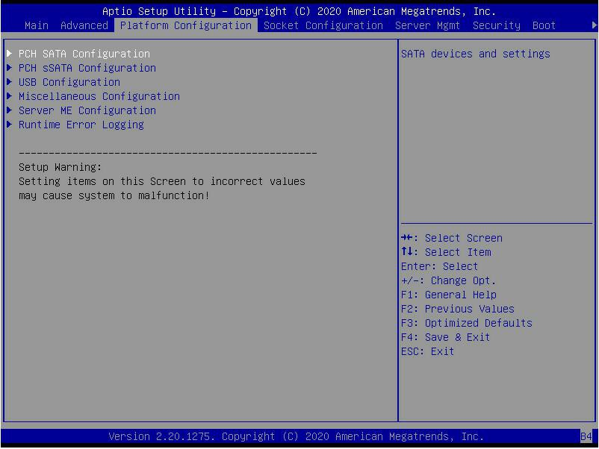
Figure 5-15

- PCH SATA Configuration
PCH SATA related configuration;

- PCH sSATA Configuration
PCH sSATA related configuration;

- USB Configuration
USB related configuration.

- Miscellaneous Configuration
other related configuration;

- Server ME Configuration
Server ME Configuration;

- Runtime Error Logging

Runtime error log.

PCH SATA Configuration

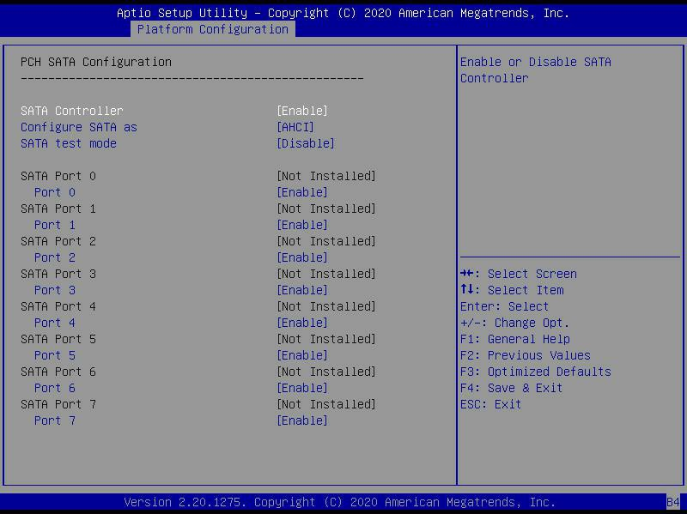
Figure 5-16

SATA Controller
SATA controller switch, control to turn on and off the SATA controller, the menu options are:
- Disabled: Turn off the SATA controller.
- Enabled: Turn on the SATA controller.
- Default value: Enabled

Configure SATA as
SATA mode selection, the menu options are:
- AHCI: Select SATA mode as AHCI mode.
- RAID: Select SATA mode as RAID mode.
- Default value: AHCI

SATA test mode
SATA test mode switch, the menu options are:
- Disable: Turn off.
- Enable: Turn on.
- Default value: Disable

SATA Port X
Display device information on SATA Port 0~7, and display Not Installed when the device is not connected.
Port X
Control the opening and closing of SATA Port X, the menu options are:
- Disabled: Close SATA Port X.
- Enabled: Enable SATA Port X.
- Default value: Enabled

Hot Plug
Control the hot plug function of SATA Port X device on and off, the menu options are:
- Disabled: Disable the hot plug function of SATA Port X.
- Enabled: Enable SATA Port X hot plug function.
- Default value: Enabled

PCH sSATA Configuration

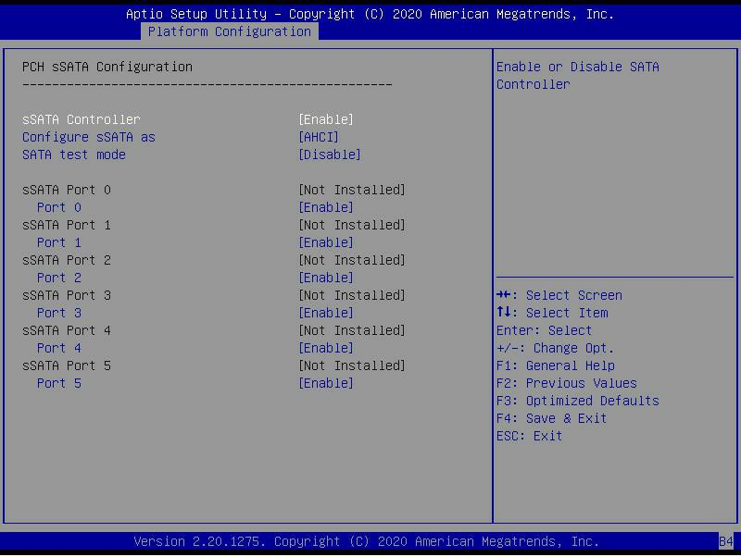
Figure 5-17
sSATA Controller
sSATA controller switch, control to turn on and off the sSATA controller, the menu options are:
- Disabled: Turn off the sSATA controller.
- Enabled: Turn on the sSATA controller.
- Default value: Enabled

Configure sSATA as
sSATA mode selection, the menu options are:
- AHCI: Select sSATA mode as AHCI mode.
- RAID: Select sSATA mode as RAID mode.
- Default value: AHCI

SATA test mode
SATA test mode switch, the menu options are:
- Disable: Turn off.
- Enable: Turn on.
- Default value: Disable

sSATA Port X
Display the device information on sSATA Port 0~7, and display Not Installed when the device is not connected.

Port X
To control the opening and closing of sSATA Port X, the menu options are:
- Disabled: Close sSATA Port X.
- Enabled: Enable sSATA Port X.
- Default value: Enabled

USB Configuration

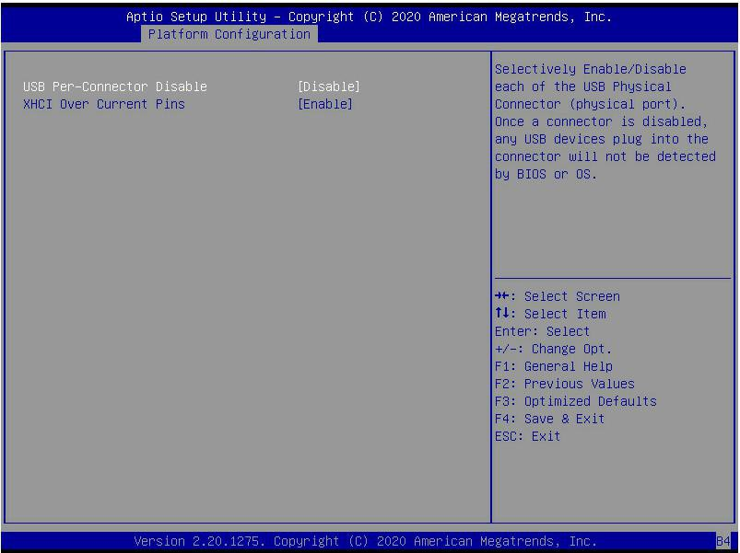
Figure 5- 18

USB Per-Connector Disable
Each USB connector switch, the menu options are:
- Enable: open
- Disable: Turn off
- Default value: Disable

XHCI Over Current Pins
XHCI overcurrent pin switch, the menu options are:
- Enable: open
- Disable: Turn off
- Default value: Enable

Miscellaneous Configuration

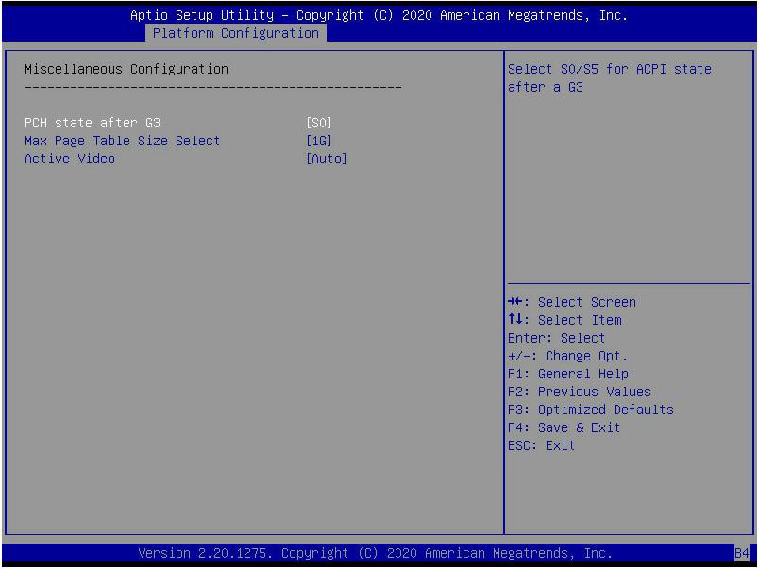
Figure 5- 19

PCH status setting after G3, the menu options are:
- S0: Power on directly
- S5: You need to press the Power button to power on
- leave power state unchanged: leave power state unchanged
- Default value: S0

Max Page Table Size Select
Select the maximum page table size setting, the menu options are:
- 2M
- 1G
- Default value: 1G

Active Video
Select the active display device type, the menu options are:
- Auto: automatic
- Onboard Device: Onboard device
- PCIE Device: PCIE device Default value: Auto

Server ME Configuration

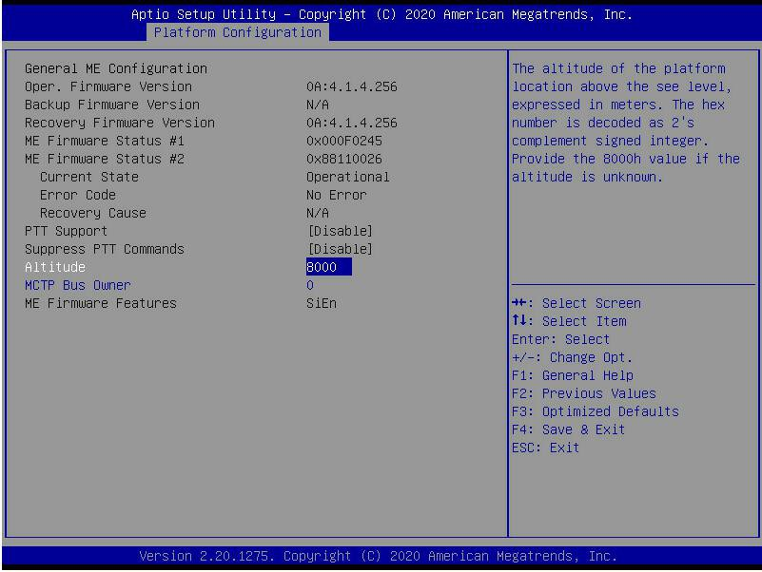
Figure 5- 20
Display Server ME version, features, status and other information;

Runtime Error Logging

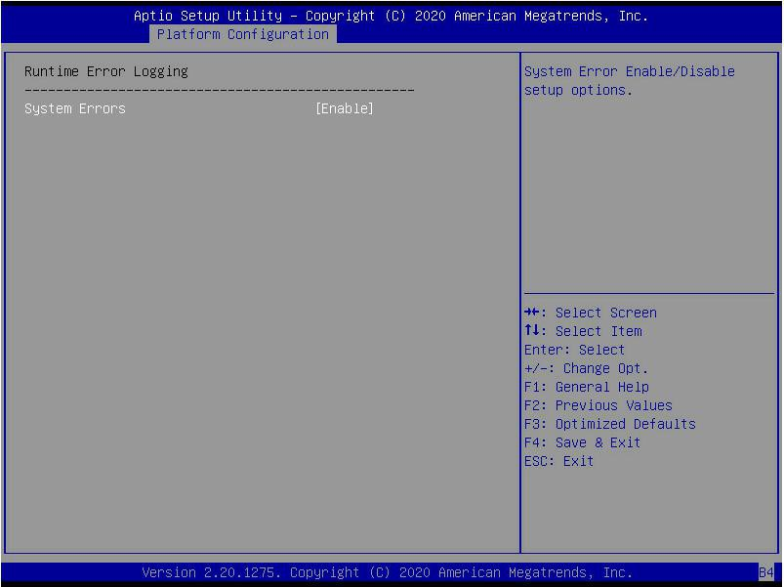
Figure 5- 21

System Errors
Turn on or off the system error function, the menu options are:
- Disabled:shut down
- Enabled: Open
- Default value: Enabled

Socket Configuration menu

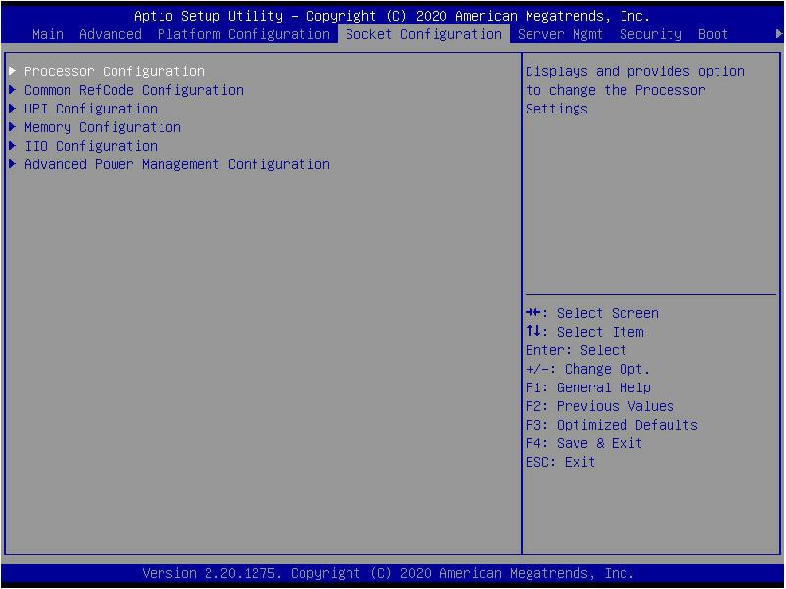
Figure 5- 22
- Processor Configuration processor related configuration;

- Common RefCode Configuration Common RefCode configuration;

- UPI Configuration UPI configuration;

- Memory Configuration memory configuration;

- IIO Configuration IIO configuration;

- Advanced Power Management Configuration

- Advanced power management configuration.

Processor Configuration

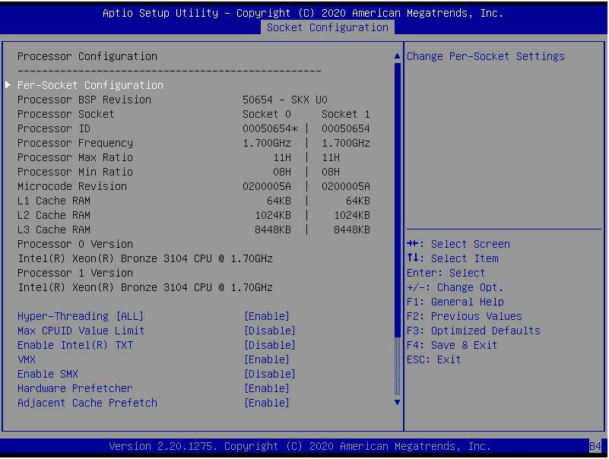
Figure 5- 23

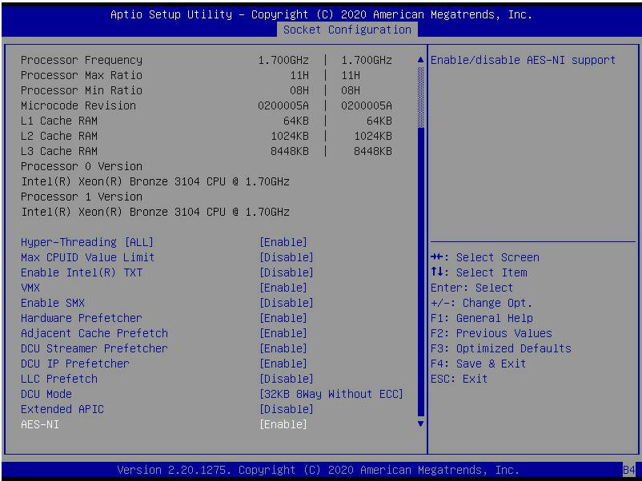
Figure 5- 24

Display CPU Type\ID\Speed\Cache and other information, configure CPU related functions;
- Pre-Socket Configuration: each slot configuration; Hyper-Threading
Hyper-threading control switch, this option can enable or disable the Intel processor hyper-threading function. Enable this
Function, each physical processor core is equivalent to two logical processor cores; disable this function, each physical processor core is equivalent to only one logical processor core. Enabling this feature will bring a higher processor core count and improve the overall performance of the application. The menu options are:
- Enable: open
- Disable: Turn off
- Default value: Enable

Max CPUID Value Limit
When starting a traditional operating system that cannot support extended CPUID, the menu options are:
- Enable: open
- Disable: Turn off
- Default value: Disable

Enable Intel(R) TXT
Intel TXT function switch, the menu options are:
- Enable: open
- Disable: Turn off
- Default value: Disable

VMX
CPU virtualization technology switch, enable this option, then the virtualization layer or operating system that supports this option can use the hardware capabilities of Intel virtualization technology. Some virtualization layers require Intel virtualization technology to be enabled. Do not use the virtualization layer or operating system that supports this option, and you can also keep this option enabled. The menu options are:
- Enable: open
- Disable: Close
- Default value: Enable

Enable SMX
Extended safe mode function switch, the menu options are:
- Enable: open
- Disable: Turn off
- Default value: Disable

Hardware Prefetcher
Hardware prefetching means that before the CPU processes instructions or data, it prefetches these instructions or data from the memory to the L2 cache, thereby reducing the time of memory reading, helping to eliminate potential bottlenecks, and improving system performance. The menu options are:
- Enable: open
- Disable: Turn off
- Default value: Enable

Adjacent Cache Prefetch
After the adjacent cache prefetch function is turned on, when the computer reads the data, it will intelligently think that the data next to or adjacent to the data to be read is also needed, so it will read the adjacent data in advance during processing. , This can speed up the reading speed. When the application scenario is to access memory sequentially, enabling this feature will improve performance. When the application scenario is random access to memory, it is recommended to disable this option. The menu options are:
- Enable: open
- Disable: Turn off
- Default value: Enable

DCU Streamer Prefetcher
DCU stream prefetch switch, the menu options are:
- Enable: open
- Disable: Turn off
- Default value: Enable

DCU IP Prefetcher
DCU IP prefetch switch, the menu options are:
- Enable: open
- Disable: Turn off
- Default value: Enable

LLC Prefetcher
LLC prefetch switch, the menu options are:
- Enable: open
- Disable: Turn off
- Default value: Disable

DCU Mode
DCU mode setting, the menu options are:
- 32KB 8Way Without ECC: 32KB 8Way Without ECC
- 16KB 4Way With ECC: 16KB 4Way With ECC
- Default value: 32KB 8Way Without ECC

Extended APIC
Enable/disable extended APIC support, the menu options are:
- Enable: open
- Disable: Turn off
- Default value: Disable

AES-NI
Turn AES (Advanced Encryption Standard) on and off, the menu options are:
- Enable: open
- Disable: Turn off
- Default value: Enable

Common RefCode Configuration

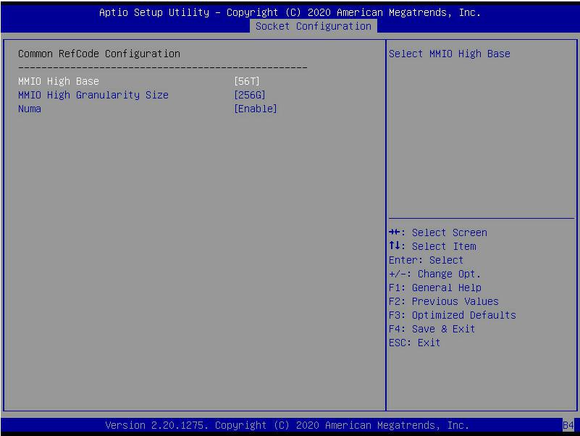
Figure 5- 25

MMIO High Base
Select MMIO high base address, the menu options are:
- 56T
- 40T
- 24T
- 16T
- 4T
- 1T
Default value: 56T

MMIO High Granularity Size
Select MMIO high interval size, the menu options are:
- 1G
- 4G
- 16G
- 64G
- 256G
- 1024G
- Default value: 256G

Numa
To turn on or off non-uniform memory access, the menu options are:
- Enable: open
- Disable: Turn off Default value: Enable

UPI Configuration

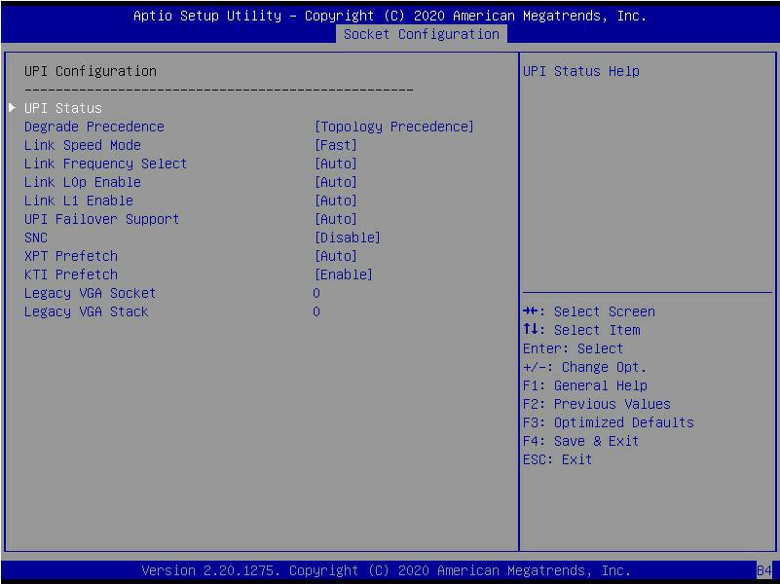
Figure 5- 26

- UPI Status: UPI link status submenu, which displays the current UPI link status
Degrade Precedence
When the system settings conflict, you can reduce the feature by setting Topology Precedence, or you can reduce the Topology by setting Feature Precedence, the menu options are:
- Topology Precedence: Topology first
- Feature Precedence: Feature priority
- default value: Topology Precedence

Link Speed Mode
Link speed mode setting, the menu options are:
- Slow: slow
- Fast: Fast default value: Fast

Link L0p Enable
Link L0p switch, the menu options are:
- Disable : shut down
- Enable : Open open
- Auto : Automatic
- default value: Auto

Link L1 Enable
Link L1 switch, the menu options are:
- Disable : shut down
- Enable : Open open
- Auto : Automatic
- default value: Auto

UPI Failover Support
UPI failover supports switch settings, the menu options are:
- Disable : shut down
- Enable : Open open
- Auto : Automatic
- default value: Auto

SNC
Sub NUMA cluster settings, the menu options are:
- Disable : shut down
- Enable : Open open
- Auto : Automatic
- Default value: Disable

XPT Prefectch
XPT prefetch settings, the menu options are:
- Disable : shut down
- Enable : Open open
- Auto : Automatic
- default value: Auto

KTI Prefectch
KTI prefetch settings, the menu options are:
- Disable : shut down
- Enable : Open open
- Auto : Automatic
- default value: Enable

- Legacy VGA Socket : Traditional VGA number setting, effective value range 0~1.
- Legacy VGA Stack : The number of traditional VGA stacks is set, and the effective value range is 0~6.

Memory Configuration

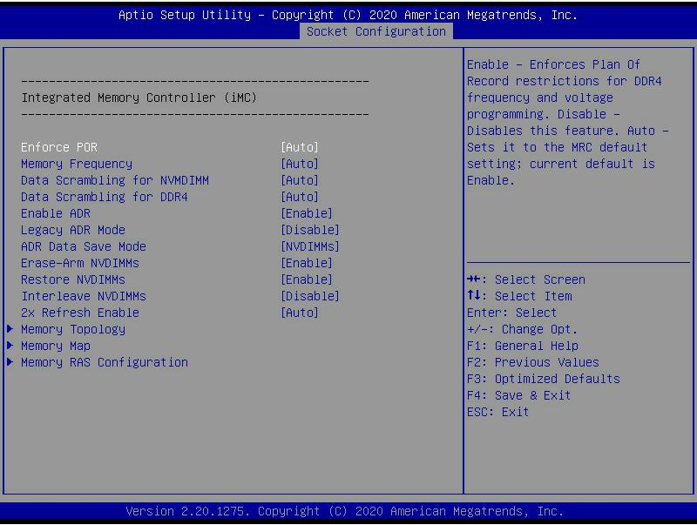
Figure 5- 27

To enforce POR settings, the menu options are:
- Auto : Automatic
- POR : Perform POR
- Disable : Off
- Default value: Auto

Memory Frequency
Memory frequency setting, the menu options are:
- Auto : Automatic
- 800
- 1000
- 1066
- 1200
- 1333
- 1400
- 1600
……
- Default value: Auto

Data Scrambling for NVDIMM
NVDIMM data scramble switch setting, the menu options are:
- Auto : Automatic
- Disable : shut down
- Enable : Open the
- default value: Auto

Data Scrambling for DDR4
DDR4 data scramble switch setting, the menu options are:
- Auto : Automatic
- Disable : shut down
- Enable : Open the
- default value: Auto

Enable ADR
ADR enable switch setting, the menu options are:
- Disable : shut down
- Enable : Open the
- default value: Enable

Legacy ADR Mode
Traditional ADR mode switch settings, the menu options are:
- Disable : shut down
- Enable : Open the
- default value: Enable

ADR Data Save Mode
ADR data saving mode setting, the menu options are:
- Disable : shut down
- Batterybacked DIMMs
- NVDIMMs
- Default value: NVDIMMs

Erase-ARM NVDIMMs
Erase-ARM NVDIMMs switch setting, the menu options are:
- Disable : shut down
- Enable : Open the
- default value: Enable

Restore NVDIMMs
Fix the switch settings of NVDIMMs, the menu options are:
- Disable : shut down
- Enable : turn on
- Auto : Automatic
- default value: Auto

Interleave NVDIMMs
Interleaved NVDIMMs switch settings, the menu options are:
- Disable : shut down
- Enable : Open the
- default value: Disable

2x Refresh Enable
2x refresh switch settings, the menu options are:
- Disable : shut down
- Enable : Open the
- default value: Disable

Memory Topology
Memory topology sub-menu, showing detailed information of the in-place memory;

Memory Map
Memory Map submenu;

Memory RAS Configuration
memory RAS configuration submenu;

Memory Topology

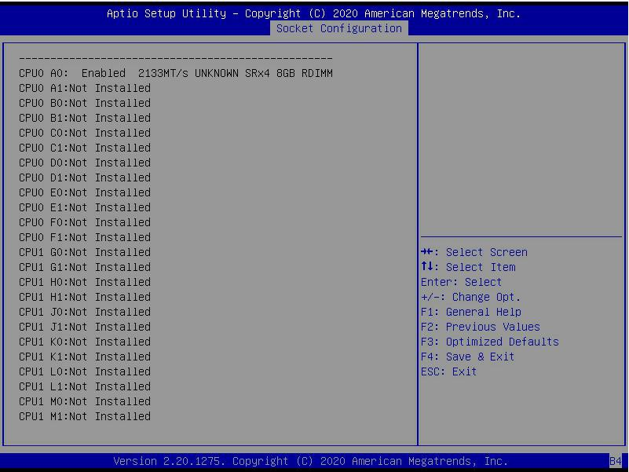
Figure 5- 28

Display the detailed information of the current memory

Memory Map

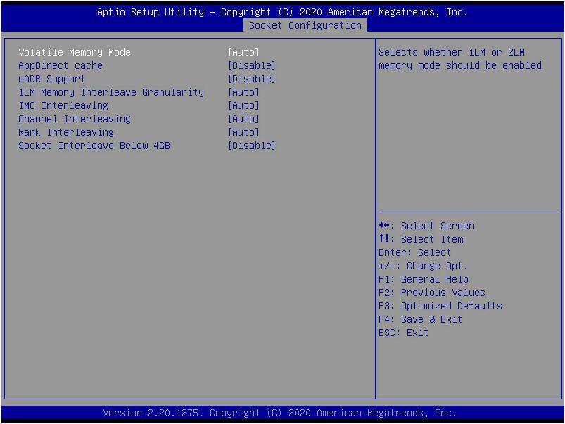
Figure 5- 29

Volatile Memory Mode
Volatile memory mode setting, the menu options are:
- 1LM
- 2LM
- Auto
- Default value: Auto

1LM Memory Interleave Granularity 1LM Memory Interleave Granularity setting, the menu options are:
- Auto
- 256B Target, 256B Channel
- 64B Target, 64B Channel
- Default Value: Auto

IMC Interleaving
IMC cross setting, the menu options are:
- Auto
- 1-way Interleavel
- 2-way Interleavel
- Default Value: Auto

Channel Interleaving
Channel cross setting, the menu options are:
- Auto
- 1-way Interleavel
- 2-way Interleavel
- 3-way Interleavel
- Default Value: Auto

Rank Interleaving
Rank cross setting, the menu options are:
- Auto
- 1-way Interleavel
- 2-way Interleavel
- 4-way Interleavel
- 8-way Interleavel
- Default Value: Auto

Socket Interleave Below 4GB
The processor interleave switch setting for the address space below 4GB, the menu options are:
- Enable : turn on
- Disable :
- Default value: Disable

Memory RAS Configuration

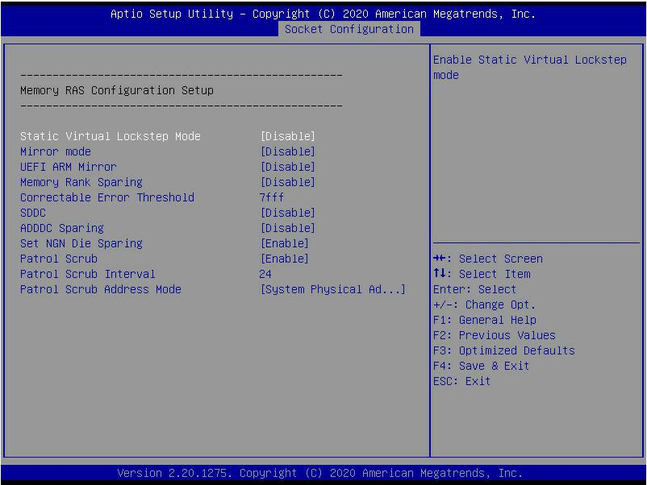
Figure 5- 30

Static Virtual Lockstep Mode
Static virtual Lockstep mode switch setting, the menu options are:
- Enable : turn on
- Disable :
- Default value: Disable

Mirror Mode
Mirror mode setting, the menu options are:
- Disable : shut down
- Enable Mirror Mode (1LM)
- Default value: Disable

UEFI ARM Mirror
UEFI ARM mirroring mode switch setting, the menu options are:
- Enable : turn on
- Disable : shut down
- Default value: Disable

Memory Rank Sparing
Memory Rank hot backup switch setting, the menu options are:
- Enable : turn on
- Disable :
- Default value: Disable

Correctable Error Threshold : The error threshold can be corrected, the effective value is 0x01-0x7fff, and the default value is 0x7fff.

SDDC
SDDC switch setting, note: AEP DIMM is not supported when it exists, the menu options are:
- Enable : turn on
- Disable :
- Default value: Disable

ADDDC Sparing
ADDDC hot standby switch setting, the menu options are:
- Enable : turn on
- Disable :
- Default value: Disable

Set NGN Die Sparing
Set NGN Die hot backup switch settings, the menu options are:
- Enable : turn on
- Disable : Off
- Default value: Enable

Patrol Scrub
Patrol Scrub switch settings, the menu options are:
- Enable : turn on
- Disable : Off
- Default value: Enable

Patrol Scrub Interval : Patrol Scrub interval time setting, the unit is hour, the range is 1-24, the default value is 24.

Patrol Scrub Address Mode
Patrol Scrub address mode setting, the menu options are:
- Reverse address
- System Physical Address
- Default value: System Physical Address

IIO Configuration

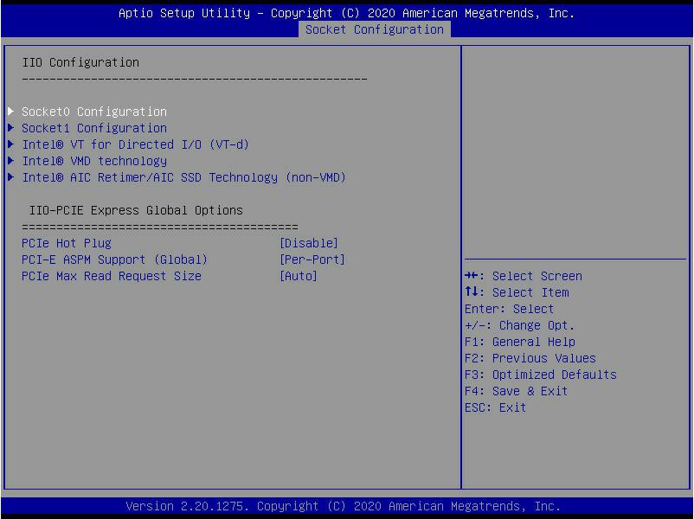
Figure 5- 31

SocketN Configuration
The SocketN configuration submenu is used to set the Link speed, Max Payload Size, ASPM and other settings of the device on the PCIE of CPU0, and display the link status of the current PCIE port.
Maximum link, current link rate, etc.;

Intel(R) VT for Directed I/O(VT-d)
Intel VT-d technology related settings sub-menu, Intel VT-d technology switch settings;

Intel(R) VMD Technology
Intel VMD technology related settings sub-menu, VMD switch settings on each PStack of each CPU;

Intel(R) AIC Retimer/AIC SSD Technology(non-VMD)
Intel AIC Retimer/AIC SSD technology related settings sub-menu, each CPU of each PStack on the AIC Retimer/AIC SSD technology switch settings.

PCIe Hot Plug
PCIe hot swap switch settings, the menu options are:
- Enable : turn on
- Disable : Default value: Disable

PCI-E ASPM Support(Global)
PCIE ASPM master switch setting, the menu options are:
- Disable : shut down
- Per-Port: each port
- L1 Only: L1 only Default value: Per-Port

PCI-E Max Read Request Size
PCIE maximum read request size setting, the menu options are:
- Auto
- 128B
- 256B
- 512B
- 1024B
- 2048B
- 4096B
Default value: Auto

Advanced Power Management Configuration

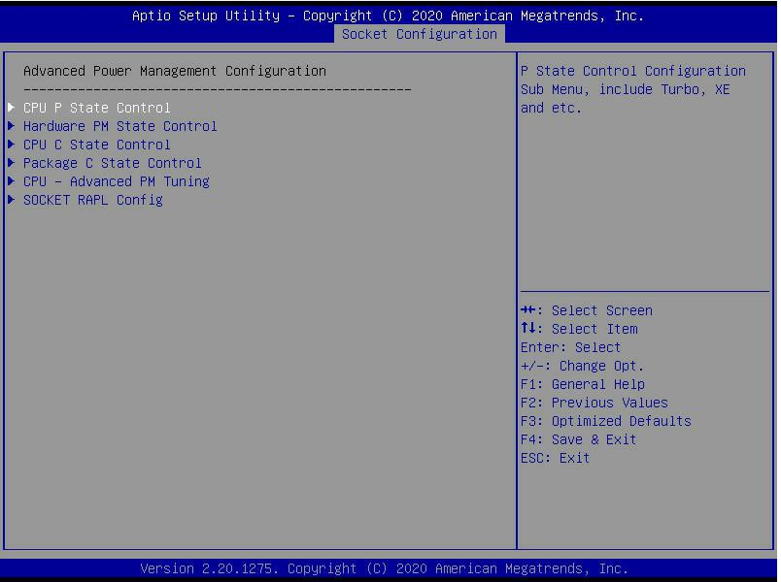
Figure 5- 32
CPU P State Control
CPU P status control setting submenu;

Hardware PM State Control
hardware power management state control submenu;

CPU C State Control
CPU C status control setting submenu;

Package C State Control
Package C state control submenu;

CPU-Advanced PM Tuning CPU
performance and energy saving adjustment sub-menu;

Socket RAPL Configuration
Socket RAPL configuration submenu;

CPU P State Control

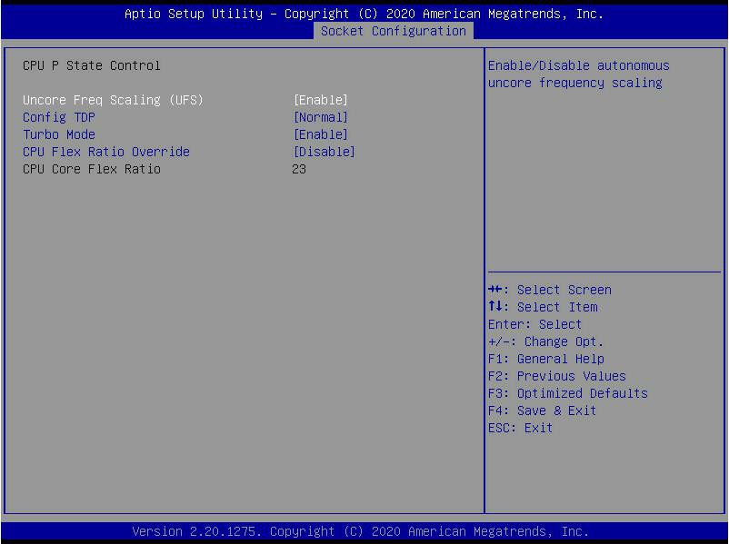
Figure 5- 33

Uncore frequency extension setting, the menu options are:
- Enable : turn on
- Disable : Off
- Default value: Enable
Config TDP
TDP level setting, the menu options are:
- Normal : Normal
- Level 1 : Level 1
- Level 2 : Level 2
- Default value: Normal
Turbo Mode
Dynamic acceleration switch settings, the menu options are:
- Enable : turn on
- Disable : Off
- Default value: Enable

Hardware PM State Control

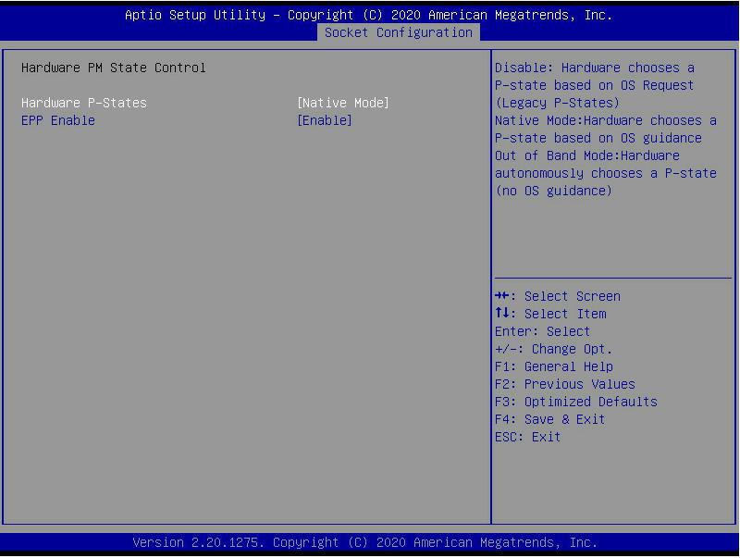
Figure 5- 34

Hardware P-State
The hardware chooses whether the P-State state is actively set by the OS, and the default value is determined according to the actual test.
The options are:
- Disable : Hardware selection P-States based on traditional OS request
- Native Mode: Hardware selection P-State is based on traditional OS boot
- Out of Band Mode: Automatic hardware selection, no OS boot required
- Native Mode with No Legacy Support Default Value: Native Mode

EPP Enable
EPP enable setting, the menu options are:
- Enable : turn on
- Disable : Off
- Default value: Enable

CPU C State Control

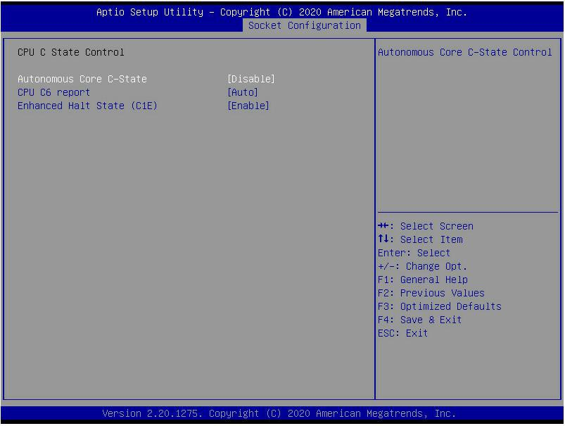

Autonomous Core C-State
Autonomous core C state switch settings, the menu options are:
- Enable : turn on
- Disable :
- Default value: Disable

CPU C6 report
Report the C6 status switch settings to the OS, the menu options are:
- Disable : shut down
- Enable : turn on
- Auto: Automatic
- default value: Auto

Enhanced Halt State(C1E) C1E switch setting, the menu options are:
- Disable : shut down
- Enable : Open
- the default value: Enable

Package C State Control

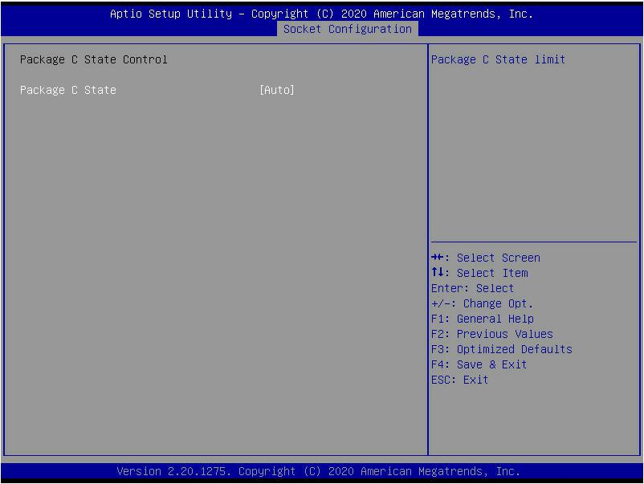

Package C State
Package C status setting, the menu options are:
- C0/C1 state
- C2 state
- C6(non Retention) state
- C6(Retention) state
- No Limit
Default value: Auto

CPU-Advanced PM Tuning

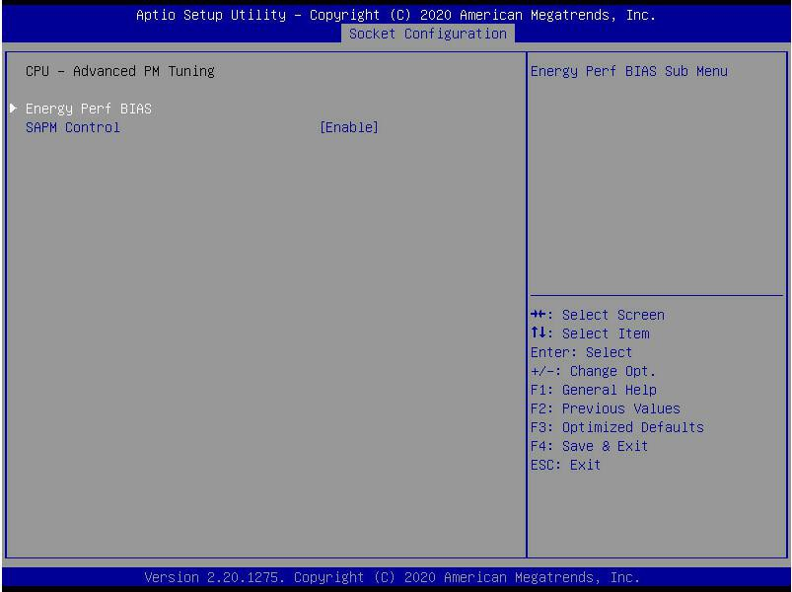
Figure 5- 37

Energy Perf BIAS
CPU power saving performance related option settings

Energy Perf BIAS

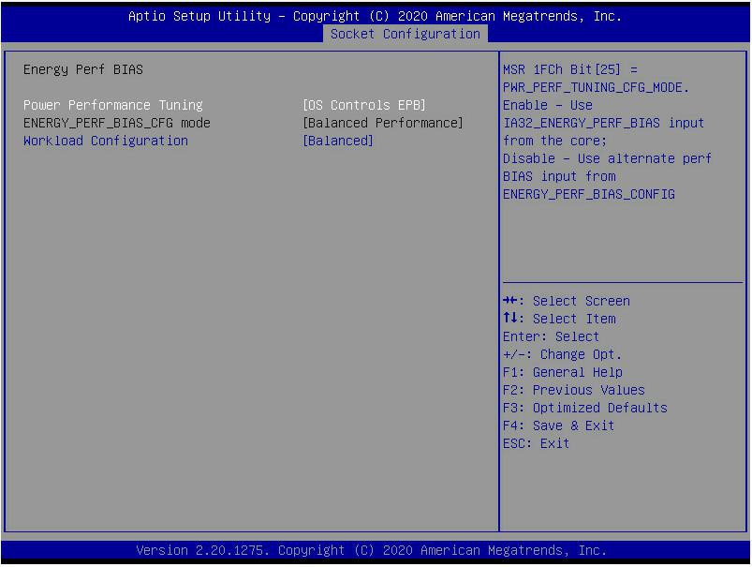
Figure 5- 38

Power Performance Tuning
Energy-saving performance adjustment settings, the menu options are:
- OS Controls EPB: OS control energy saving performance adjustment
- BIOS Controls EPB: BIOS control energy
saving performance adjustment
default value: OS Controls EPB

ENERGY_PERF_BIAS_CFG Mode
Energy-saving performance management settings. This item can be set when Power Performance Tuning is set to BIOS Control EPB. The menu options are:
- Performance: Performance
- Balanced Performance: Balance performance
- Balanced Power: Balance energy saving
- Power: Energy saving
Default value: Balanced Performance
Workload Configuration
Optimize settings for workload characteristics, the menu options are:
- Balanced
- I/O Sensitive
Default value: Balanced

Server Mgmt menu

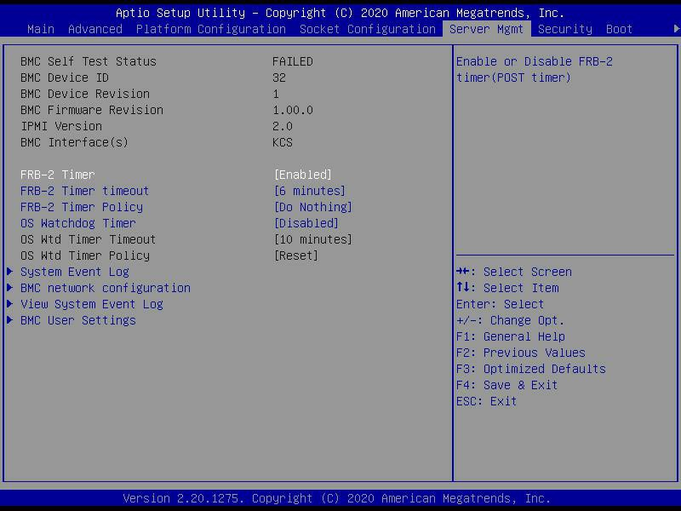
Figure 5-39

Display BMC self-check status, device ID, device version, BMC software version, and support IPMI specification version.

FRB-2 Timer
FRB-2 clock switch settings, the menu options are:
- Enabled : turn on
- Disabled : Off
Default value: Enabled

FRB-2 Timer timeout
FRB-2 clock timeout setting, the menu options are:
- 3 minutes
- 4 minutes
- 5 minutes
- 6 minutes
Default value: 6 minutes

FRB-2 Timer Policy
The policy setting after FRB-2 clock timeout, the menu options are:
- Do Nothing
- Reset
- Power Down
- Power Cycle
Default value: Do Nothing

OS Watchdog Timer
OS watchdog clock switch settings, the menu options are:
- Enabled : turn on
- Disabled :
Default value: Disabled

OS Wtd Timer timeout
OS watchdog clock timeout setting, the menu options are:
- 5 minutes
- 10 minutes
- 15 minutes
- 20 minutes
Default value: 10 minutes

OS Wtd Timer Policy
The policy setting after the OS watchdog clock timeout, the menu options are:
- Do Nothing
- Reset
- Power Down
- Power Cycle
Default Value: Reset

- System Event Log
Menu System Event Log Control Menu
- BMC network configuration menu
BMC network configuration menu
- View System Event Log menu
View system event log control menu
- BMC User Settings menu
BMC User Settings menu

System Event Log menu

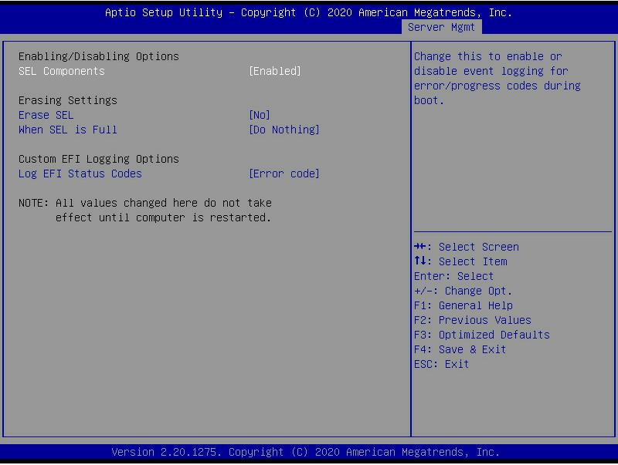
Figure 5- 40

SEL Components
System event recording function control switch during startup, menu options:
- Enabled: open
- Disabled: Closed
Default value: Enabled

Erase SEL
Clear system event record control switch, menu options:
- No: do not clear
- Yes, On next reset: reset next time
- Yes, On every reset: Clear every restart
Default value: No

When SEL is Full
When the system event record storage space is full, operate the control switch and menu options:
- Do Nothing: do not operate
- Erase Immediately: Erase Immediately
Default value: Do Nothing

Log EFI Status Codes
Configuration record EFI Status Codes, menu options:
- Disabled: do not record
- Both: Record Error code & Progress code
- Error code: Only record Error code
- Progress code: Only record Progress code
Default value: Error code

BMC network configuration menu

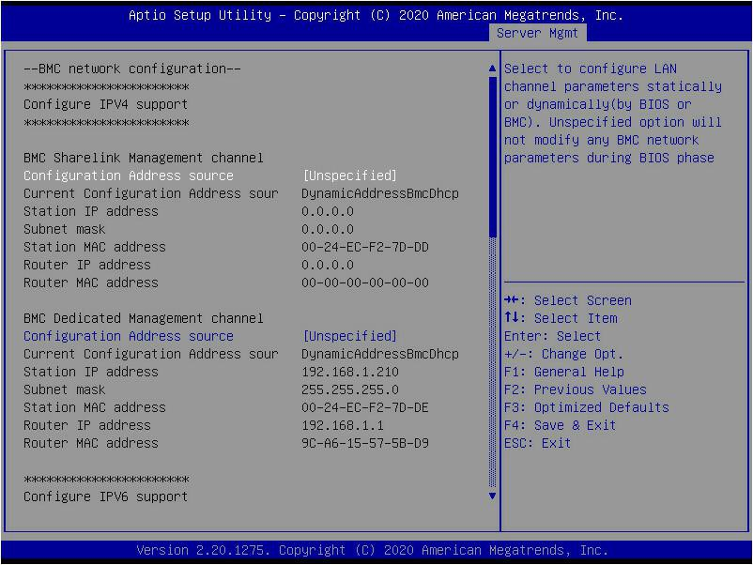
Figure 5- 41

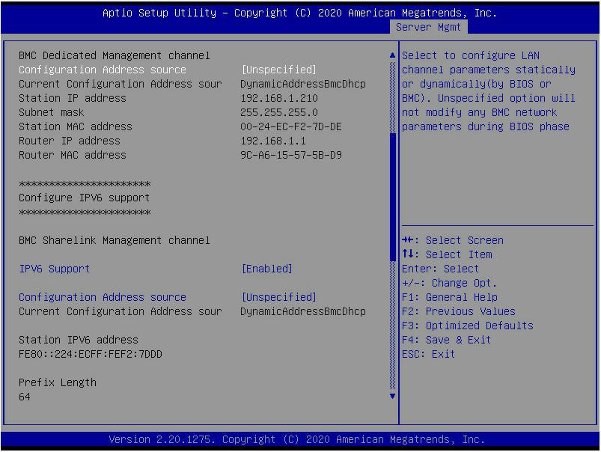
Figure 5- 42
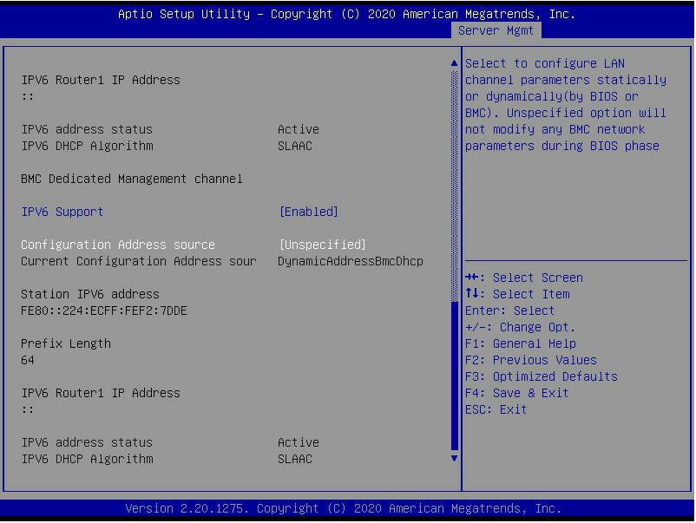
Figure 5- 43

Configure IPV4 support
BMC sharelink Management Channel Configuration Address source
Configure the BMC IP address allocation mode, the menu options are:
- Unspecified: Do not change BMC parameters
- Static: BIOS static IP setting
- DynamicBmcDhcp: BMC runs DHCP to dynamically allocate IP
- DynamicBmcNonDhcp: BMC runs Non-DHCP protocol to dynamically allocate IP
Default value: Unspecified
Modify from Unspecified to other parameters, save and restart after execution, the option will restore the Unspecified value,
There is no need to configure the BMC IP every time you start the process.

When the Configuration Address source option is Unspecified, the network parameter information (IPV4) of the system's shared network port will be displayed, the current IP configuration method, BMC IP, subnet mask, MAC address, routing IP, routing MAC;

BMC Dedicated Management Channel
Configuration Address source
Configure the BMC IP address allocation mode, the menu options are:
- Unspecified: Do not change BMC parameters
- Static: BIOS static IP setting
- DynamicBmcDhcp: BMC runs DHCP to dynamically allocate IP
- DynamicBmcNonDhcp: BMC runs Non-DHCP protocol to dynamically allocate IP
Default value: Unspecified
Modify from Unspecified to other parameters, save and restart after execution, the option will restore the Unspecified value,
There is no need to configure the BMC IP every time you start the process.

When the Configuration Address source option is Unspecified, the network parameter information (IPV4) of the system's dedicated network port will be displayed, the current IP configuration method, BMC IP, subnet mask, MAC address, routing IP, routing MAC;

Configure IPV6 support
BMC Sharelink Management Channel IPV6 Support
Choose whether to support IPV6, the menu options are:
- Enabeld: Support IPV6
- Disabled: IPV6 is not supported
Default value: Enabeld
Modify from Unspecified to other parameters, save and restart after execution, the option will restore the Unspecified value,
There is no need to configure the BMC IP every time you start the process.

When the Configuration Address source option is Unspecified, the network parameter information (IPV6) of the system shared network port will be displayed;

BMC Dedicated Management Channel IPV6 Support
Choose whether to support IPV6, the menu options are:
- Enabeld: Support IPV6
- Disabled: IPV6 is not supported
Default value: Enabeld
Modify from Unspecified to other parameters, save and restart after execution, the option will restore the Unspecified value,
There is no need to configure the BMC IP every time you start the process.

When the Configuration Address source option is Unspecified, the network parameter information (IPV6) of the system dedicated network port will be displayed;

View System Event Log menu

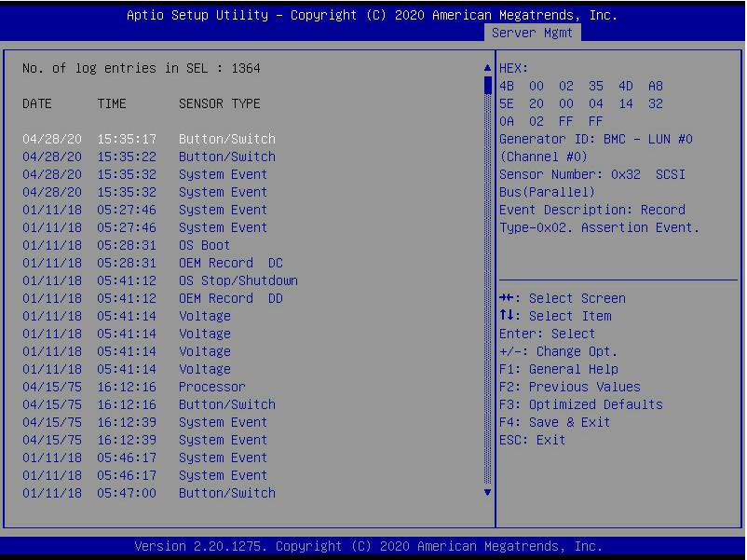
Figure 5- 44

View system event log information.
Note that when entering this menu, BIOS needs to read the SEL data, and it takes a while.

BMC User Setting

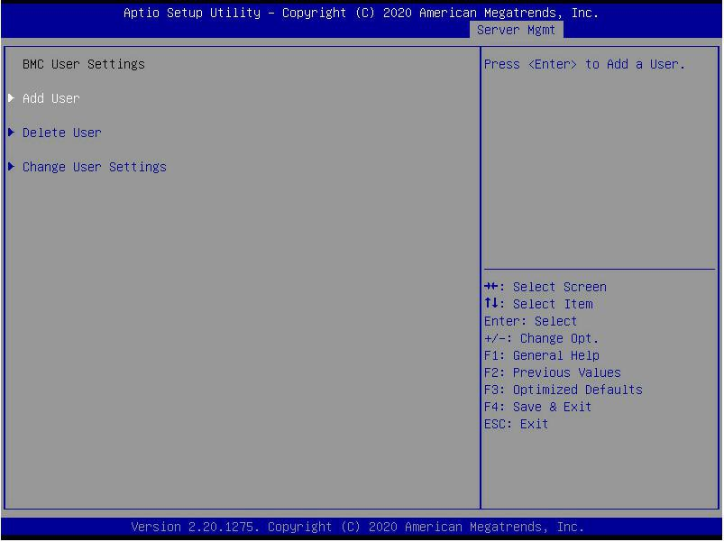
Figure 5- 45

- Add User
Add user submenu
- Delete User delete user submenu
- Change User Setting submenu

Add User

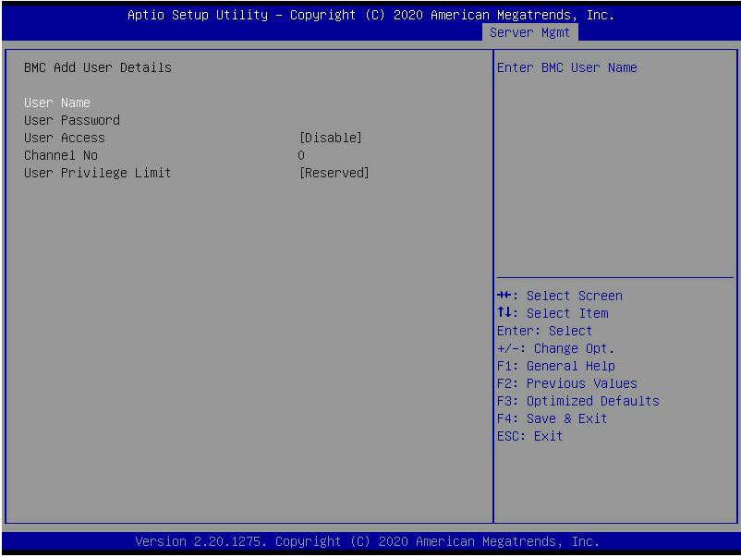
Figure 5- 46

User Name : User name setting, maximum support 16 characters.

User Password : User password setting, password characters must include uppercase and lowercase letters, special characters and numbers, with a minimum of 8 characters and a maximum of 20 characters.
Channal No : BMC channel setting, enter 1 or 8 User Privilege Limit
User permission settings, the menu options are:
- Reserved
- Callback
- User
- Operator
- Administrator
After the setting is successful, it will prompt "Set User Acess Command Passed", and BMC User will take effect immediately.

Delete User

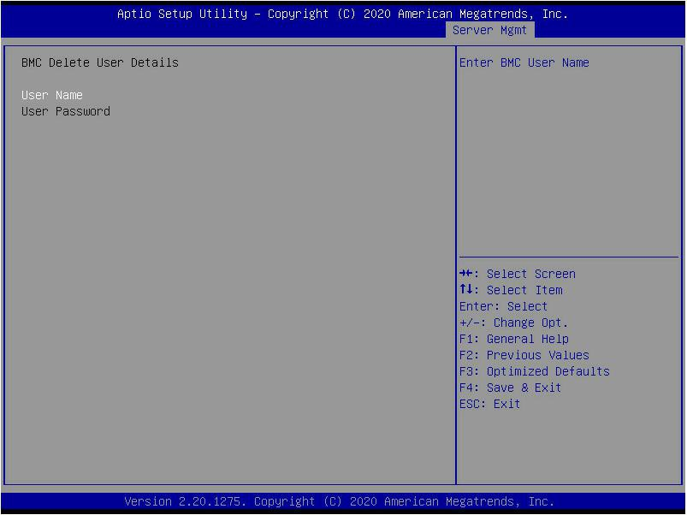
Figure 5- 47

User Name : Enter the name of the user to be deleted.

User Password : Enter the password of the user to be deleted. After entering the correct password, a prompt "User Delete!!!" will pop up. The successfully deleted user will immediately take effect in the BMC, and the user will not be able to log in to the BMC Web interface.

Change User Setting

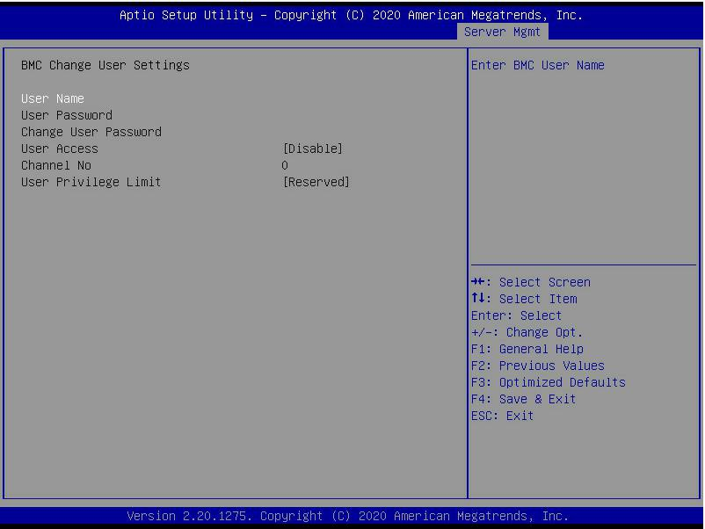
Figure 5- 48

User Name : Enter the user name to be modified.

User Password : Enter the user password to be modified. Only the name and password are entered correctly, the following options can be modified.

User
User permission switch settings, the menu options are:
- Enabled : turn on
- Disabled :
Default value: Disabled

Change User Password : To modify the user password, the input password characters must include uppercase and lowercase letters, special characters and numbers, at least 8 characters, and maximum 20 characters.

Channel NO : BMC channel setting, input 1 or 8.
User Privilege Limit
Modify user permission settings, the menu options are:
- Reserved
- Callback
- User
- Operator
- Administrator

Security menu

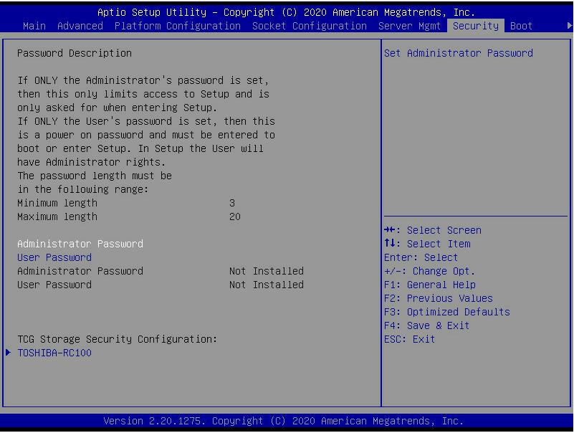
Figure 5-49

Select this option to set the administrator password;

User Password
Select this option to set user password;

Administrator Password
Display the status of the administrator password, the system has an administrator password, displays Installed, there is no administrator
Password, display Not Installed;

User Password
Display the user password status, the system has a user password, and it displays Installed. If there is no user password, it displays Not Installed;

HDD Security Configuration
The hard disk list is displayed dynamically. The hard disks connected to the SATA and sSATA controllers will be displayed here. Enter the hard disk interface to set the hard disk password, and it will not display if there is no hard disk connected.

Boot menu

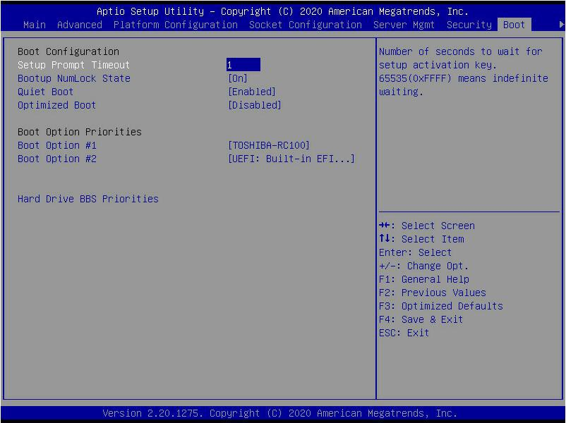
Figure 5- 50

Setup Prompt Timeout : Setup prompts timeout setting, set the time to wait for Setup to activate the key, the maximum value is 65535 seconds, and the default value is 1.

Bootup Numlock State
The keyboard Numlock indicator status switch setting during the startup process, the menu options are
- On : turn on
- OFF : Off
Default value: On

Quiet Boot
Turn on and off the Quiet Boot function, the menu options are:
- Disabled:Turn off Quiet Boot, the POST message will be displayed at this time
- Enabled:Turn on Quiet Boot, and the OEM Logo will be displayed.
Default value: Enabled

Optimized Boot
Turn on and off the Optimized Boot function, the menu options are:
- Disabled:Turn off Quiet Boot
- Enabled:Turn on Quiet Boot, and then disable Csm support and connect to network devices to reduce startup time
Default value: Disabled

Boot Option Priorities
Startup option list. This list is displayed dynamically and is determined by the number of startup options in the system. When there is no startup item, it is not displayed.

XXXX Driver BBS Priorities
XXXX device BBS priority setting

Save & Exit menu

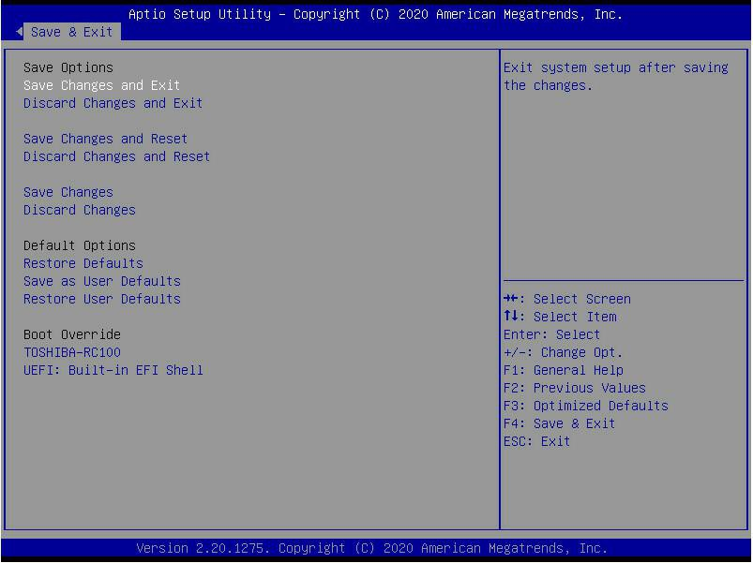
Figure 5-51

Save Changes and Exit
Save the settings and exit the BIOS setup menu;

Discard Changes and Exit
Give up saving the settings and exit the BIOS setup menu;

Save Changes and Reset
save the settings and restart the system;

Discard Changes and Reset
give up saving the settings and restart the system;

Save Changes to save the settings;

Discard Changes
Give up saving settings;

Restore Defaults
Load BIOS factory settings;

Save as user Defaults
save as user default settings;

Restore user Defaults
reload user default configuration;

Boot Override
Startup options list, you can select startup options here.

User operation reminder
- With the option of, you need to understand the operating specifications in detail when you need to operate.
- When operating options, please understand the meaning of the options in conjunction with the operating manual and the BIOS Setup interface option description.

RAID Setting Instructions

PCH group RAID

Configure RAID in UEFI boot mode
- Operation before group raid
- During the server startup, press Delete/Esc as prompted to enter the BIOS Setup interface.
- Move to the PlatForm page -->PCH Configuration-->PCH Sata Configuration-->Configure SATA as. Configure SATA to RAID mode, as shown in Figure 6-1.
Figure 6-1 Configure SATA to RAID mode:
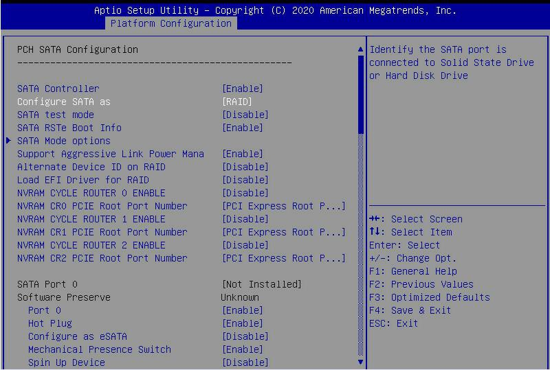
Figure 6-1
- Ensure that Storage and video in CSM Configuration are in UEFI mode, as shown in Figure 6-2
Figure 6-2 Set Storage and Video to UEFI mode
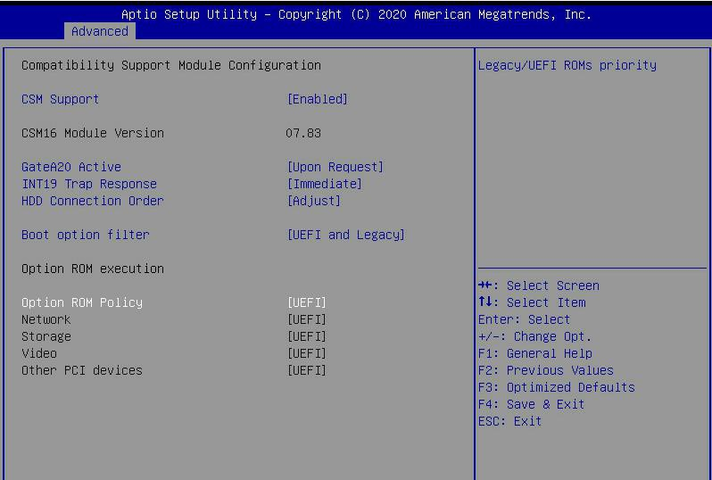
Figure 6-2
- Restart the server and enter the BIOS Setup interface, move to the Advanced page, you will see the intel(R) RSTe SATA Controller, press enter to enter the configuration RAID, as shown in Figure 6-3
Figure 6-3 Intel RSTe SATA Controller
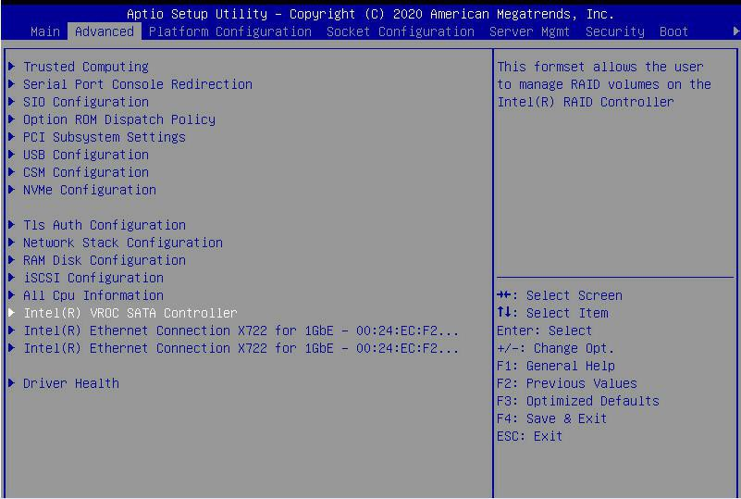
Figure 6-3

- Create RAID
- Select Create RAID Volume and press enter. Figure 6-4
Figure 6-4 Create RAID
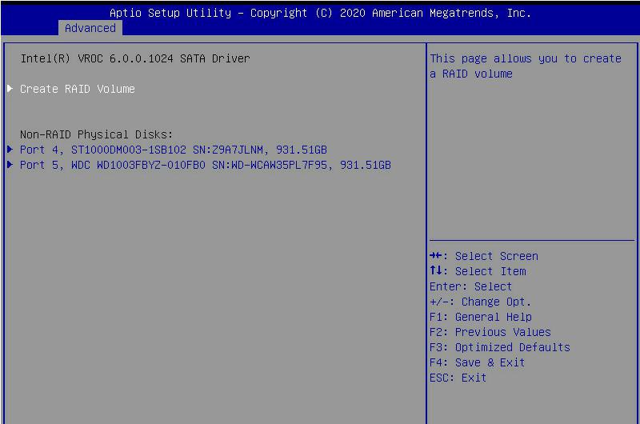
Figure 6-4
- Change the name of the created raid, and note that it cannot contain special characters. Figure 6-5
Figure 6-5 Create RAID name
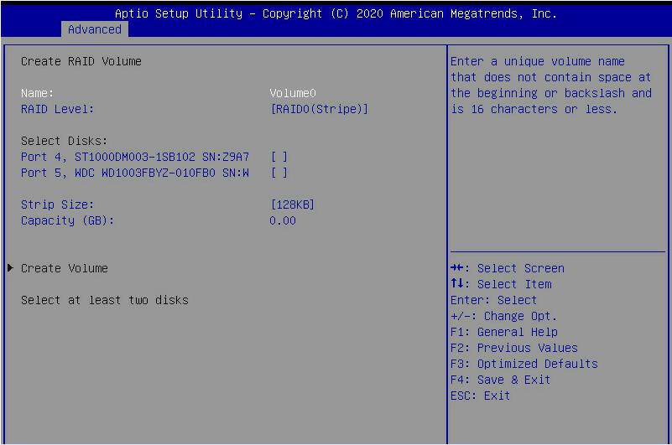
Figure 6-5
- RAID Level:You can select the level of group raid, as shown in Figure 6-6
Figure 6-6 Select the level of group RAID
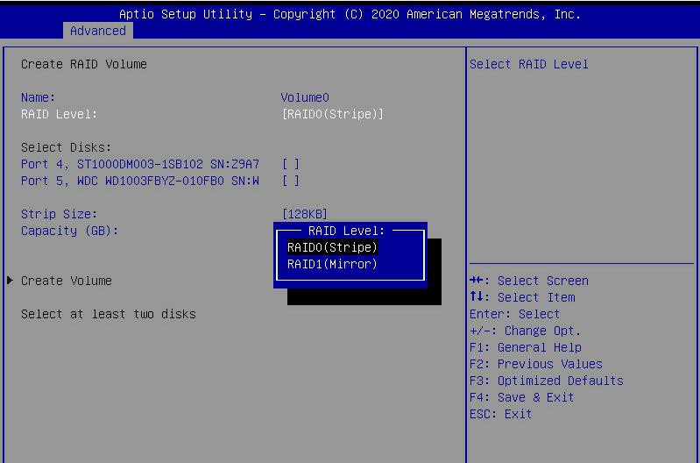
Figure 6-6
- Select Disks:Press the space bar to select the disks that need to participate in the RAID group. Figure 6-7
Figure 6-7 Selecting the disks of group RAID
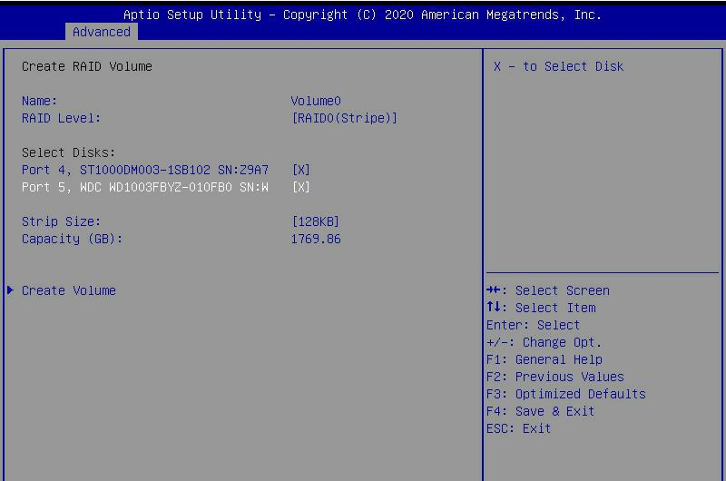
Figure 6-7
- Select Create Volume and press Enter to group the raid.
Related parameters are described in Table 1-28:
parameter | Description
Name | The name of the RAID.
RAID Level | RAID level, which determines the performance, fault tolerance and capacity of the logical disk.
Select  Disks | Select the member disks that make up the RAID. Available disks are displayed under the Select Disks column, press Enter  Select the disk, [X] means that the disk has been selected.
Strip Size | Stripe size, the size of striped data blocks written on each disk.
Capacity | The capacity of the logical disk.
Table 1- 23

After the RAID is created, it will be displayed under the RAID Volumes directory. Select a RAID and press Enter to view the detailed information of the RAID (including RAID name, level, and disk information, etc.).
- Configure hot spare disk
- As shown in Figure 6-8, select the disk to be configured as a hot spare disk and press Enter.
Figure 6-8 Select the disk to be configured as a hot spare disk
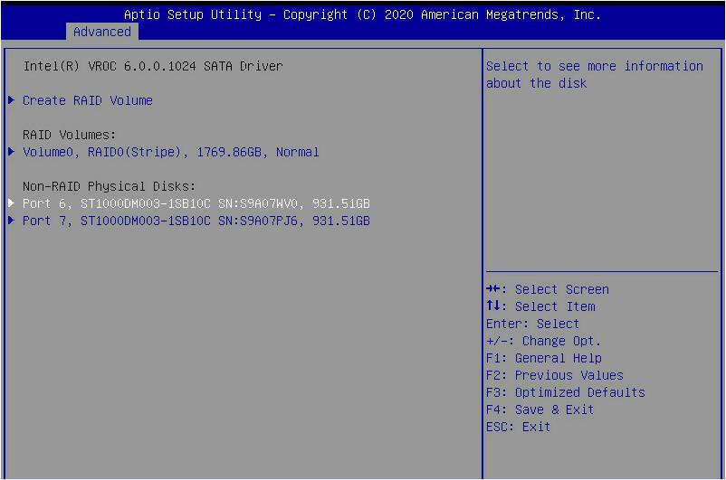
Figure 6-8
- Enter the interface shown in Figure 6-9, select "Mark as Spare", and press Enter.
Figure 6-9 Hot spare disk configuration interface
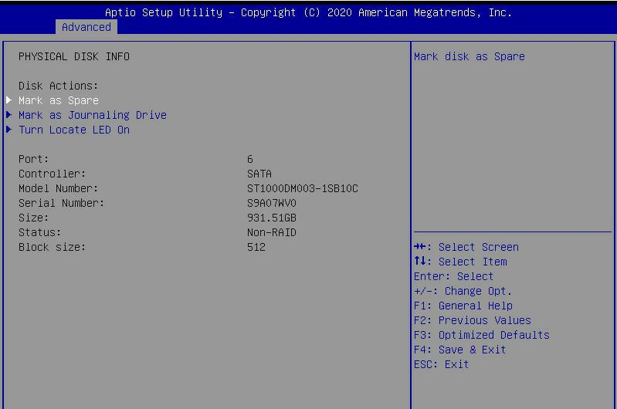
Figure 6-9
- Enter the interface shown in Figure 6-10, select "Yes", and press Enter to complete the hot spare disk configuration.
Figure 6-10 Confirm hot spare disk configuration
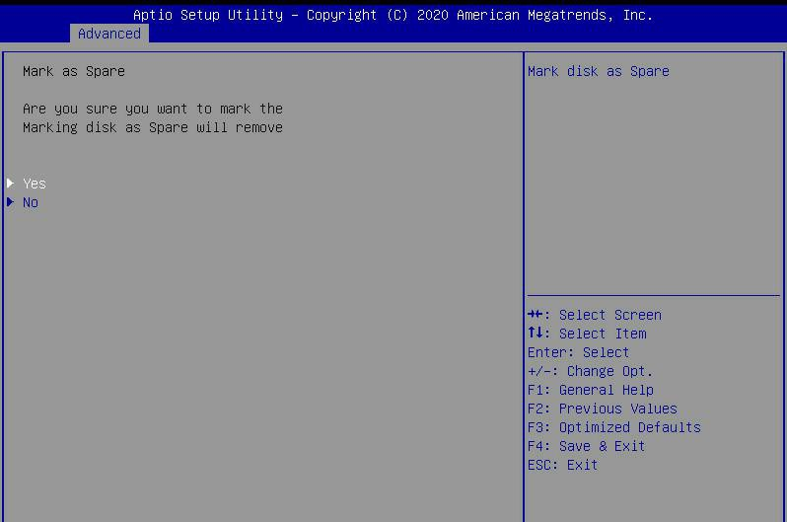
Figure 6-10
- Delete RAID
- Enter the RSTe configuration interface.
- As shown in Figure 6-11, select the RAID to be deleted in the RAID Volumes directory and press Enter.
Figure 6-11 Select the RAID to be deleted
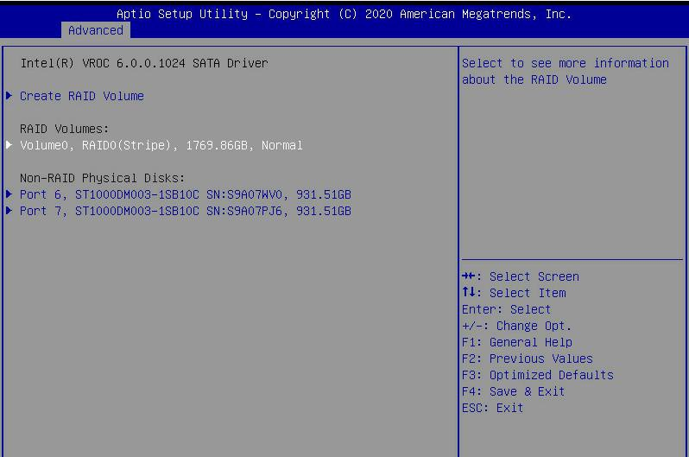
Figure 6-11

- Enter the RAID information interface shown in Figure 6-12, select Delete, and press Enter to delete the RAID.
Figure 6-12 RAID Information Interface
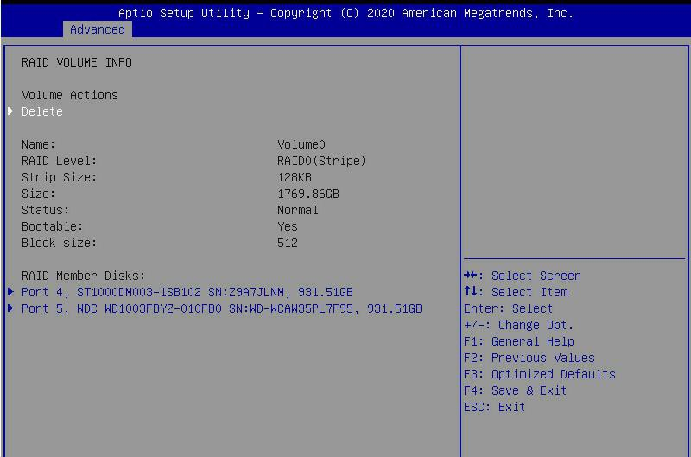
Figure 6-12

Configure RAID in Legacy Boot Mode
- Set RSTe working mode
- Enter the BIOS Setup interface.
- Move to PlatForm page-->PCH Configuration-->PCH Sata Configuration
Figure 6-13 PCH SATA Configuration interface
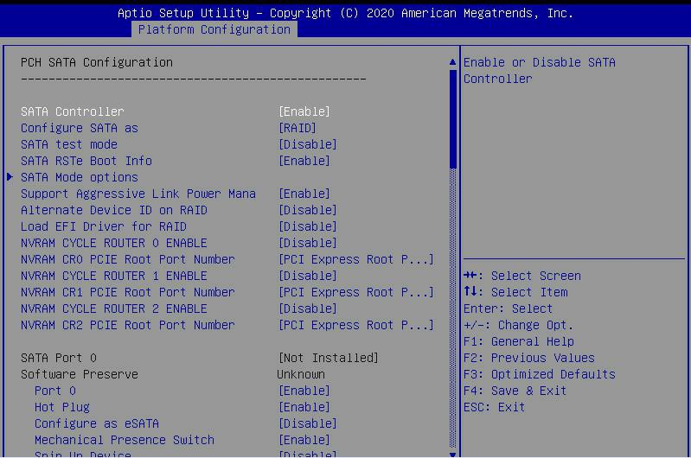
Figure 6-13
RSTe onboard software RAID has two controllers, SATA and sSATA, which manage the disks connected to the two interfaces of the RAID card. The SATA controller supports up to 8 disks, and the sSATA controller supports up to 6 disks.
- Enter the interface shown in Figure 6-14, select Configure SATA As, and press Enter to select the operating mode of RSTe onboard software RAID.
Figure 6-14 Modify the working mode of the RAID card
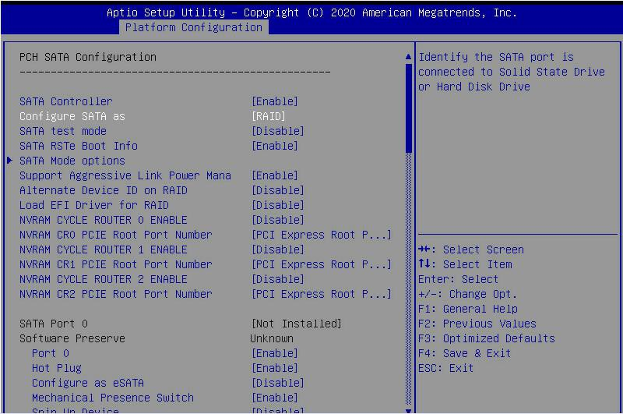
Figure 6-14
- Enter RSTe configuration interface
- Power on or restart the server. After the interface shown in Figure 6-15 appears during BIOS startup, press Ctrl+I.
Figure 6-15 BIOS startup interface
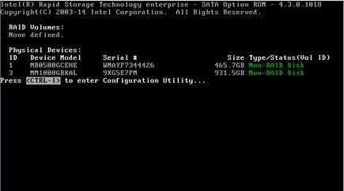
Figure 6-15

If the working mode of both sSATA and SATA controllers is set to RAID, the prompt "Press <CTRL-I> to enter Configuration Utility" will appear twice during the BIOS startup process, corresponding to sSATA and SATA controllers in turn. Please configure RAID according to the configuration. Select the controller for the desired disk.
- Enter the RSTe configuration interface shown in Figure 6-16 (see Table 1-29 for interface description). Please refer to the key operation prompts on the lower border of the interface to navigate and modify settings in the interface.
Figure 6-16 RSTe configuration interface
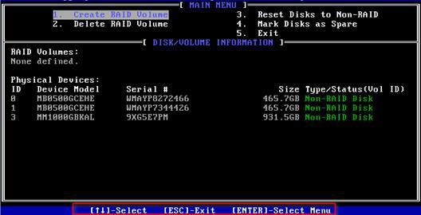
Figure 6-16
Table 1-29 RSTe configuration interface description
Options | Description
Located on the upper side of the interface, you can perform the following operation tasks:
MAIN MENU
(main menu)

DISK/VOLUME INFORMATION  (Disk and volume information) | 1.Create RAID Volume: Configure RAID volume.  2.Delete RAID Volume: Delete RAID volume.  3. Reset Disks to Non-RAID: Clear the RAID configuration information of the disk.  4. Mark Disks as Spare: Configure hot spare disks.  5.Exit: Exit.
Located at the bottom of the configuration interface, you can view the summary information of the created RAID and physical disks.
Table 1- 24

- Common tasks to configure RAID:
- Enter the RSTe configuration interface.
- As shown in Figure 6-17, select Create RAID Volume on the RSTe configuration interface and press Enter.
Figure 6-17 RSTe configuration interface
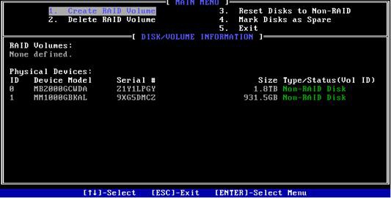
Figure 6-17
- Enter the interface shown in Figure 6-18, and make the corresponding settings in the Name, RAID Level, Disks, Strip Size and Capacity columns (for parameter descriptions, see Table 1-30), then select Create Volume and press Enter.
Figure 6-18 Create RAID Volume interface
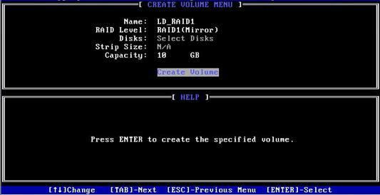
Figure 6-18

Table 1-30
parameter | Description
Name | The name of the RAID.
RAID  Level | RAID level. The RAID level determines the performance, fault tolerance, and capacity of the logical disk.
Disks | Select the member disks that make up the RAID. Select the Disks column and press Enter, and press SPACE to select the disk.
Strip Size | Stripe size, the size of striped data blocks written on each disk.
Capacity | The capacity of the logical disk.
Table 1- 25

- Enter the interface shown in Figure 6-19, you can view the detailed information of the RAID (including RAID name, level, and disk information, etc.).
Figure 6-19 RAID information interface
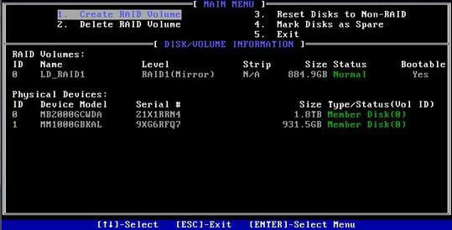
Figure 6-19
Configure hot spare disk:
- Enter the RSTe configuration interface.
- As shown in Figure 6-20, select Mark Disks as Spare on the RSTe configuration interface, and press Enter.
Figure 6-20 RSTe configuration interface
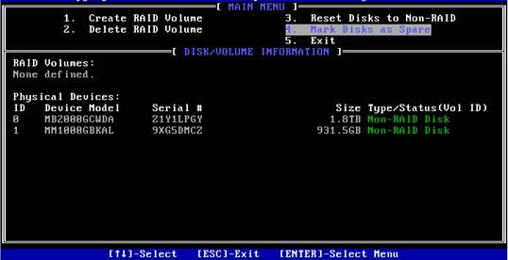
Figure 6-20
- Enter the interface shown in Figure 6-21, select the disk to be configured as a hot spare disk and press SPACE to select it, then press Enter, in the prompt bar that appears, enter y and press Enter to complete the hot spare disk configuration.
Figure 6-21 Select Disk
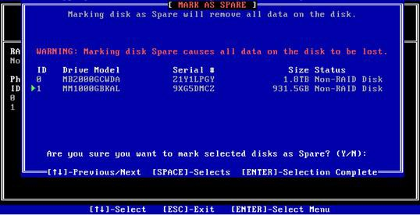
Figure 6-21
- In the RSTe configuration interface, you can see the hot spare disk information, as shown in Figure 6-22.
Figure 6-22 View hot spare disk information on the RSTe configuration interface
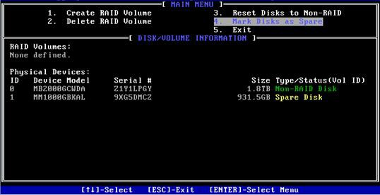
Figure 6-22

Delete RAID:
- Enter the RSTe configuration interface.
- As shown in Figure 6-23, select Delete RAID Volume on the RSTe configuration interface and press Enter.
Figure 6-23 RSTe configuration interface
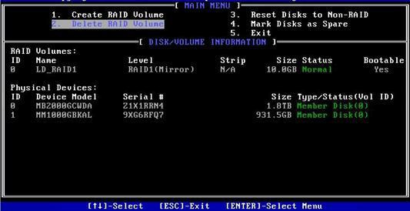
Figure 6-23
- Enter the interface shown in Figure 6-24, select the RAID to be deleted, and press Delete to complete the deletion.
Figure 6-24 Select the RAID to be deleted
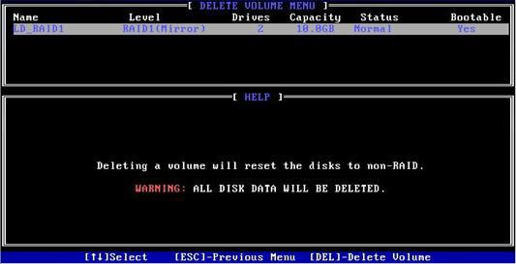
Figure 6- 24

LSI 9361-8i group RAID

Configure RAID in UEFI boot mode
- Enter the RAID card configuration interface
- During the server startup, press Delete/Esc as prompted to enter the BIOS Setup interface.
- Select Advanced>AVAGO MegaRAID<AVAGO MegaRAID SAS 91311-8i>Configuration Utility, and press Enter.
- Enter the interface shown in Figure 6-25, and five types of configuration tasks are displayed on the interface (refer to Table 1-31 for related instructions).
Figure 6-25 RAID card configuration interface, as shown in Figure 6-25
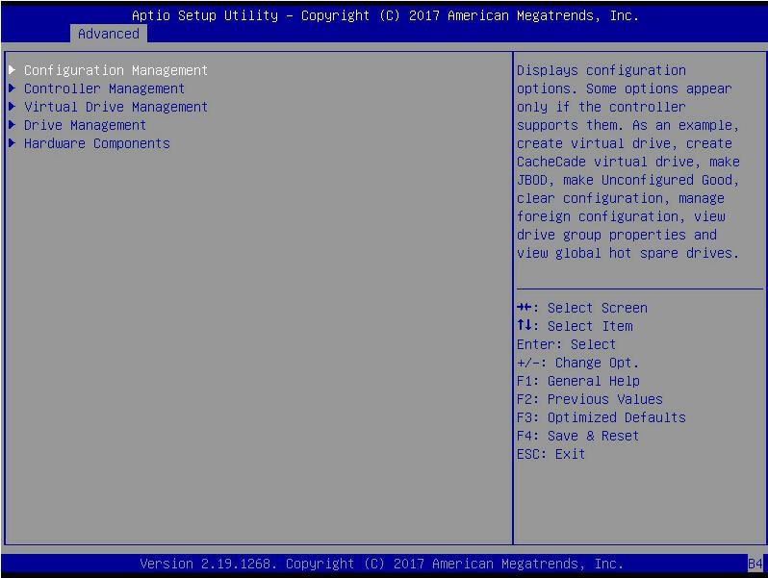
Figure 6-25
Table 1-31 Parameter description

Options | Summary description
Configuration  Management | Select configuration management to perform tasks, such as creating logical disks, viewing disk group properties, and viewing  Hot backup information and clear configuration.
Controller  Management | Select Controller Management to view and manage controller properties and perform tasks, such as clearing the controller  Event, dispatch and run controller events, and run patrol reading.
Virtual Drive  Management | Select logical disk management to perform tasks, such as viewing logical disk attributes, locating logical disks,  And run a consistency check.
Drive Management | Select Disk Management to view physical disk properties and perform tasks, such as locating disks, initializing  Disk and rebuild after disk failure.
Hardware  Components | Select hardware components to view super capacitor properties, manage super capacitors and manage peripheral components.
Table 1- 26
- Common task switching disk mode:
The RAID card supports switching between the following three disk modes.
- Unconfigured Good: indicates that the physical disk is normal and can be used to configure RAID or hot spare disks.
- Unconfigured Bad: It means that there is residual RAID information on the physical disk, which needs to be cleared manually.
- JBOD: Just a Bunch Of Disks, only connect the disks in series to expand the capacity, but does not have the RAID function.
Here is an example of switching from Unconfigured Good mode to Unconfigured Bad mode.
- As shown in Figure 6-26, select Drive Management on the RAID card configuration interface and press Enter.
Figure 6-26 RAID card configuration interface
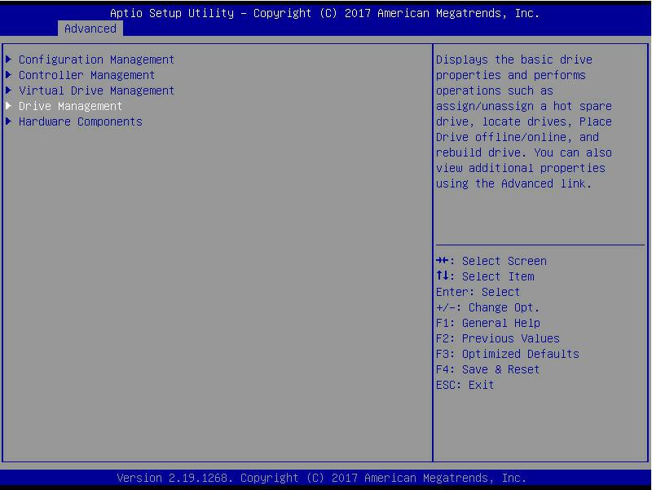
Figure 6-26
- Enter the interface shown in Figure 6-27, select the disk to be configured, and press Enter.
Figure 6-27 Drive Management management interface

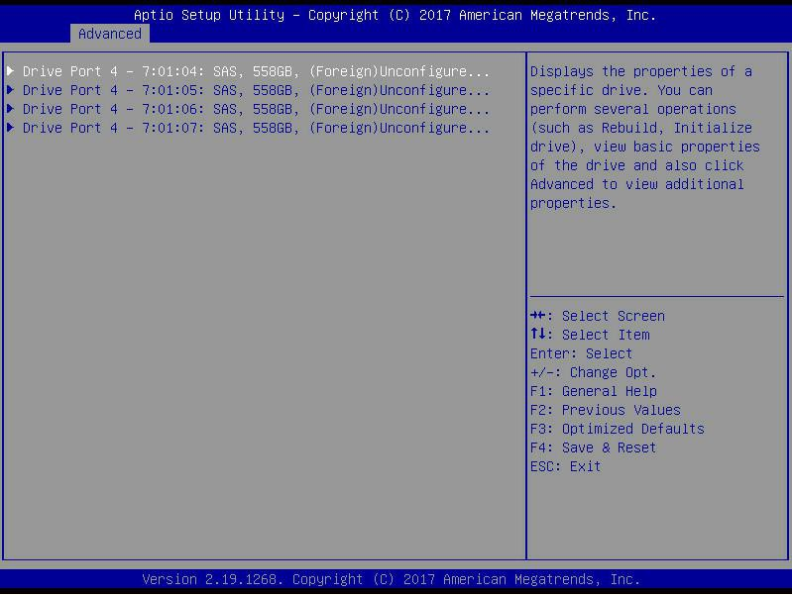
Figure 6-27
- Enter the interface shown in Figure 6-28, select Operation, press Enter, and then select Make Unconfigured Bad in the pop-up dialog box, and press Enter.
Figure 6-28 Operation interface
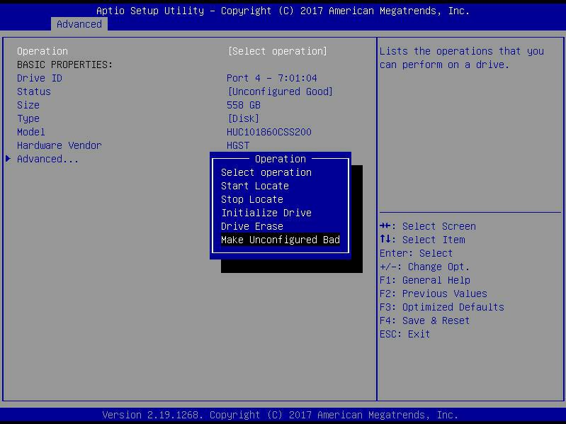
Figure 6-28
- Enter the interface shown in Figure 6-29, select Go, and press Enter.
As shown in Figure 6-29, select Go
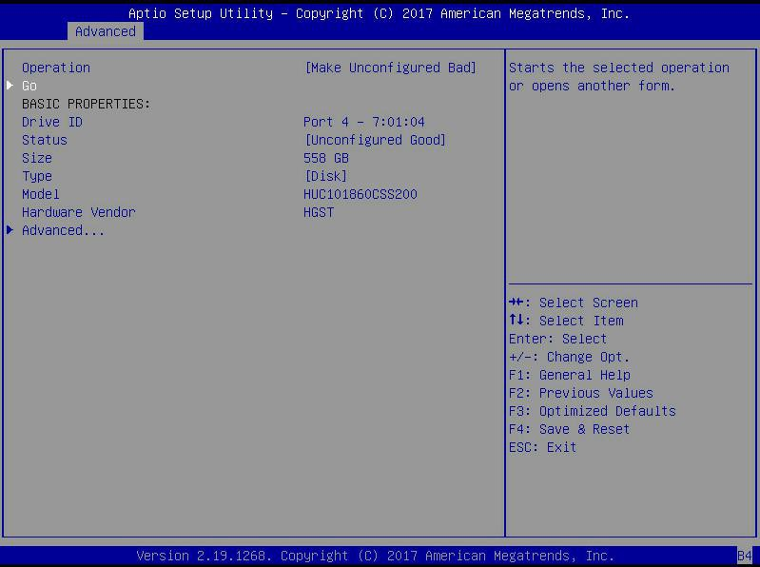
Figure 6- 29
- Enter the interface shown in Figure 6-30 to complete the operation of switching the disk mode.
Figure 6-30 Finish switching disk mode
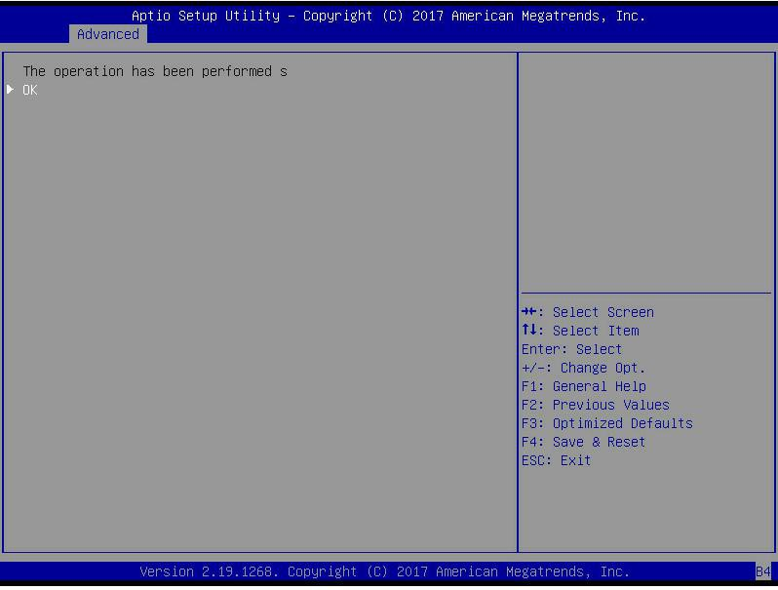
Figure 6-30

Create RAID:
- As shown in Figure 6-31, select Configuration Management on the RAID card configuration interface, and press Enter.
Figure 6-31 RAID card configuration interface
Figure 6-31
- Enter the interface shown in Figure 6-32, select Create Virtual Drive, and press Enter.
Figure 6-32 Select Create Virtual Drive
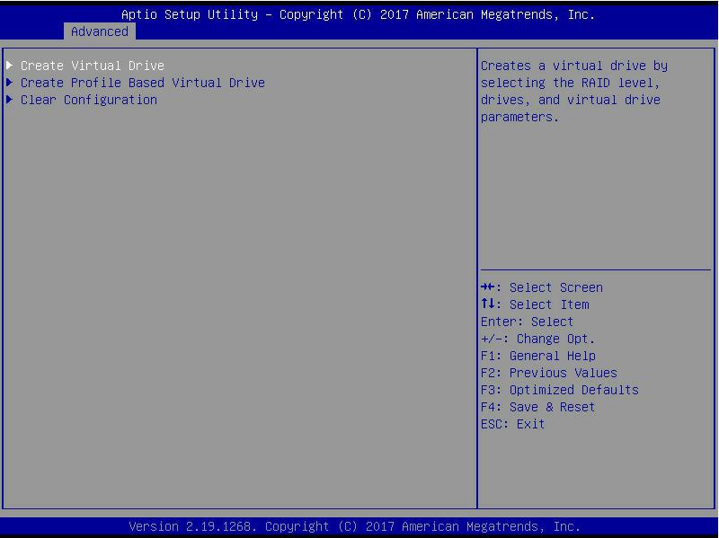
Figure 6-32
- Enter the interface shown in Figure 6-33, select Select RAID Level, set the RAID level, and press Enter.
Figure 6-33 Set RAID level
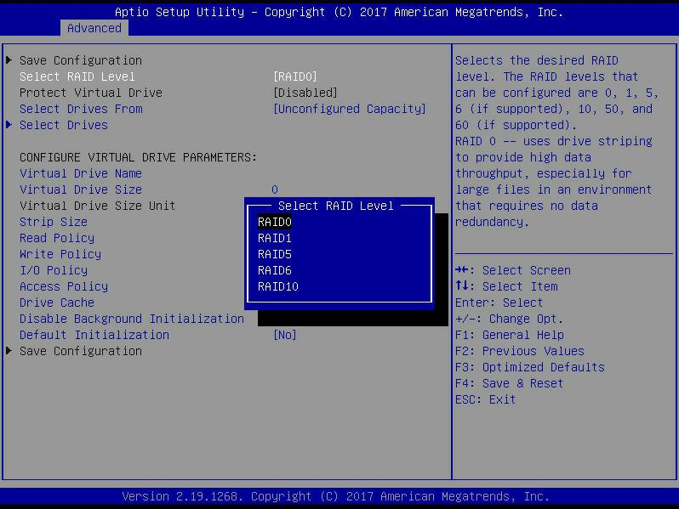
Figure 6- 33
- Enter the interface shown in Figure 6-34, select Select Drives From, set the disk capacity source of the RAID, and press Enter.
- [Unconfigured Capacity] indicates that the capacity comes from the remaining capacity of the disk that has been configured with RAID.
- [Free Capacity] means that the capacity comes from an empty disk.
- Figure 6-34 Set the disk capacity source of RAID
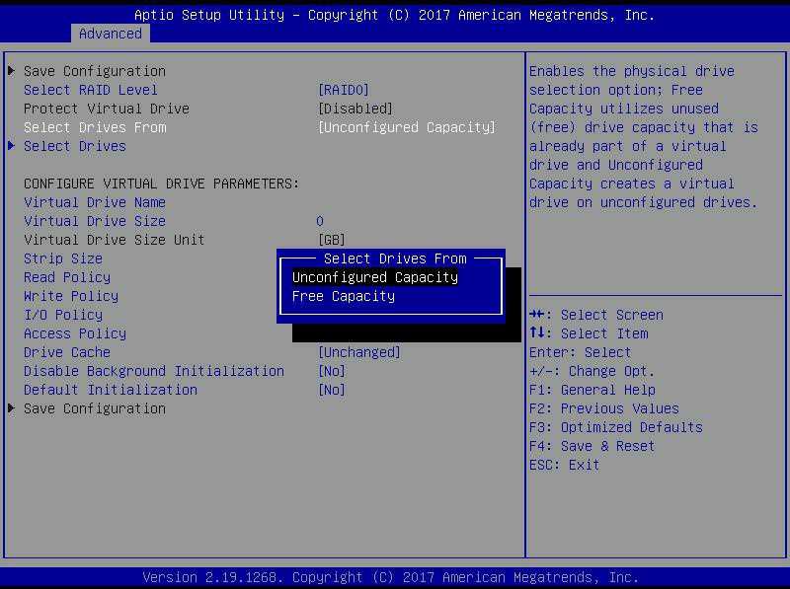
Figure 6- 34
- Enter the interface shown in Figure 6-35, select Select Drives, and press Enter.
Figure 6-35 Select Select Drives
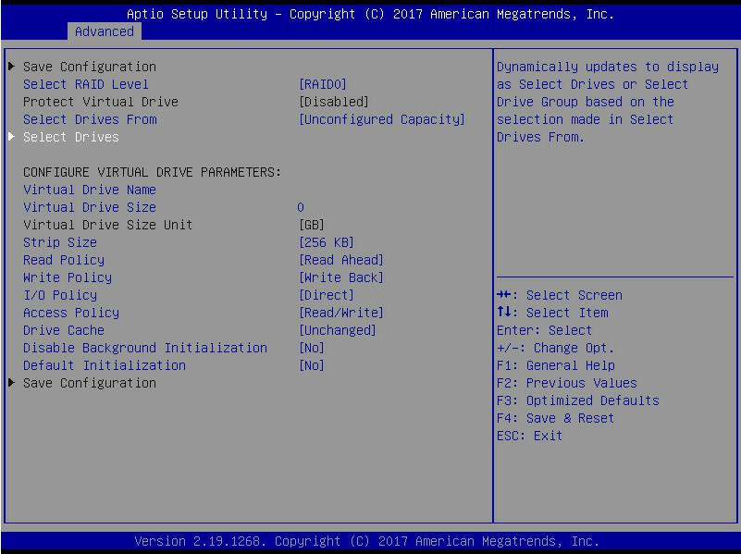
Figure 6-35
- Enter the interface shown in Figure 6-36, select the disk to be used to configure RAID, [Enabled] means selected, then select Apply Changes, and press Enter. If the status of the disk is JBOD or Unconfigured Bad, it cannot be selected.
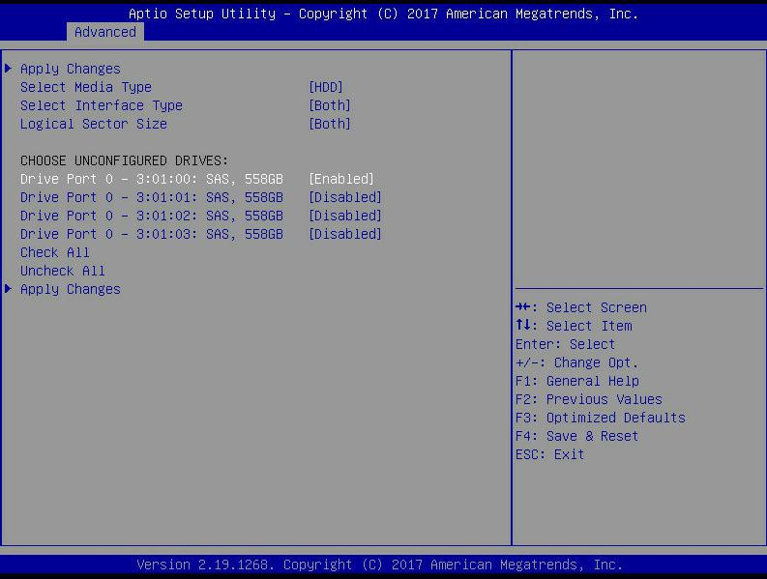
Figure 6- 36
- Enter the interface shown in Figure 6-37, make corresponding settings (for parameter descriptions, see Table 1-32), then select Save Configuration, and press Enter.
Figure 6-37 Set RAID parameters
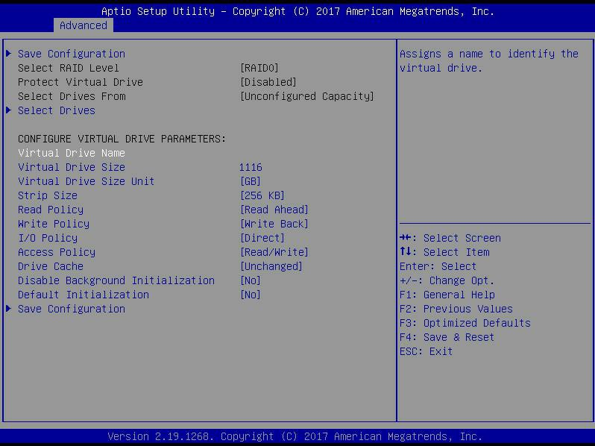

- Parameter Description
parameter | Description
Virtual Drive Name | RAID name, only supports letters, numbers and underscores, not case sensitive
Virtual Drive Size | RAID capacity
Virtual Drive Size  Unit | RAID capacity unit
Stripe Size | Stripe size, the size of the striped data block written on each disk
Read Policy | The read cache strategy is divided into Read Ahead (open read cache) and No Read Ahead (close read cache)  Save)
Write Policy | Write caching strategy, divided into Write Through (write through mode), Always Write Back (write back  Mode 1) and Write Back (write back mode 2)
I/O Policy | I/O strategy, divided into Cached (cache mode) and Direct (direct read and write mode)
Access Policy | Read and write strategy, divided into Read/Write (read/write), Read Only (read only) and Blocked (prohibited operation)
Drive Cache | Disk caching strategy, divided into Enable (open), Disable (close) and Unchanged (automatic)
Default Initialization | Default initialization method
Save Configuration | Save the configuration created by the wizard
Table 1- 27

- Do not use special characters as the name of the RAID.
- Compared with No Read Ahead, Write Through and Direct, Read Ahead, Write Back and Cached have improved performance, but data consistency cannot be guaranteed.
- If the super capacitor is abnormal, when the write cache strategy selects "Write Back", the firmware write data implementation is "Write Through"; the write cache strategy selects "Always Write Back", the firmware write data implementation is "Write Back".

- Enter the interface shown in Figure 6-38, select Confirm to enable it, select Yes, and press Enter.
Figure 6-38 Confirm configuration
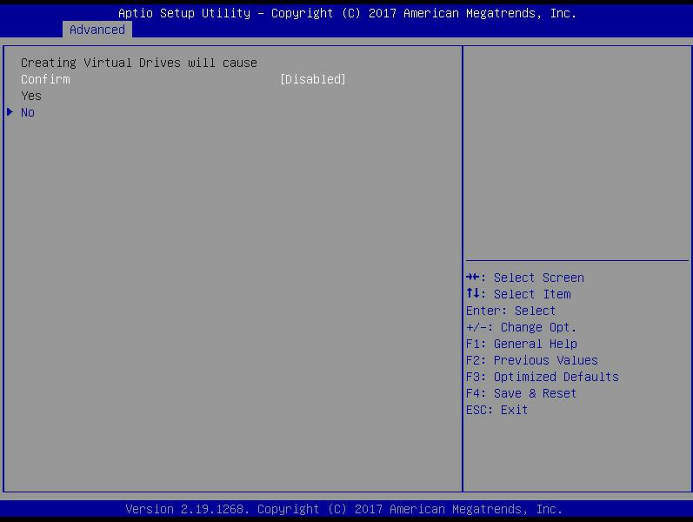
Figure 6- 38
- Enter the interface shown in Figure 6-39, complete the RAID configuration operation, select OK to return to the RAID card configuration interface.
Figure 6-39 Complete RAID configuration
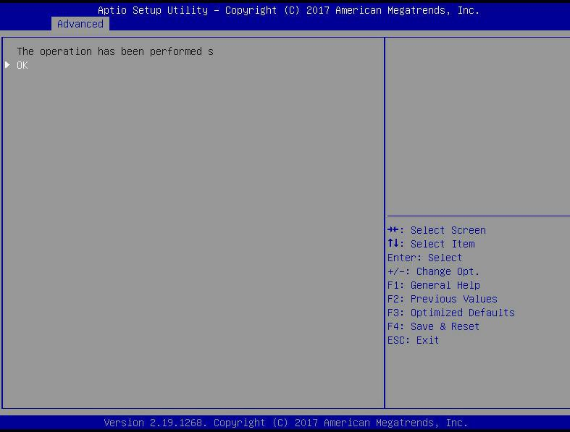
Figure 6-39

- As shown in Figure 6-40, select Virtual Drive Management on the RAID card configuration interface, and press Enter.
Figure 6-40 RAID card configuration interface
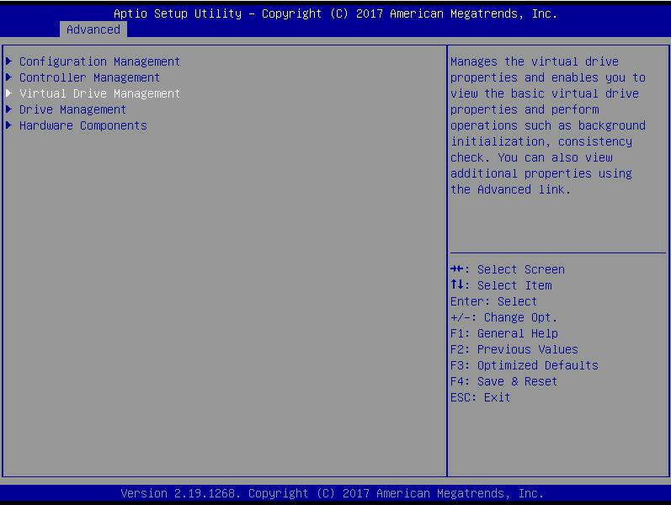
Figure 6- 40
- Enter the interface shown in Figure 6-41, you can see the created RAID, select the RAID you want to view, and press Enter.
- Figure 6-41 Vitrual Drive Management interface
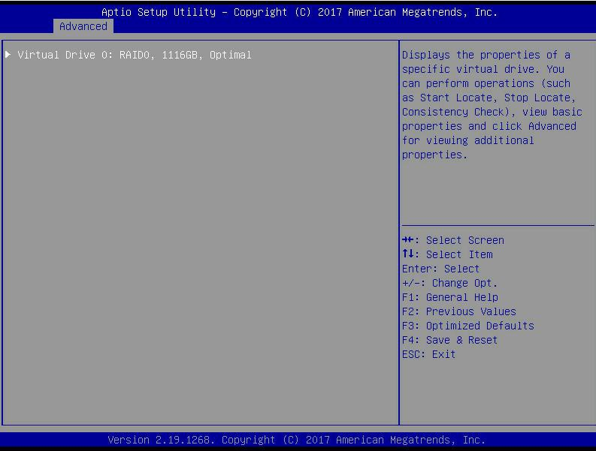
Figure 6- 41
- Enter the interface shown in Figure 6-42, select View Associated Drives, and press Enter to view the detailed information of the RAID (including RAID name, level, and disk information, etc.).
Figure 6-42 Select View Associated Drives
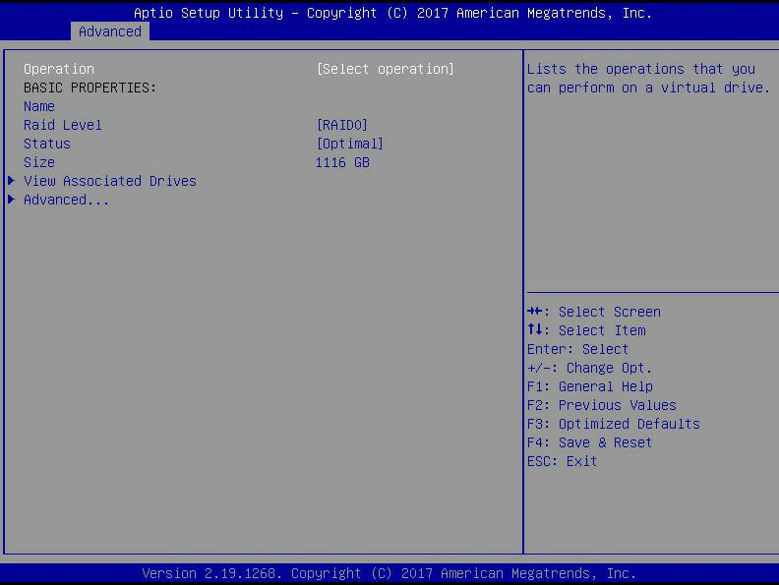
Figure 6- 42

Configure hot spare disk:
After RAID is configured, hot spare disks are generally configured to improve data security. You can configure a global hot spare disk or a dedicated hot spare disk as needed.
- Hot spare disks are only available for RAID levels with redundancy.
- The capacity of the hot spare disk is larger than the capacity of a single member disk of the RAID to contribute to the RAID.
- Only the disk whose configuration mode is Unconfigured Good is supported as a hot spare disk.
- Configure global hot spare disk
- As shown in Figure 6-43, select Drive Management on the RAID card configuration interface and press Enter.
Figure 6-43 RAID card configuration interface
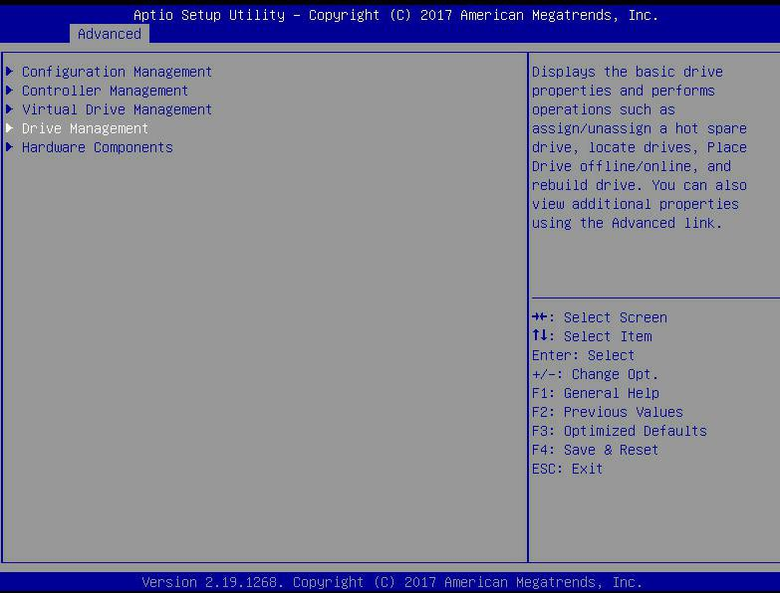
Figure 6- 43
- Enter the interface shown in Figure 6-44, select the disk to be configured as a global hot spare disk, and press Enter.
Figure 6-44 Drive Management management interface
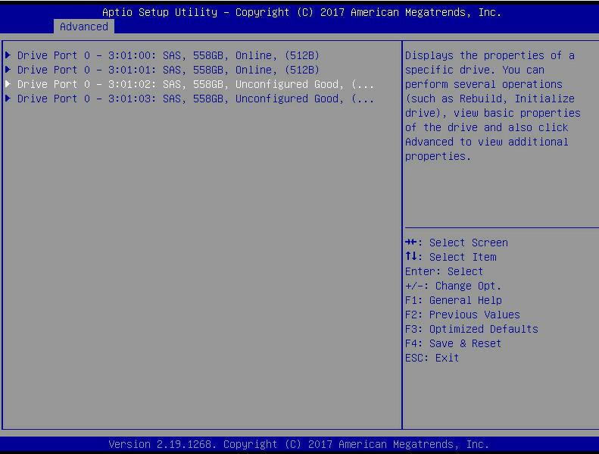
Figure 6-44
- Enter the interface shown in Figure 6-45, select Operation, press Enter, then select Assign Dedicated Hot Spare Drive, and press Enter.
Figure 6-45 Operation interface
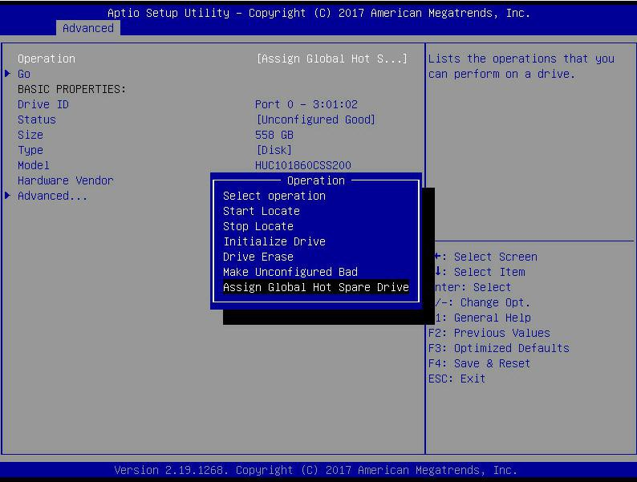
Figure 6-45
- Enter the interface shown in Figure 6-46, select Go, and press Enter.
Figure 6-46 Select Go
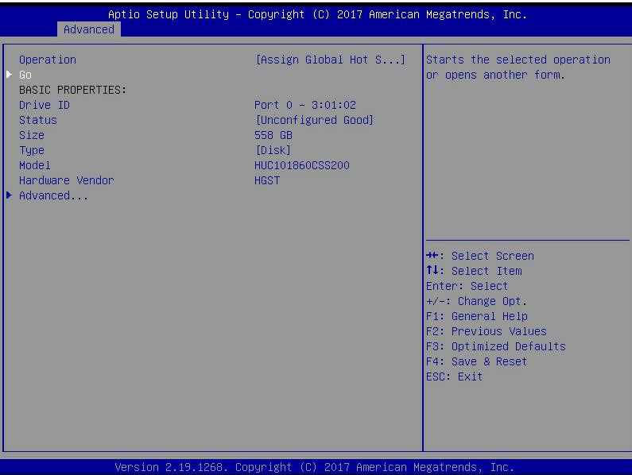
Figure 6- 46
- Enter the interface shown in Figure 6-47, select Confirm to enable it, select Yes, and press Enter.
Figure 6-47 Confirm configuration
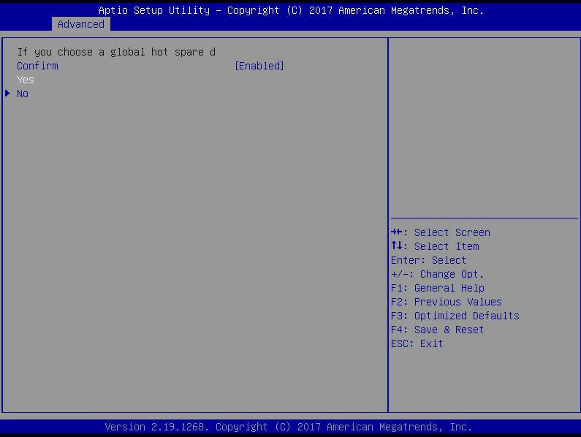
Figure 6- 47
- Enter the interface shown in Figure 6-48 to complete the configuration of the global hot spare disk.
Figure 6-48 Complete configuration of global hot spare disk
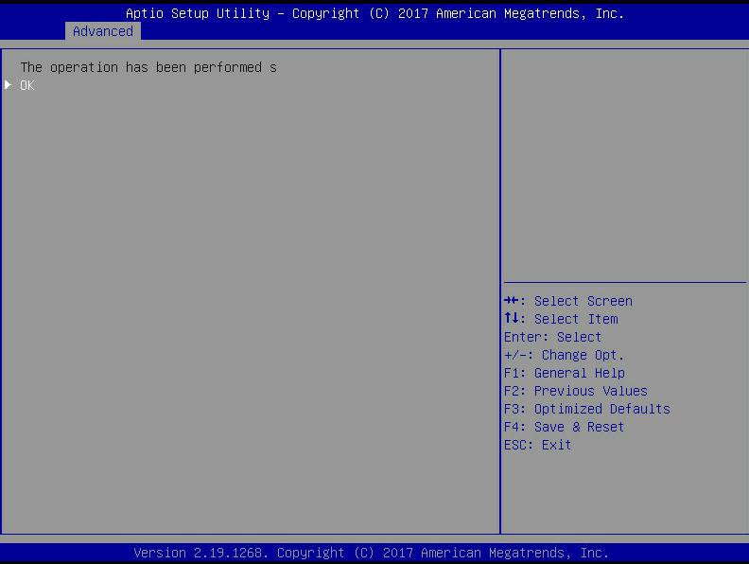
Figure 6-48

Delete RAID:
- As shown in Figure 6-49, select Virtual Drive Management on the RAID card configuration interface, and press Enter.
Figure 6-49 RAID card configuration interface
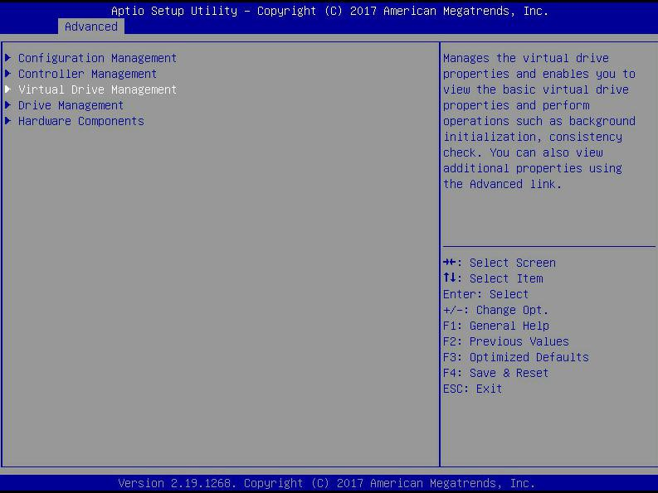
Figure 6-44
- Enter the interface shown in Figure 6-50, select the logical disk to be deleted, and press Enter.
Figure 6-50 Logical Disk Management Interface
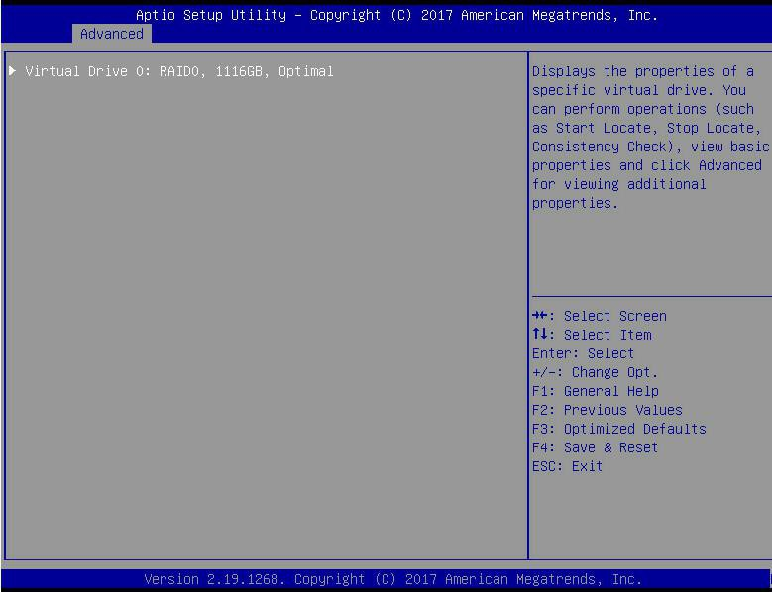
Figure 6- 50
- Enter the interface shown in Figure 6-51, select Operation, press Enter, and then select Delete Virtual Drive in the pop-up dialog box, and press Enter.
Figure 6-51Operation operation interface
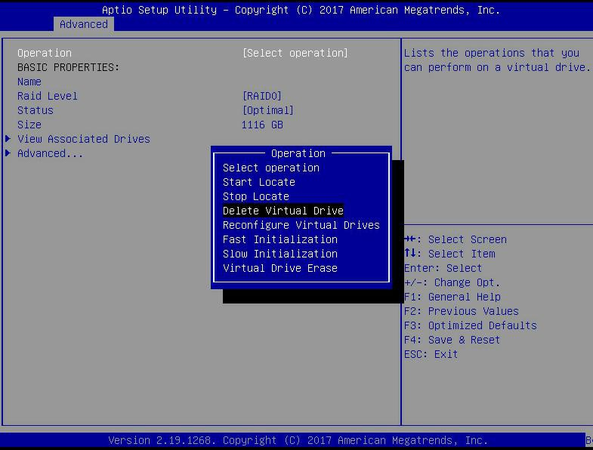
Figure 6-51
- Enter the interface shown in Figure 6-52, select Go, and press Enter.
Figure 6-52 Select Go
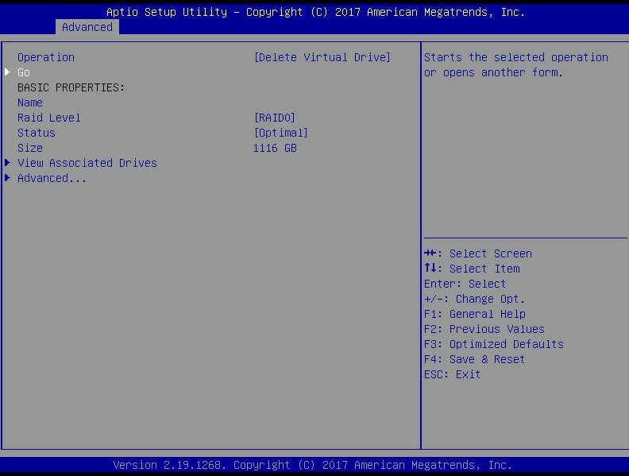
Figure 6-52
- Enter the interface shown in Figure 6-53, select Confirm to enable it, select Yes, and press Enter.
Figure 6-53 Confirm deletion
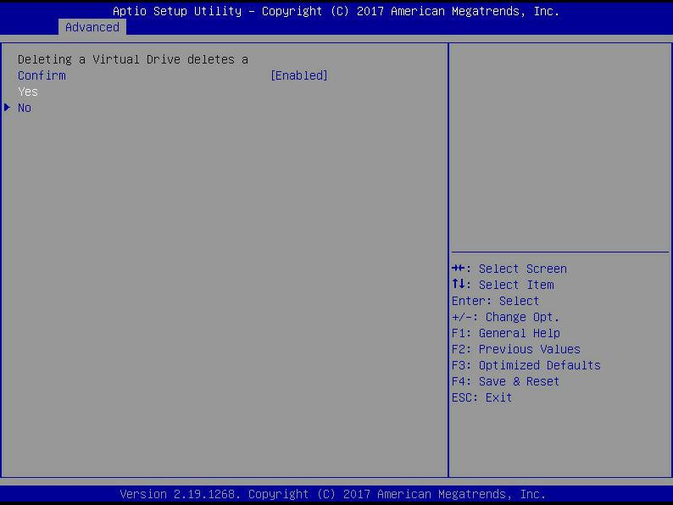
Figure 6-53
- Enter the interface shown in Figure 6-54 to complete the RAID deletion operation.
Figure 6-54 Completed RAID deletion
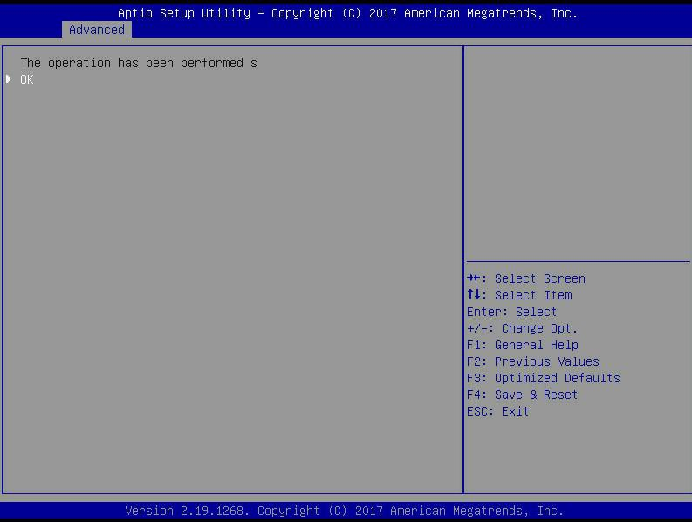
Figure 6-54
Locate the disk location:
- Locate the physical disk
  - As shown in Figure 6-55, select Drive Management on the RAID card configuration interface and press Enter.
Figure 6-55 Select Drive Management
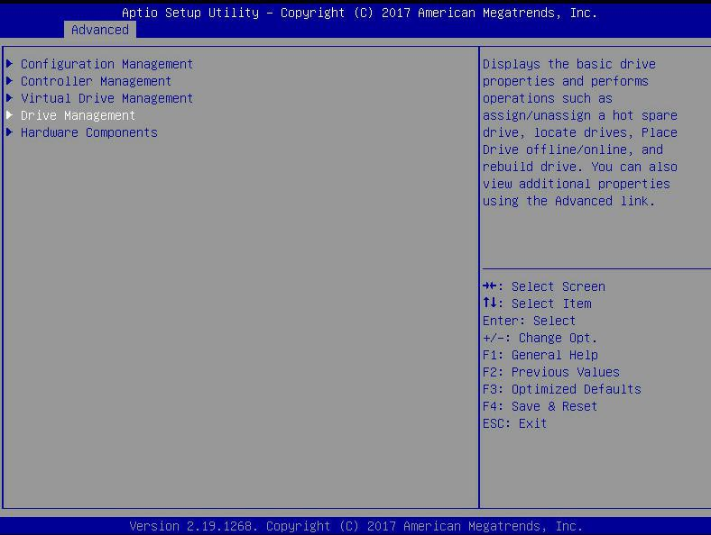
Figure 6-55
  - Enter the interface of Figure 6-56, select the disk to be located, and press Enter.
Figure 6-56 Select the disk to be located
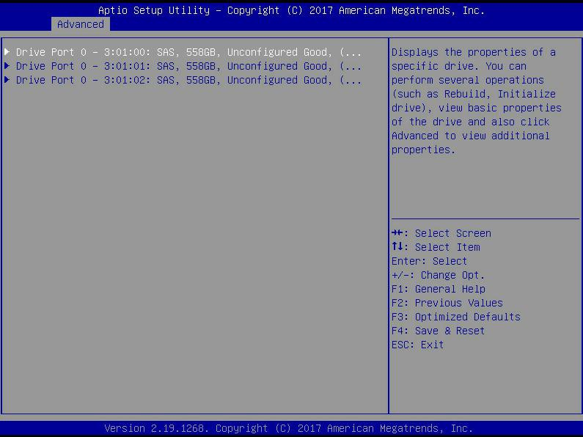
Figure 6-56
  - Enter the interface of Figure 6-57, select Operation, press Enter, and then select Start Locate in the pop-up dialog box, and press Enter.
Figure 6-57 Operation interface
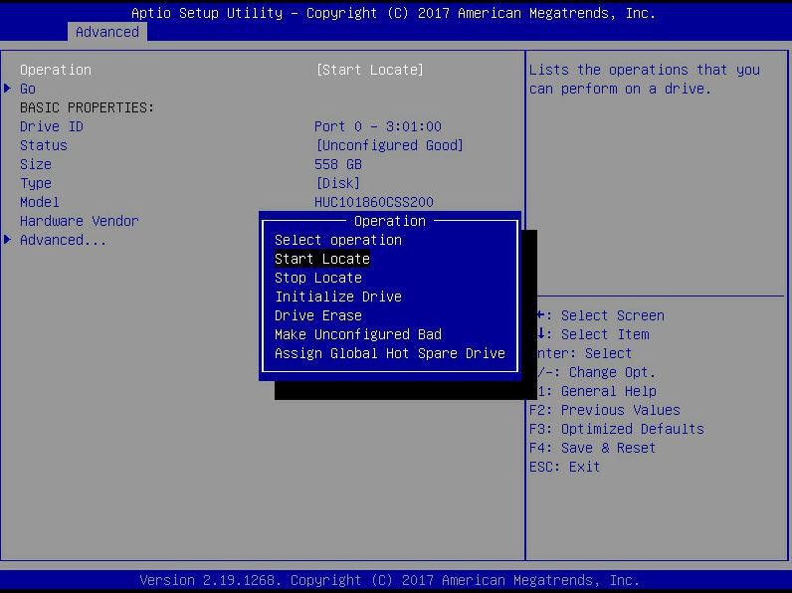
Figure 6-57
  - Enter the interface of Figure 6-58, select Go, and press Enter.
Figure 6-58 Select Go
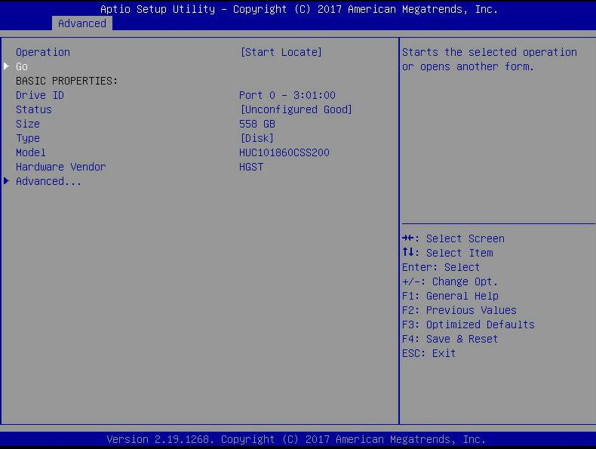
Figure 6-58
  - Enter the interface of Figure 6-59 to complete the operation of locating the physical disk position.
Figure 6-59 Finish positioning the physical disk location
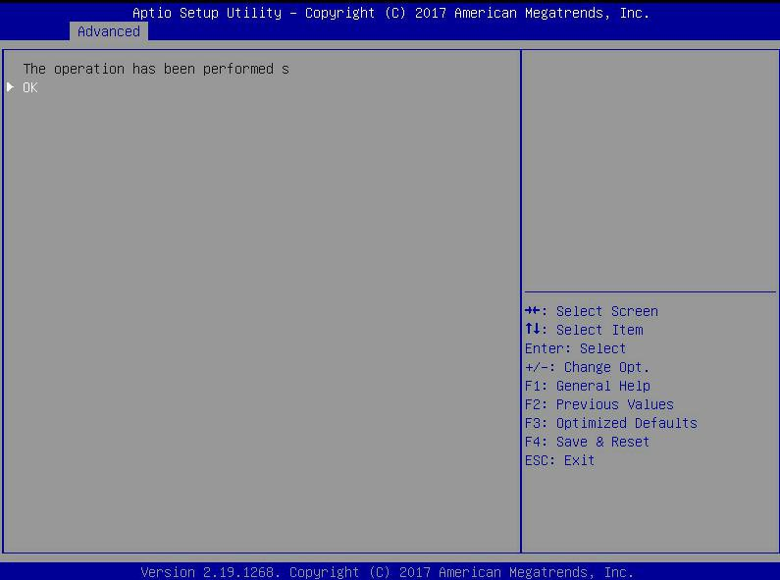
Figure 6-59
- Locate all disks in the logical disk
  - As shown in Figure 6-60, select Virtual Drive Management on the RAID card configuration interface, and press Enter.
Figure 6-60 RAID card configuration interface
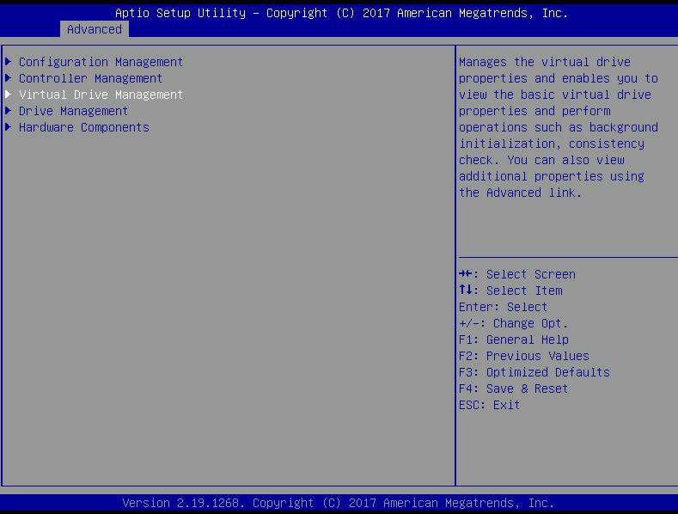
Figure 6- 60
  - Enter the interface of Figure 6-61, select the logical disk to be located, and press Enter.
Figure 6-61 Select the logical disk to be located
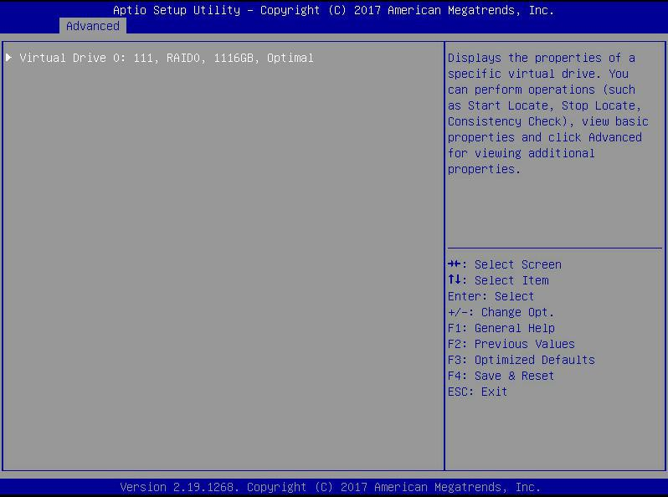
Figure 6-61
  - Enter the interface of Figure 6-62, select Operation, press Enter, and then select Start Locate in the pop-up dialog box, and press Enter.
Figure 6-62 Operation interface
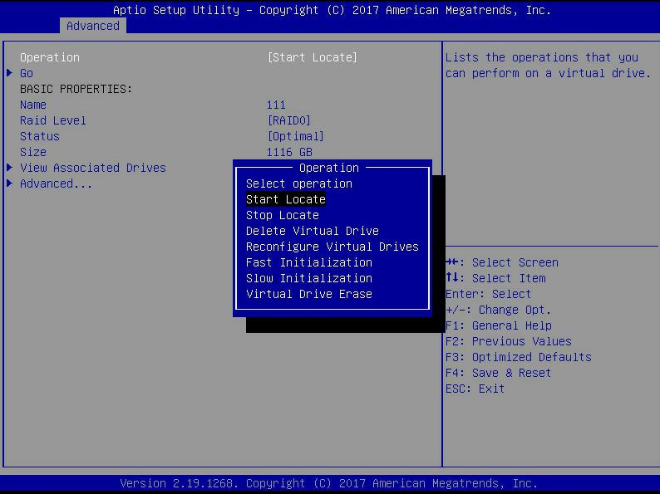
Figure 6-61
  - Enter the interface of Figure 6-63, select Go, and press Enter.
Figure 6-63 Select Go
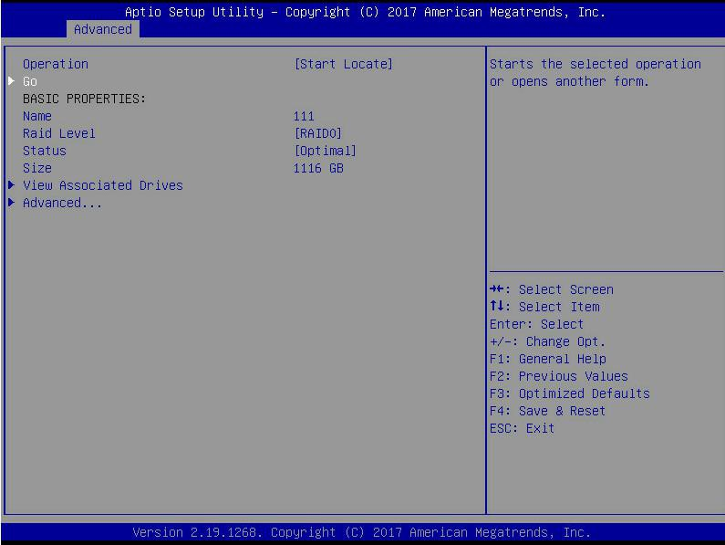
Figure 6-63
  - Enter the interface of Figure 6-64 to complete the operation of locating all disk positions in the logical disk.
Figure 6-64 Finish locating all disks in the logical disk
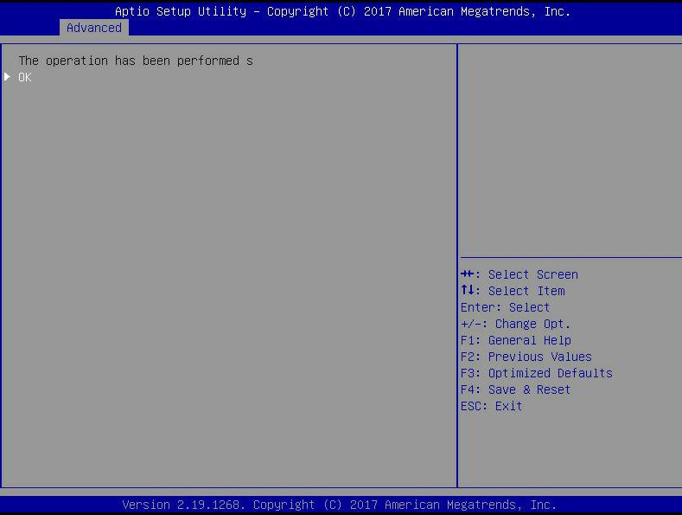
Figure 6-64
Initialize the logical disk:
This function is used to initialize the internal data space of the logical disk so that it can be recognized and used by the operating system.
- As shown in Figure 6-65, select Virtual Drive Management on the RAID card configuration interface, and press Enter.
Figure 6-65 RAID card configuration interface
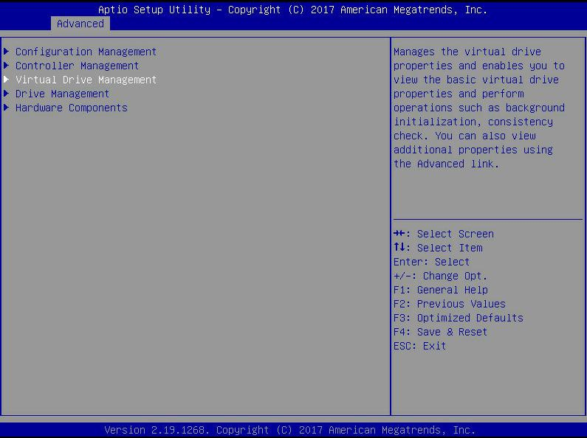
Figure 6-65

- Enter the interface shown in Figure 6-66, select the logical disk to be initialized, and press Enter.
Figure 6-66 Logical Disk Management Interface
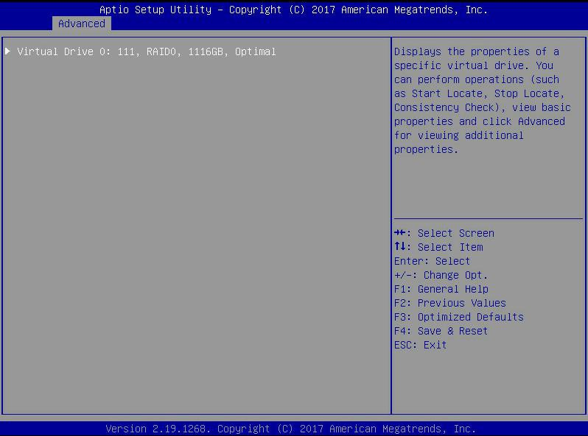
Figure 6-66
- Enter the interface shown in Figure 6-67, select Operation, press Enter, and then select Fast/Slow Initialization in the pop-up dialog, and press Enter.
Figure 6-67 Operation interface
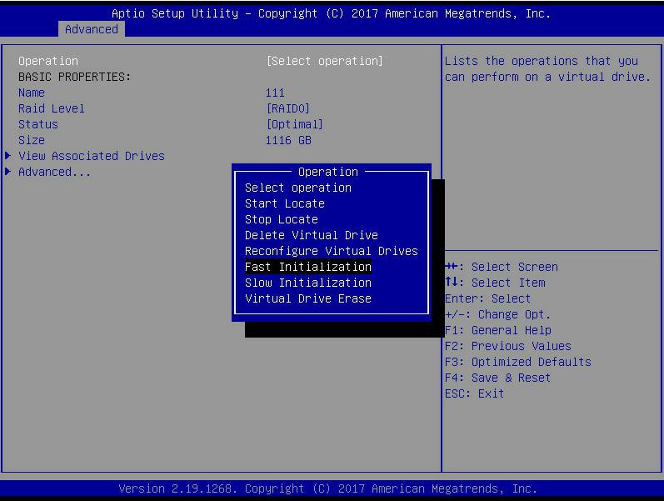
Figure 6- 67

The difference between Fast Initialization and Slow Initialization is that the former can write data immediately, while the latter needs to wait for the disk space to be initialized before writing data.

- Enter the interface shown in Figure 6-68, select Go, and press Enter.
Figure 6-68 Select Go
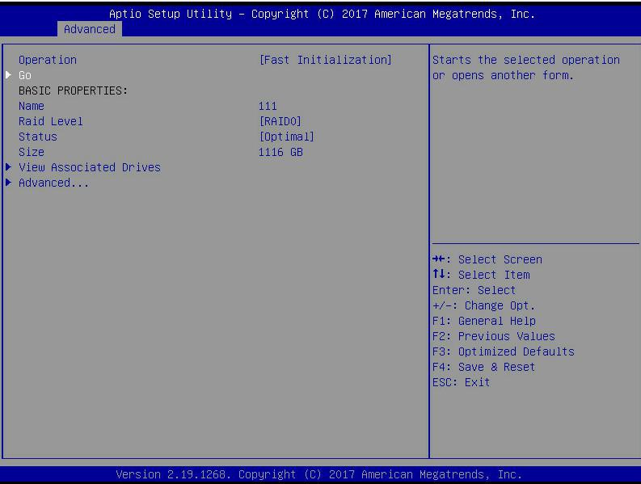
Figure 6- 68
- Enter the interface shown in Figure 6-69, select Confirm to enable it, select Yes, and press Enter.
Figure 6-69 Confirm initialization
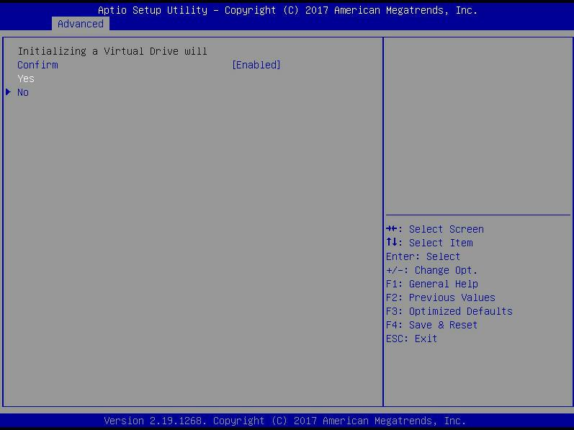
Figure 6- 69
- Enter the interface shown in Figure 6-70 to complete the initialization of the logical disk.
Figure 6-70 Finish initializing the logical disk
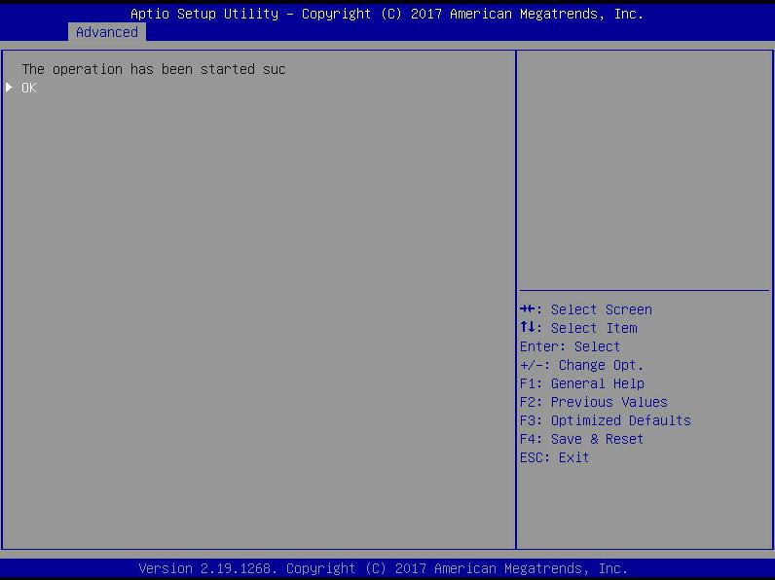
Figure 6-70
Initialize the physical disk:
- As shown in Figure 6-71, select Drive Management on the RAID card configuration interface and press Enter.
Figure 6-71 RAID card configuration interface
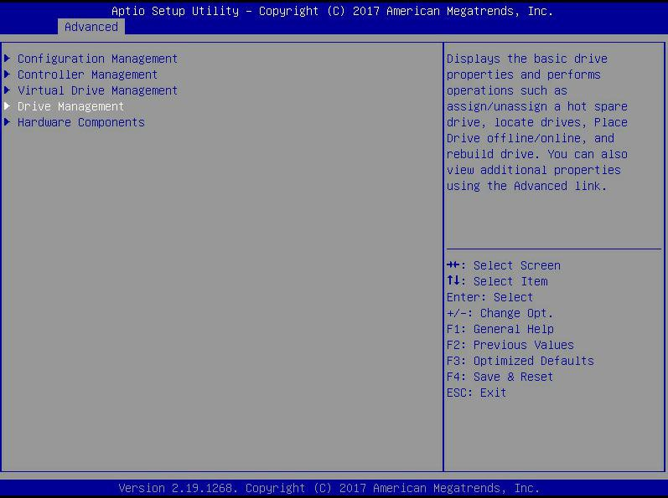
Figure 6-71
- Enter the interface shown in Figure 6-72, select the disk to be initialized, and press Enter.
Figure 6-72 Disk Management Interface
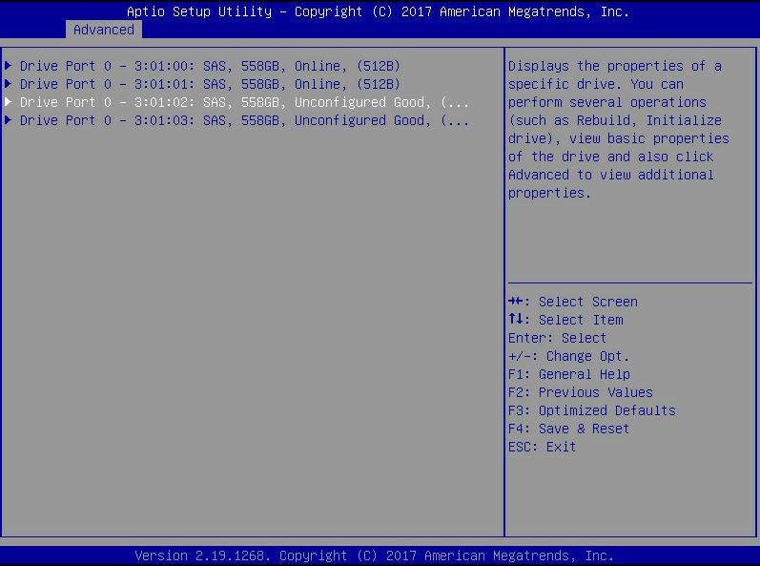
Figure 6-72
- Enter the interface of Figure 6-73, select Operation, press Enter, and then select Initialize Drive in the pop-up dialog box, and press Enter.
Figure 6-73 Operation management interface
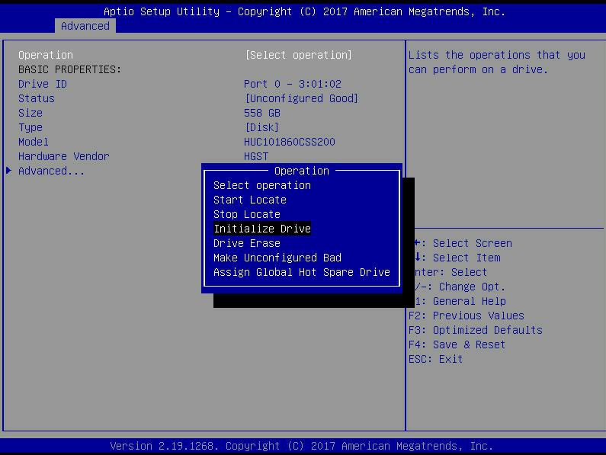
Figure 6-73
- Enter the interface of Figure 6-74, select Go, and press Enter.
Figure 6-74 Select Go
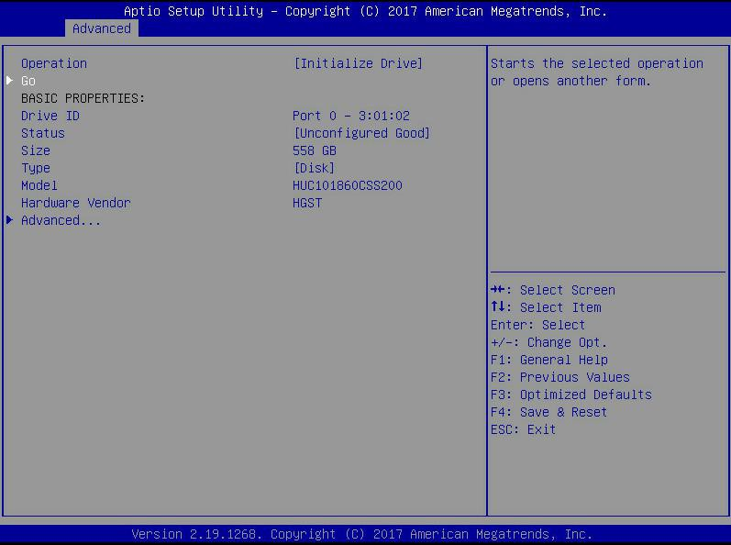
Figure 6-74
- Enter the interface shown in Figure 6-75, select Confirm to enable it, select Yes, and press Enter.
Figure 6-75 Confirm initialization
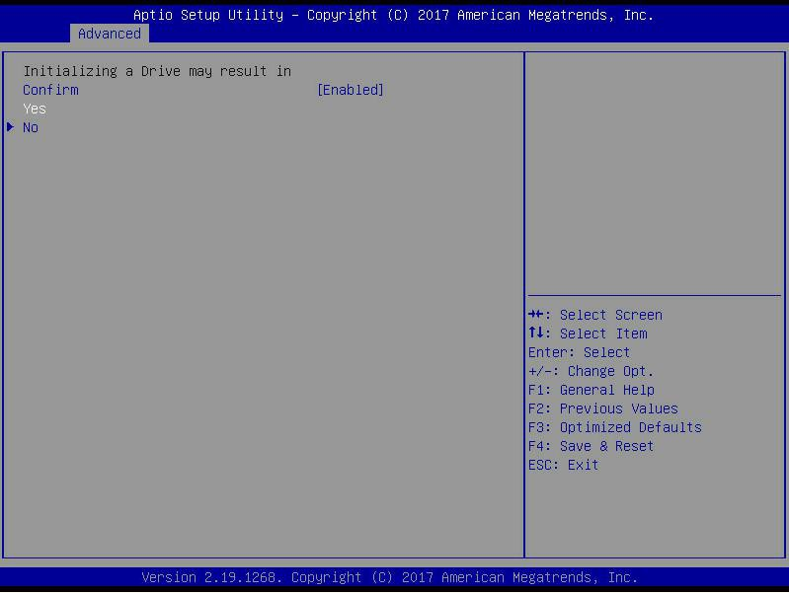
Figure 6-75
- Enter the interface of Figure 6-76 to complete the initialization of the physical disk.
Figure 6-76 Finish initializing the physical disk
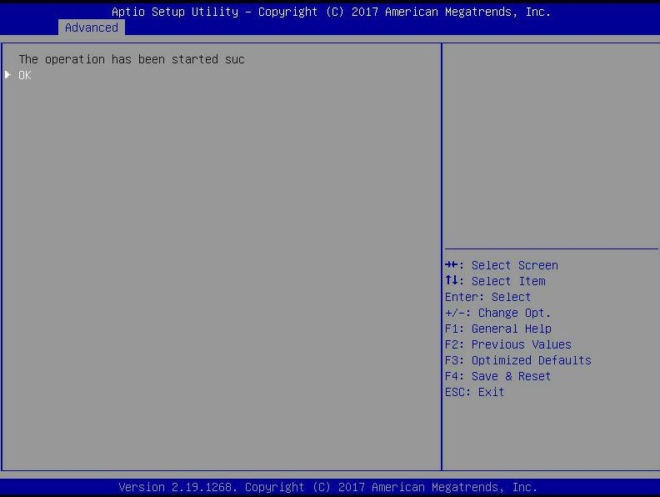
Figure 6- 76

Erase disk data:
This function is used to delete internal disk data, including erasing physical disk data and logical disk data.
- Wipe physical disk data
  - As shown in Figure 6-77, select Drive Management on the RAID card configuration interface and press Enter.
Figure 6-77 RAID card configuration interface
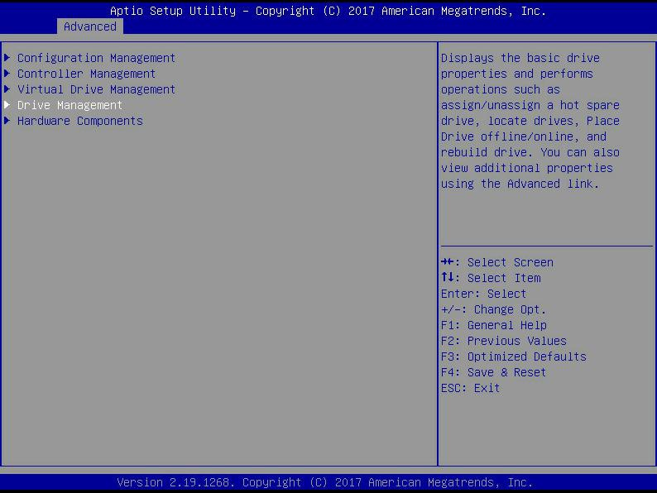
Figure 6-77
  - Enter the interface shown in Figure 6-78, select the disk to be erased, and press Enter.
Figure 6-78 Disk Management Interface
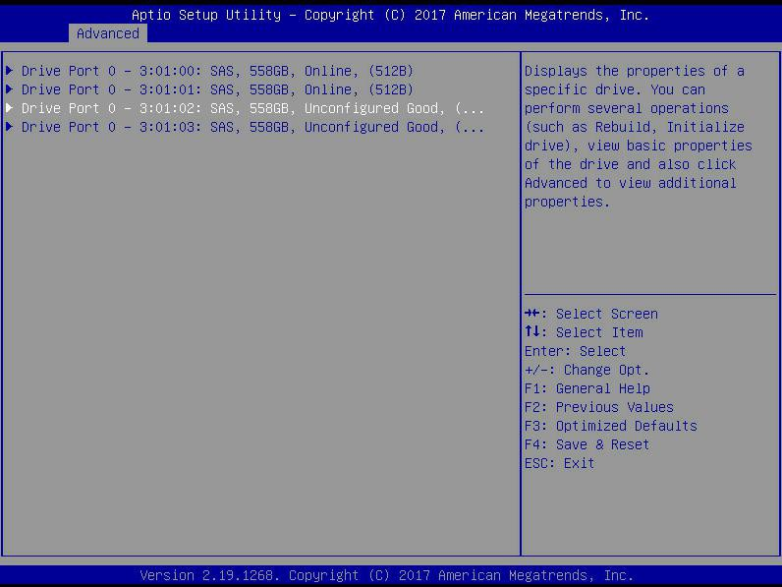
Figure 6- 78
  - Enter the interface shown in Figure 6-79, select Operation, press Enter, then select Drive Erase in the pop-up dialog box, and press Enter.
Figure 6-79 Operation interface
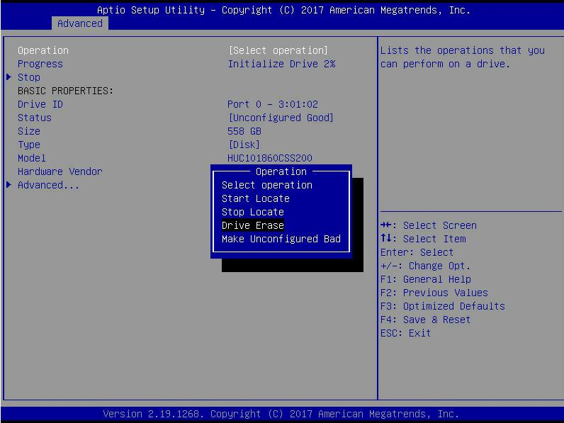
Figure 6-79
  - Enter the interface shown in Figure 6-80, press Enter, and then select the erase mode in the pop-up dialog box
(It is recommended to use the default mode: Simple).
Figure 6-80 Erase Mode interface
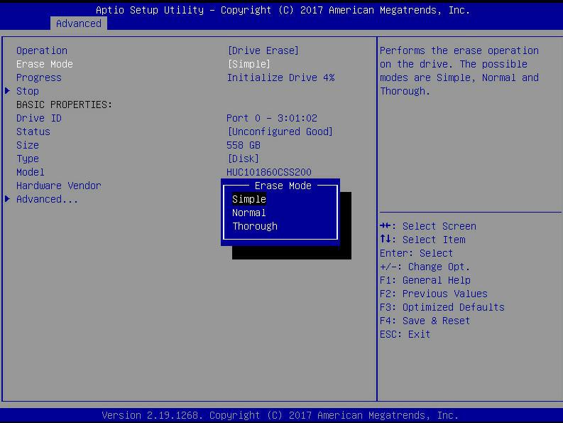
Figure 6-80
  - Enter the interface shown in Figure 6-81, select Go, and press Enter.
Figure 6-81 Select Go
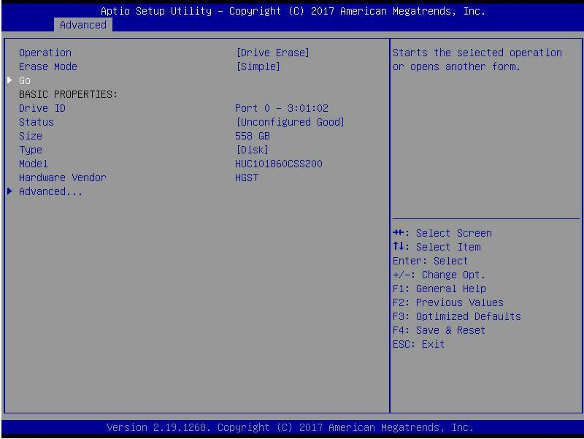
Figure 6-81
  - Enter the interface shown in Figure 6-82, select Confirm to enable it, select Yes, and press Enter.
Figure 6-82 Confirm erasure
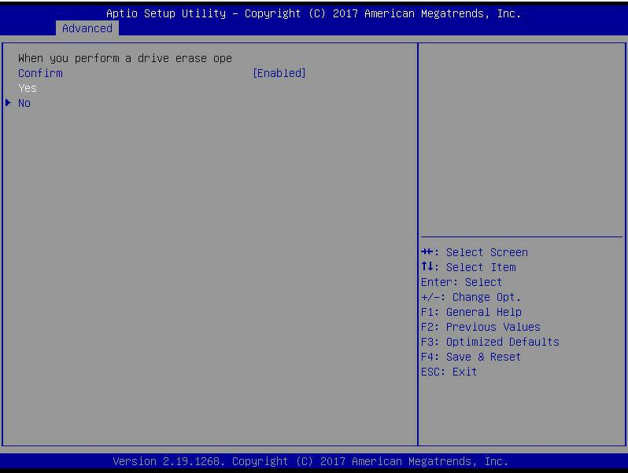
Figure 6-82
  - Enter the interface shown in Figure 6-83 to complete the operation of erasing physical disk data.
Figure 6-83 Complete erasure of physical disk data
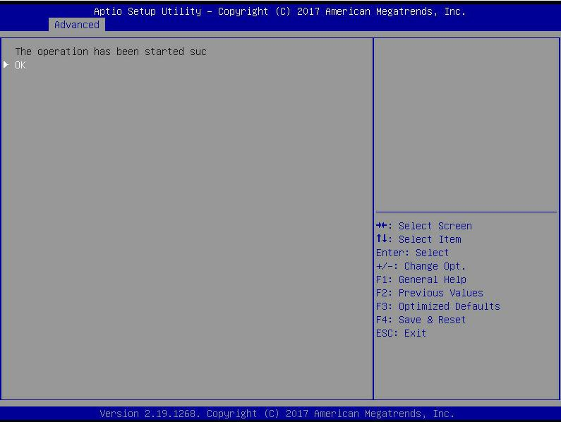
Figure 6- 83

: To avoid disk failure, do not perform other operations during the erasing of physical disk data.

- Erase logical disk data
  - As shown in Figure 6-84, select Virtual Drive Management on the RAID card configuration interface, and press Enter.
Figure 6-84 RAID card configuration interface
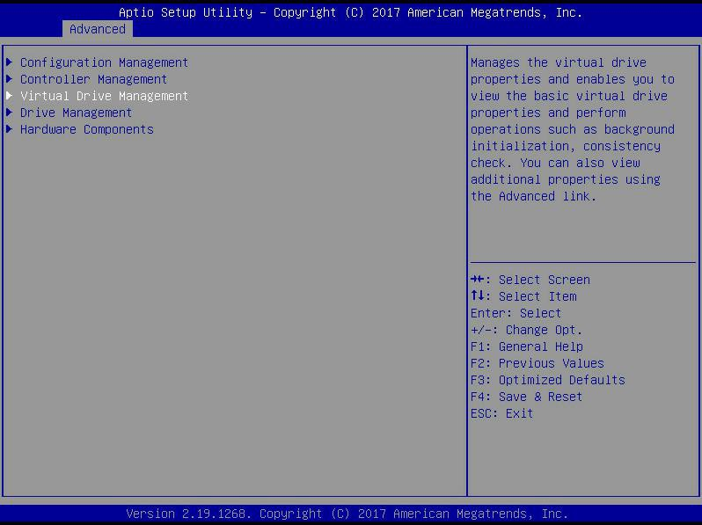
Figure 6- 46
  - Enter the interface shown in Figure 6-85, select the logical disk to be erased, and press Enter.
Figure 6-85 Logical Disk Management Interface
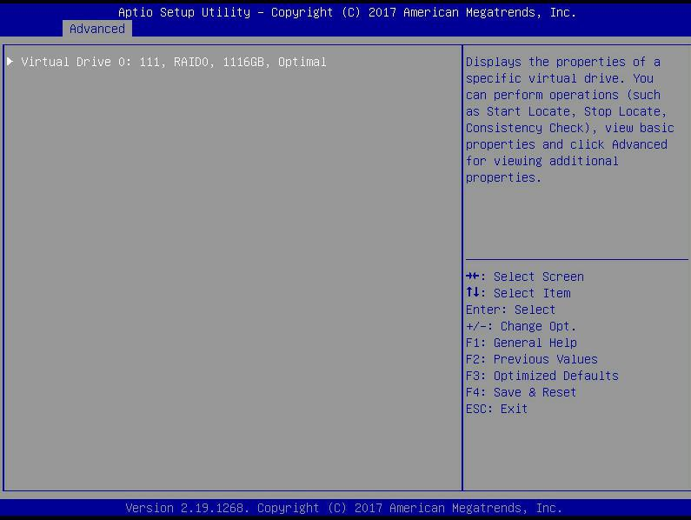
Figure 6-85
  - Enter the interface shown in Figure 6-86, select Operation, press Enter, and then select Virtual Drive Erase in the pop-up dialog box, and press Enter.
Figure 6-86 Operation interface
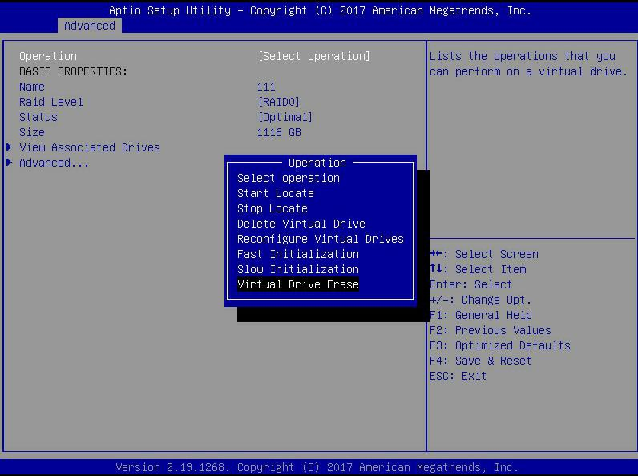
Figure 6-86
- Enter the interface shown in Figure 6-87, press Enter, and then select the erase mode in the pop-up dialog box
(It is recommended to use the default mode: Simple).
Figure 6-87 Erase Mode interface
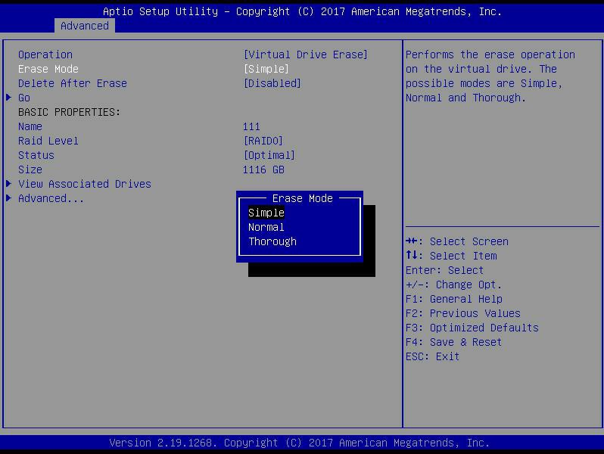
Figure 6- 87
- Enter the interface shown in Figure 6-88, select Go, and press Enter.
Figure 6-88 Select Go
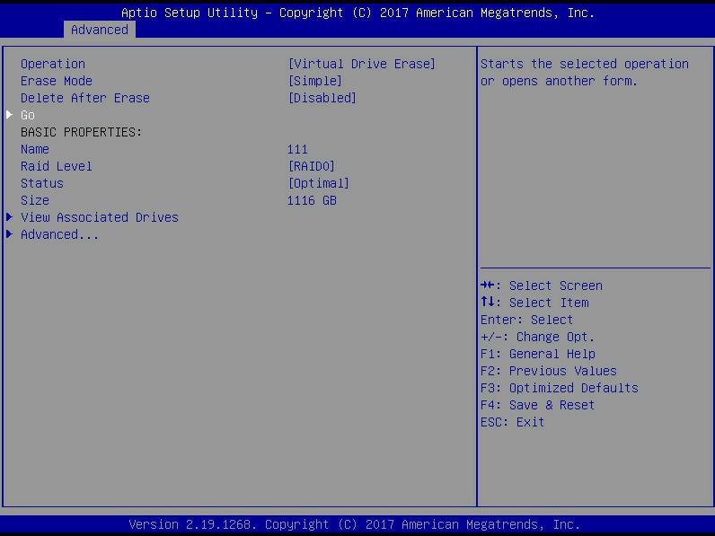
Figure 6-88
- Enter the interface shown in Figure 6-89, select Confirm to enable it, select Yes, and press Enter.
Figure 6-89 Confirm erasure
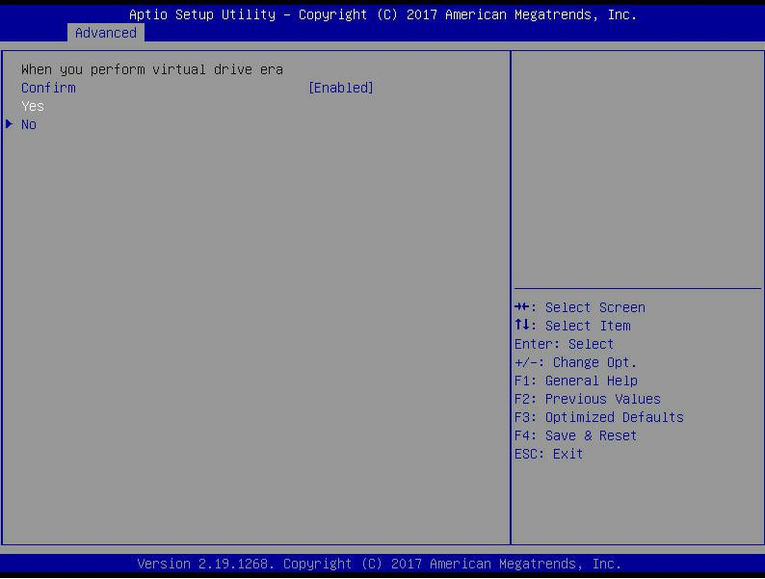
Figure 6- 89
- Enter the interface shown in Figure 6-90 to complete the operation of erasing logical disk data.
Figure 6-90 Completed erasing logical disk data
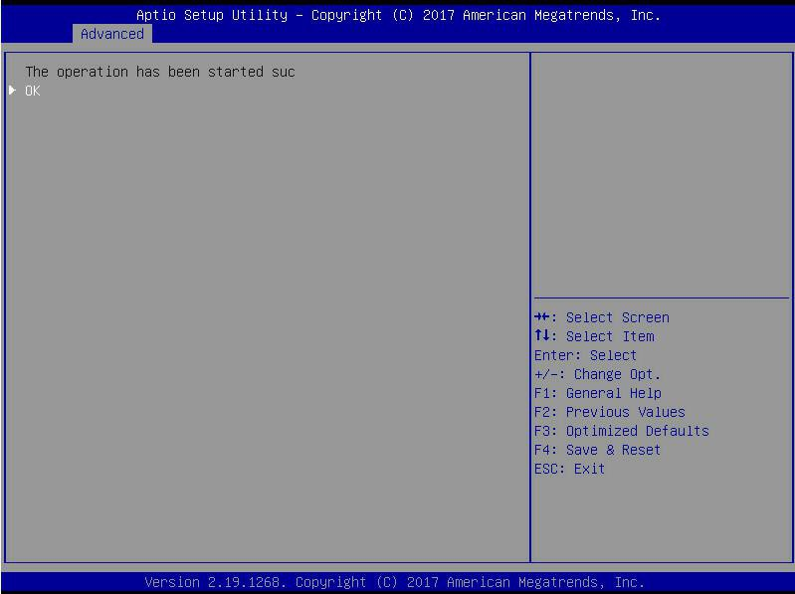
Figure 6-90

Migrate RAID level:
This function is used to modify the RAID level to meet the configuration requirements without affecting the current data integrity.
- As shown in Figure 6-91, select Virtual Drive Management on the RAID card configuration interface, and press Enter.
Figure 6-91 RAID card configuration interface
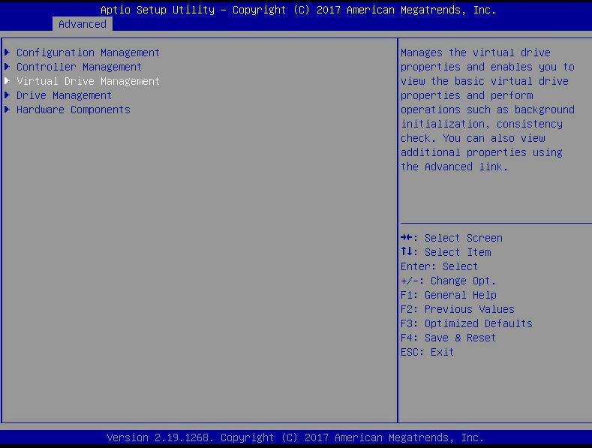
Figure 6-91
- Enter the interface shown in Figure 6-92, select the logical disk to be rebuilt, and press Enter.
Figure 6-92 Virtual Drive Management management interface
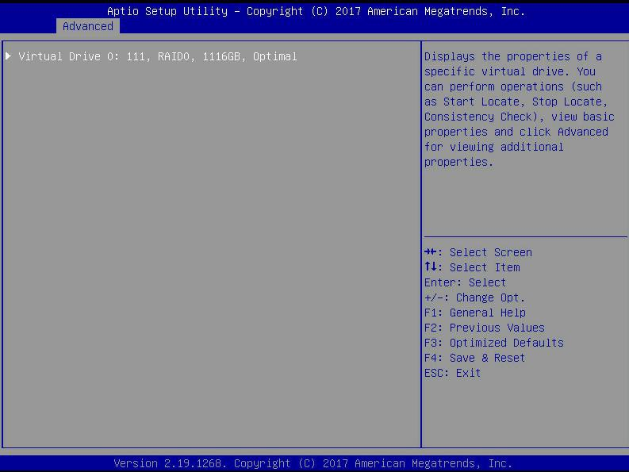
Figure 6- 92
- Enter the interface shown in Figure 6-93, select Operation, press Enter, and then select Reconfigure Virtual Drive in the pop-up dialog box, and press Enter.
Figure 6-93 Operation interface
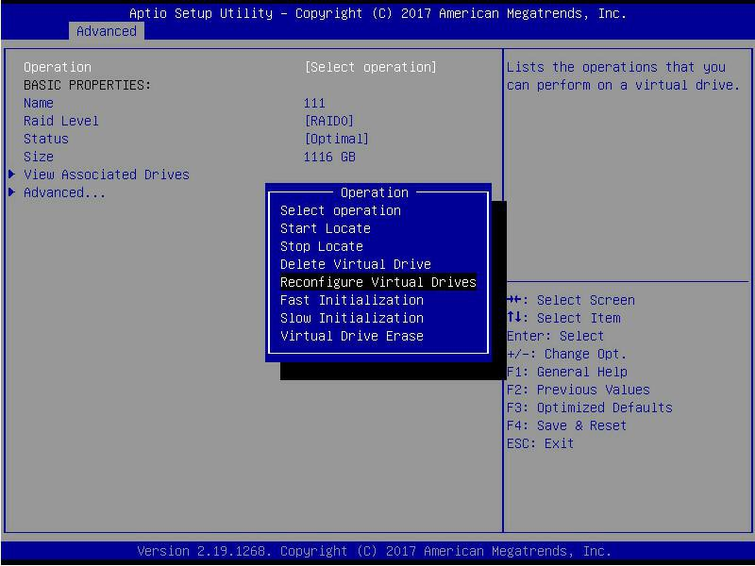
Figure 6-93
- Enter the interface shown in Figure 6-94, select Go, and press Enter.
Figure 6-94 Select Go
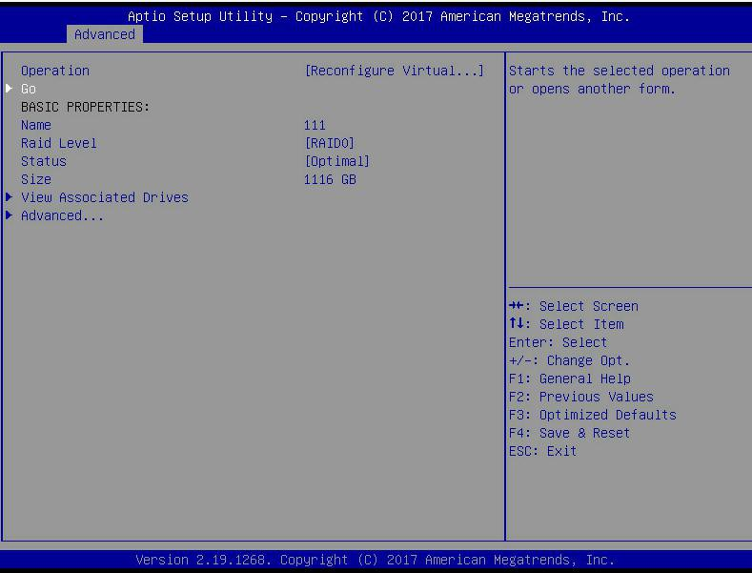
Figure 6-94
- Enter the interface shown in Figure 6-95, set the RAID level, select Add Drives, and press Enter.
Figure 6-95 Advanced interface
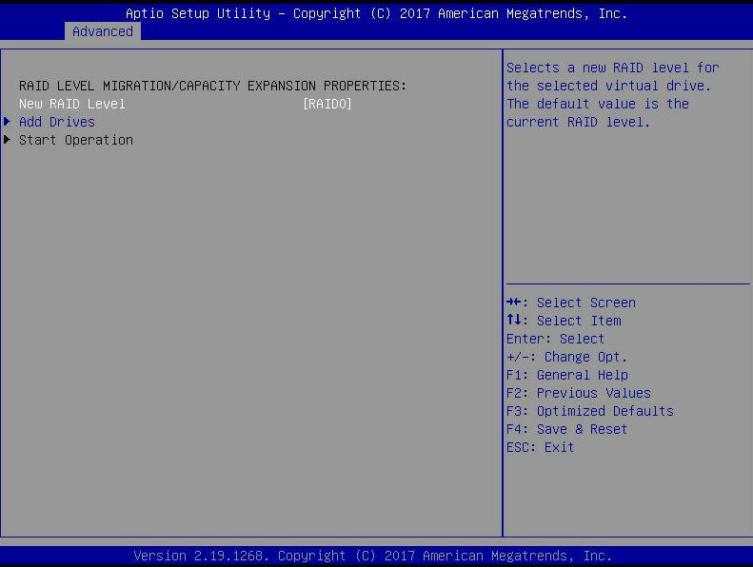
Figure 6- 95
- Enter the interface shown in Figure 6-96, select the disk to be added, make it Enabled, select Apply Changes, and press Enter.
Figure 6-96 Add Drives interface
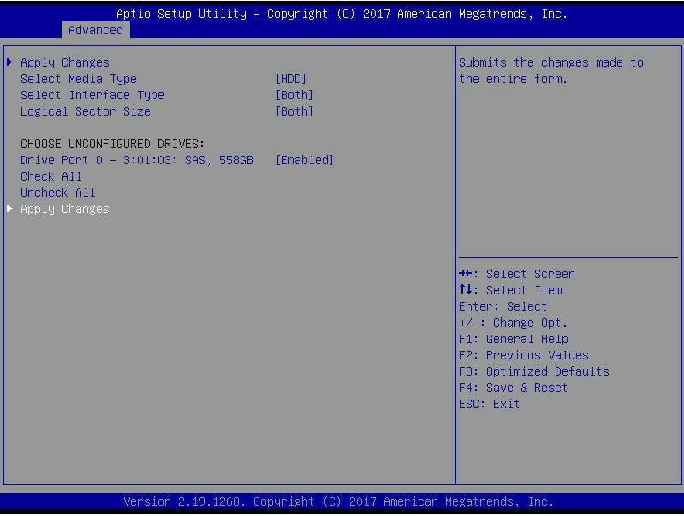
Figure 6- 96
- Enter the interface shown in Figure 6-97, select Confirm to enable it, select Yes, and press Enter.
Figure 6-97 Confirm migration
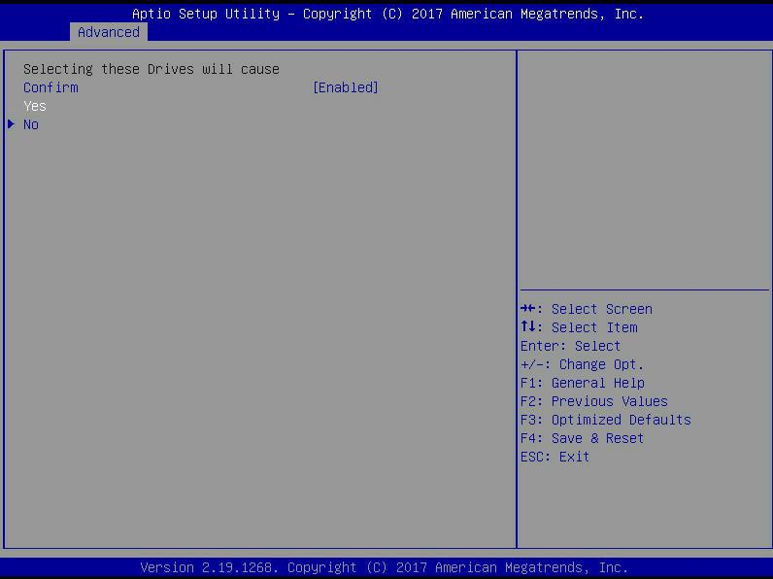
Figure 6- 97
- Enter the interface shown in Figure 6-98, select Start Operation, and press Enter.
Figure 6-98 Start Operation interface
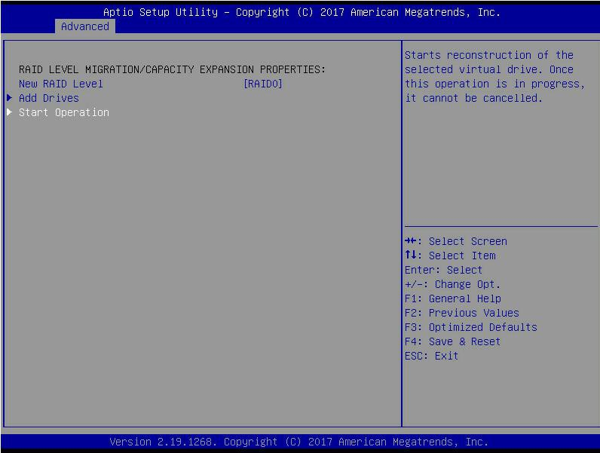
Figure 6- 98
- Enter the interface shown in Figure 6-99, select OK, and press Enter.
Figure 6-99 Select OK
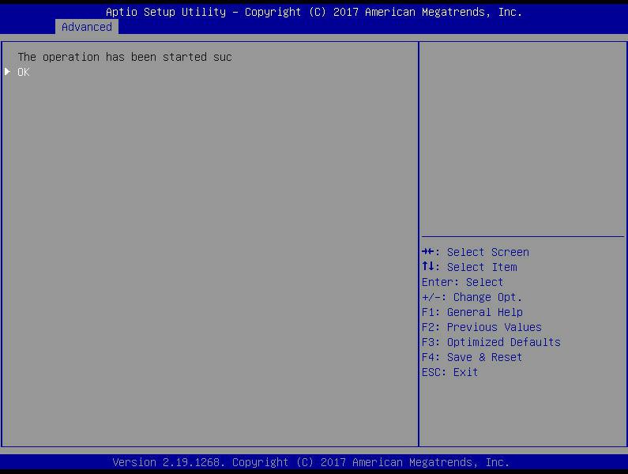
Figure 6-99
- Enter the interface shown in Figure 6-100 to view the current migration progress.
Figure 6-100 RAID information interface
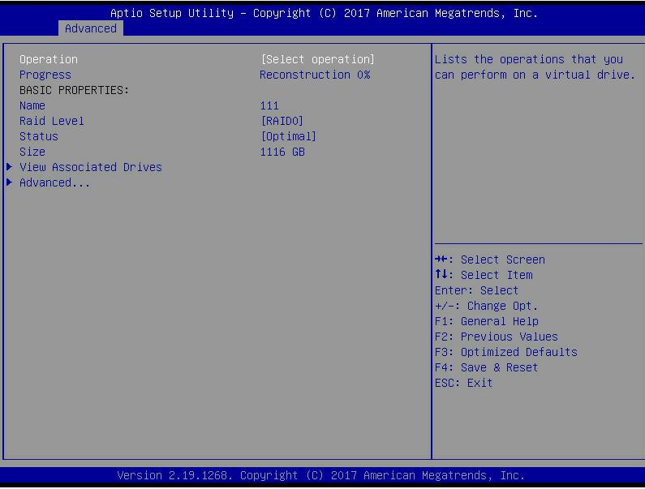
Figure 6- 100

Clear disk RAID information:
This function is used to clear the residual RAID information in the disk, so that the disk can be reused to configure RAID. This function is often used for disks whose mode is Unconfigured Bad.
- Switch the disk mode Unconfigured Bad to Unconfigured Good.
- As shown in Figure 6-101, select Configuration Management on the RAID card configuration interface, and press Enter.
Figure 6-101 RAID card configuration interface
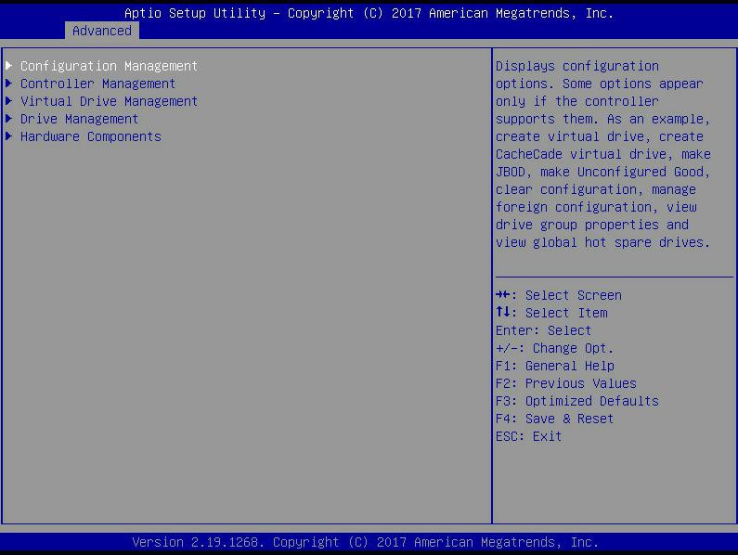
Figure 6-101
- Enter the interface shown in Figure 6-102, select Manage Foreign Configuration, and press Enter.
Figure 6-102 Select Manage Foreign Configuration
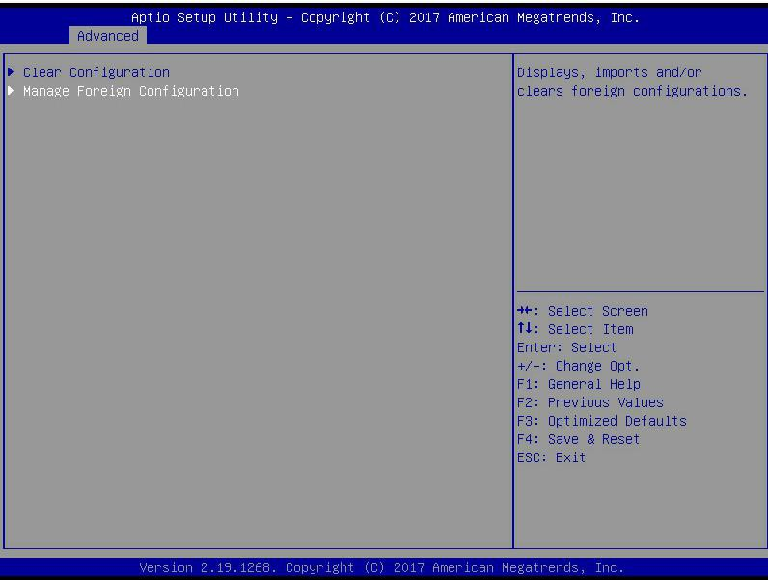
Figure 6- 47
- Enter the interface shown in Figure 6-103, select Clear Foreign Configuration, and press Enter.
Figure 6-103 Select Clear Foreign Configuration
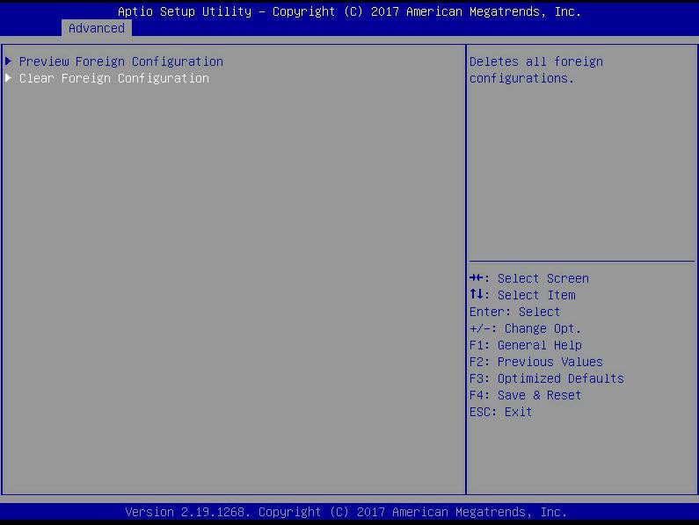
Figure 6-48
- Enter the interface shown in Figure 6-104, select Confirm to enable it, select Yes, and press Enter.
Figure 6-104 Confirm clear
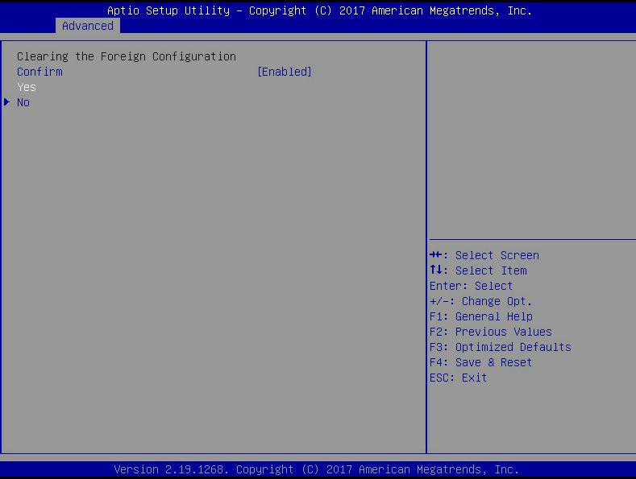
Figure 6-49
- Enter the interface shown in Figure 6-105 to complete the operation of clearing disk RAID information.
Figure 6-105 Complete clearing disk RAID
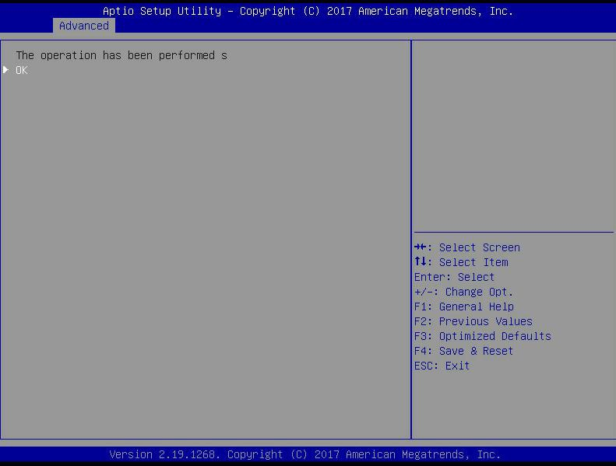
Figure 6- 105

Configure RAID in Legacy Boot Mode
- Enter the RAID card configuration interface
- During the BIOS startup process, after the interface shown in Figure 6-105 appears, press Ctrl+R.
Figure 6-106 Press Ctrl+R as prompted during BIOS startup
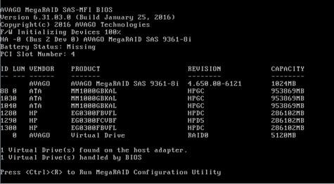
Figure 6- 106
- Enter the interface shown in Figure 6-107. Please refer to the key operation tips at the lower border of the interface to navigate and modify settings in the interface.
Figure 6-107 LSI RAID management interface
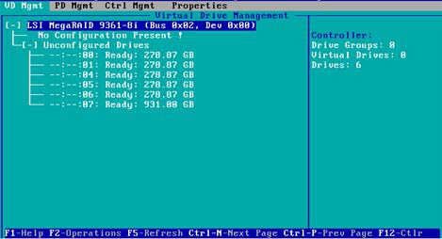
Figure 6- 50
- Common tasks
Configure RAID:
- As shown in Figure 6-108, press F2 on the VD Mgmt interface and select Create Virtual Drive.
Figure 6-108 Select Create Virtual Drive
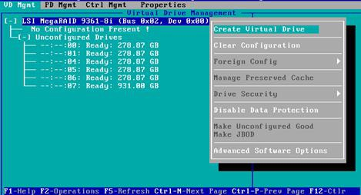
Figure 6-51
- Enter the interface shown in Figure 6-109, set the RAID level, and press Enter.
Figure 6-109 Set RAID level
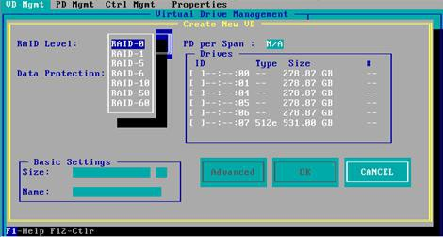
Figure 6-52
- Enter the interface shown in Figure 6-110, select the disk used to configure RAID, and press Enter.
Figure 6-110 Select Disk
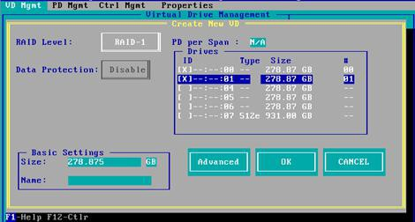
Figure 6-53
- Enter the interface shown in Figure 6-111, set the Size and Name accordingly, then select Advanced, and press Enter.
Figure 6-111 Set RAID name and capacity
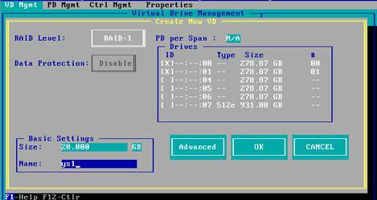
Figure 6-54
- Enter the interface shown in Figure 6-112, set the relevant parameters, then select OK, and press Enter.
Figure 6-112 Set advanced parameters
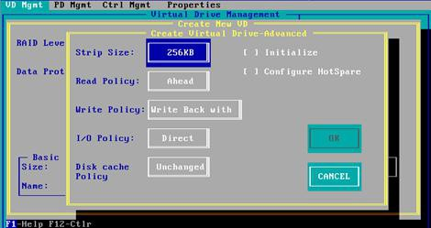
Figure 6-55
- Enter the interface shown in Figure 6-113, select OK, and press Enter to complete the RAID configuration operation.
Figure 6-113 Confirm creation
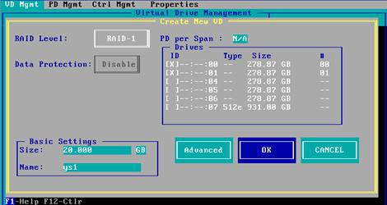
Figure 6- 56
- Select the RAID to be viewed and press Enter to view the detailed information of the RAID (including RAID name, level, and disk information, etc.), as shown in Figure 6-114.
Figure 6-114 View RAID information
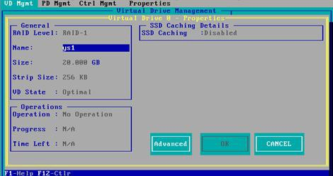
Figure 6-57

Configure hot spare disk:
After RAID is configured, hot spare disks are generally configured to improve data security. You can configure global hot spare disks and dedicated hot spare disks as needed.
- Hot spare disks are only available for RAID levels with redundancy.
- The capacity of the hot spare disk is larger than the capacity of a single member disk of the RAID to contribute to the RAID.
- Only the disk whose configuration mode is Unconfigured Good is supported as a hot spare disk.
- Configure global hot spare disk
  - As shown in Figure 6-115, select the disk to be configured as a global hot spare on the PD Mgmt interface, and press F2.
- Figure 6-115 Select the disk to be configured as a global hot spare disk
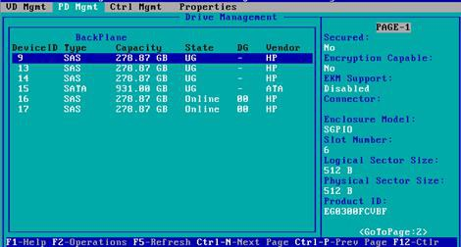
Figure 6- 58
  - Enter the interface shown in Figure 6-116, select Make Global HS, and press Enter to complete the configuration of the global hot spare disk.
Figure 6-116 Select Make Global HS
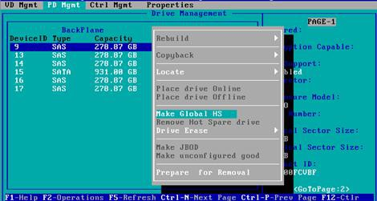
Figure 6-59
  - Return to the interface shown in Figure 6-117, select the hot spare disk to view the related information of the global hot spare disk.
Figure 6-117 View global hot spare disk information
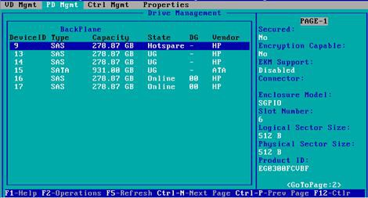
Figure 6- 60

Delete RAID:
This function is used to delete the damaged or hard to meet the demand of RAID.
- As shown in Figure 6-118, select the logical disk to be deleted on the VD Mgmt interface, and press F2.
Figure 6-118 Select the logical disk to be deleted
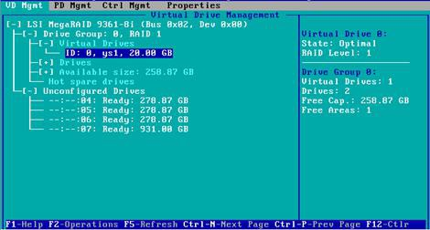
Figure 6-118
- Enter the interface shown in Figure 6-119, select Delete VD, and press Enter.
Figure 6-119 Select Delete VD
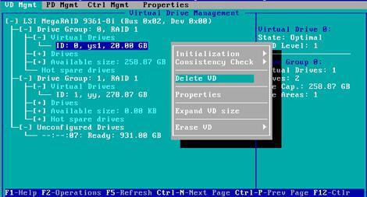
Figure 6-61
- Enter the interface shown in Figure 6-120, select YES, and press Enter to complete the RAID deletion operation.
Figure 6-120 Confirm delete
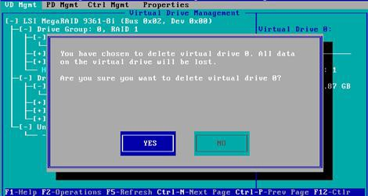
Figure 6- 120

Locate the disk location:
This function is convenient for you to find the disk quickly by lighting the blue indicator of the corresponding slot of the disk. A single physical disk or all member disks included in a logical disk can be located.
- As shown in Figure 6-121, select the disk to be located on the PD Mgmt interface and press F2.
Figure 6-121 Select the disk to be located
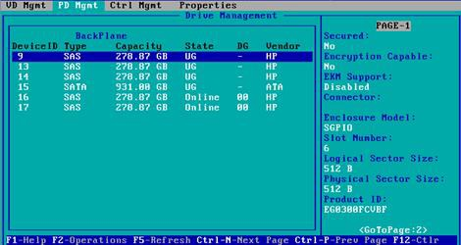
Figure 6- 62
- Enter the interface shown in Figure 6-122 and select Locate->Start to complete the disk positioning operation.
Figure 6-122 Select Locate-〉Start
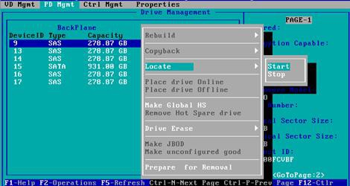
Figure 6-63

- Locate->Start: Start the disk positioning operation.
- Locate->Stop: Stop positioning the disk operation.

Initialize the logical disk:
This function is used to initialize the internal data space of the disk so that it can be recognized and used by the operating system.
- As shown in Figure 6-123, select the disk to be initialized on the VD Mgmt interface and press F2.
Figure 6-123 Select the disk to be initialized
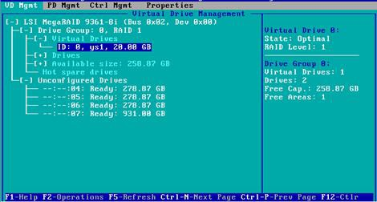
Figure 6-64
- Enter the interface shown in Figure 6-124 and select Initialization->Start FGI.
Figure 6-124 Select Initialization-〉Start FGI
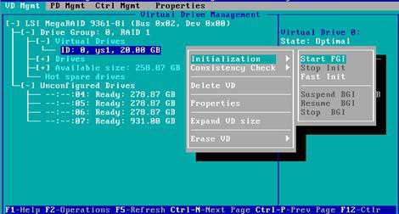
Figure 6-65
BGI: Backgroud Initialization, background initialization, first initialize part of the RAID space for writing data, and the remaining space is initialized in the background.
FGI: Full Groud Initialization, full disk initialization, initialize all the space of the RAID, and write data after the initialization is completed.
- Enter the interface shown in Figure 6-125, select YES, and press Enter to complete the initialization disk operation.
Figure 6-125 Confirm initialization
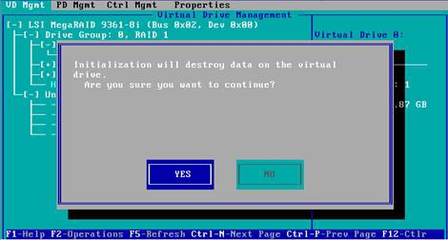
Figure 6-66

Erase disk data:
This function is used to delete internal disk data, including erasing physical disk data and logical disk data.
- Wipe physical disk data
  - As shown in Figure 6-126, select the physical disk to be erased on the PD Mgmt interface and press F2.
Figure 6-126 Select the physical disk to be erased
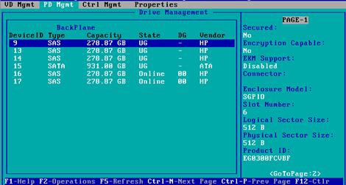
Figure 6- 67
  - Enter the interface shown in Figure 6-127, select the erasing mode (the default mode is recommended: Simple), and press Enter.
Figure 6-127 Select erasing mode
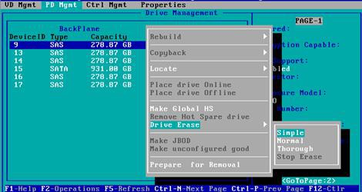
Figure 6- 68
  - Enter the interface shown in Figure 6-128, select Yes, and press Enter to complete the operation of erasing physical disk data.
Figure 6-128 Confirm erasure
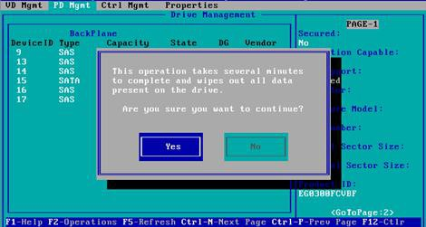
Figure 6- 69
To avoid disk failure, please do not perform other operations during the erasing of physical disk data.
- Erase logical disk data
  - As shown in Figure 6-129, select the logical disk to be erased on the VD Mgmt interface and press F2.
Figure 6-129 Select the logical disk to be erased.
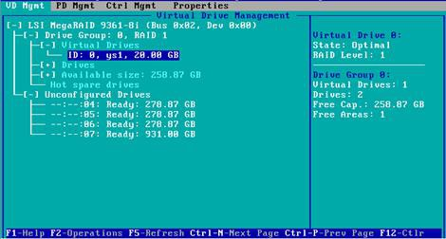
Figure 6-70
  - Enter the interface shown in Figure 6-130, select the erase mode (the default mode is recommended: Simple), and press Enter.
Figure 6-130 Select erasing mode
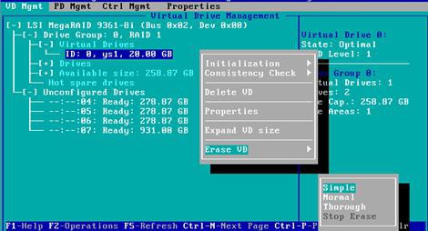
Figure 6-71
  - Enter the interface shown in Figure 6-131, select Yes, and press Enter to complete the operation of erasing logical disk data.
Figure 6-131 Confirm erasure
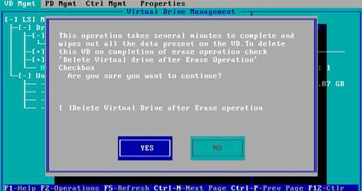
Figure 6-72

Clear disk RAID information:
This function is used to clear the residual RAID information in the disk, so that the disk can be reused to configure RAID. This function is often used for disks whose mode is Unconfigured Bad.
- Switch the disk mode Unconfigured Bad to Unconfigured Good.
- As shown in Figure 6-132, in the Foreign View interface, select the RAID card, press F2, select Foreign Config->Clear, and press Enter.
Figure 6-132 Select Foreign Config->Clear
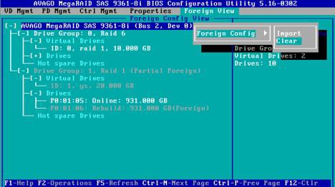
Figure 6-73
- In the pop-up dialog box shown in Figure 6-133, select OK and press Enter to complete the operation of clearing the disk RAID information.
Figure 6-133 Confirm clear
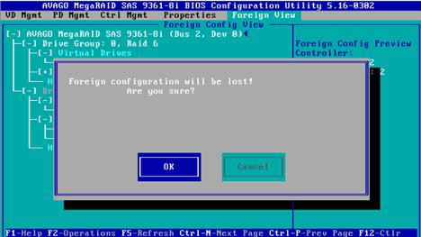
Figure 6-74

IPMI Rapid Deployment

Rapid deployment of IPMI process

Make sure the motherboard supports IPMI function
Check your motherboard manual and confirm that your motherboard supports IPMI, then find the dedicated IPMI network port for the motherboard, or you can choose to share the network port, as shown in Figure 7-2.
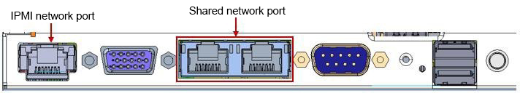
Figure 7-2 Main board dedicated network port

Enter BIOS to set IPMI function
Restart your system and press ESC or DEL to enter the motherboard BIOS system while the device is booting. The BIOS setting interface is shown in Figure 7-3.
Figure 7-3 Mainboard BIOS setting interface
After entering this interface, use the left and right keys of the keyboard to switch the menu item to the Server Mgmt option, and you will see the page shown in Figure 7-4.
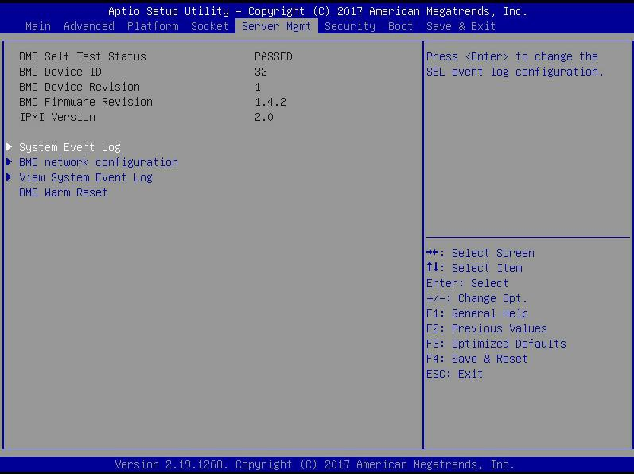
Figure 7-4 Server Mgmt interface
After entering this interface, enter the BMC network configuration option through the keyboard, and you will enter the following interface, as shown in Figure 7-5.
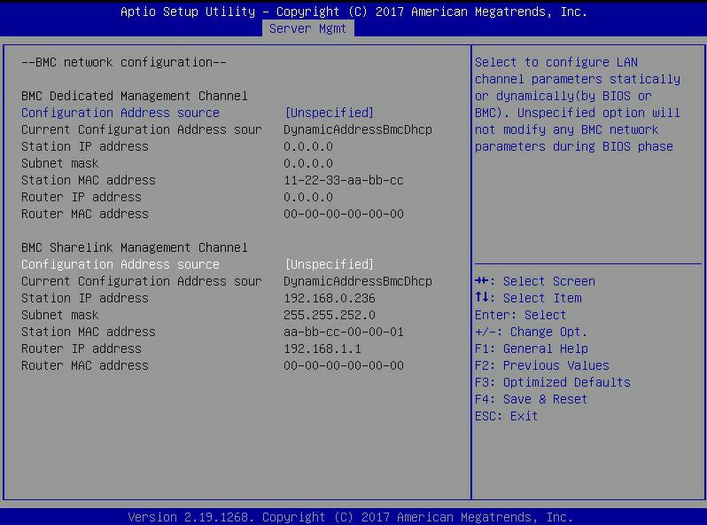
Figure 7-5 BMC network configuration option interface
On this page, you can see two configurable network ports, one is Dedicated dedicated network port, and the other is Sharelink shared network port. Take the shared network port as an example here. If you connect a dedicated network port, the setting method is the same as the shared network port. Switch to the Configuration Address Source option and press Enter to set the network mode of changing the network port, as shown in Figure 7-6.

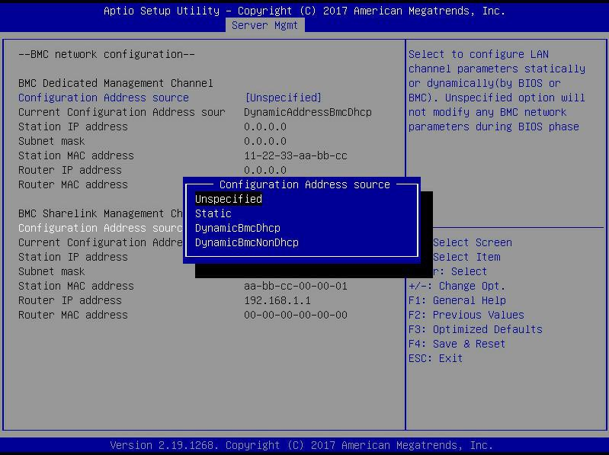
Figure 7-6 Configure network port network mode
There are four network modes that can be configured on this interface, namely Unspecified, Static, DynamicBMCDHCP, DynamicBMCNonDHCP. Static is the static mode, you can manually set the IP address, and DHCP is the dynamic mode. Setting this option allows BMC to automatically obtain an IP address from the DHCP server.

IPMI interface configuration Static mode
If you choose to configure Static mode for the IPMI interface, you should pay attention to the following issues:
- If there are multiple IPMI devices in your local area network, please note that the IP addresses between the devices cannot be repeated, otherwise communication cannot be established.
- If the IP of your IPMI device is an intranet address, the terminal device communicating with it must be in the same network segment as the IPMI device address.
- The IP address of the IPMI device can be mapped to the WAN through the routing device for remote management.
- The IPMI port has the function of obtaining an IP address through DHCP.
- IPMI supports two protocols, TCP/IP v4 and TCP/IP v6.

Configure the IP address and subnet mask according to your actual situation. For example, here we set the IP address to 192.168.0.236 and the subnet mask to 255.255.252.0, as shown in Figure 7-7 below. After setting, press F4 to save and exit the BIOS interface.
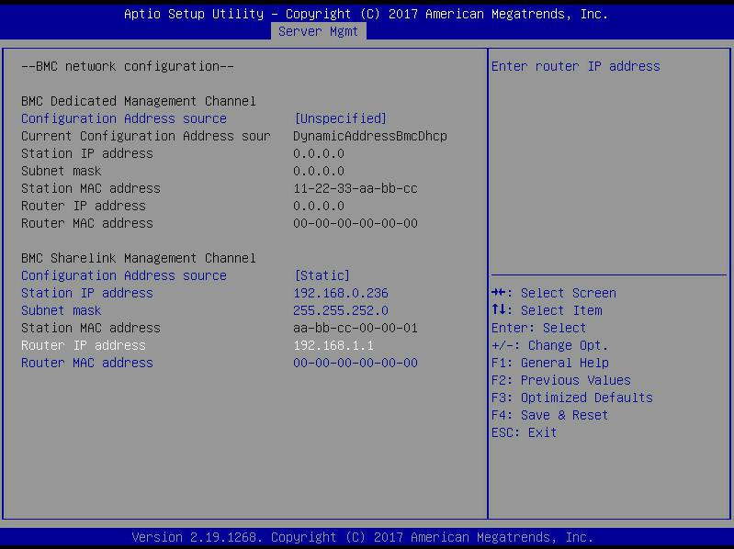

IPMI configuration Java SOL
- Press the <Del> key when the system starts to enter the BIOS setting interface.
- Switch to the Advanced menu, select Serial Port Console Redirection, and press
<Enter> key.
- Make sure that the Console Redirection of COM0 is in the [Enabled] state, if not, select Console Redirection, and then press the <Enter> key to set the state to [Enabled]. To ensure the normal operation of iBMC, this option has been set to [Enabled] by default.

IPMI function quick start instructions

After completing the previous configuration steps, we can start to log in to the IPMI management interface. The IPMI management interface can be accessed using a standard web browser. Here we recommend using Google Chrome browser, Firfox Firefox browser, and IE browser. Browser (IE 11 and above) to get the best browsing experience. Since the new version of the operation interface is based on HTML5, it costs a lot of computer resources. We recommend that the client configure more than 8G of memory when using KVM.

Enter the operation interface
Take the Google Chrome browser as an example. Enter the IPMI access address in the address bar of the browser and press Enter to access the IPMI management interface. Since all HTTP links have been converted to HTTPS encrypted links, it will enter as shown in Figure 7-8. The privacy setting error page shown, the content of other browsers may be different.
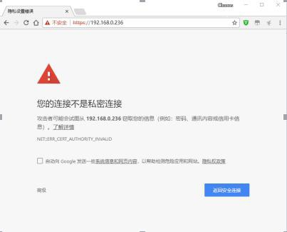
Figure 7-8 Google Chrome privacy settings error page
On this page, click "Advanced" >> "Continue" to access the IPMI management page normally and enter the login page, as shown in Figure 7-9.
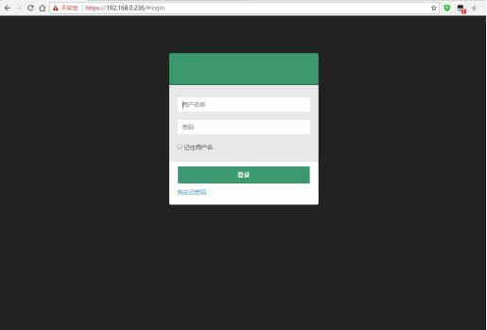
Figure 7-9 IPMI management login interface

Default username and password
Factory default user name: admin Factory default password: admin
When you log in with this user name, you will have full administrator rights. It is recommended that you change your password after logging in.

IPMI management system content
When you log in to the IPMI management system correctly, you can see the page shown in Figure 7-10.
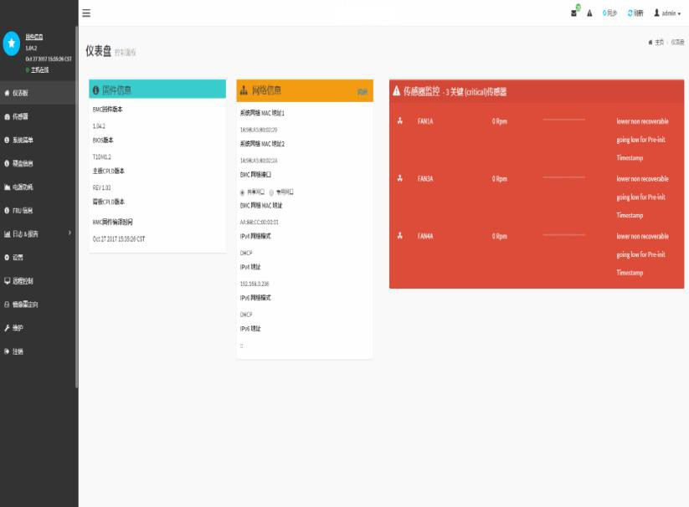
Figure 7-10 IPMI Management System Home Page

IPMI management interface menu description
- dash board
On this page, users can view the basic information of the IPMI management system. Including firmware information, network information, and sensor monitoring information.
The firmware information includes BMC firmware version information, BIOS version information, motherboard CPLD version information, backplane CPLD version information, and BMC firmware compilation time information.
The network information includes the MAC address of the system network and BMC network information. You can choose to view the shared network port or dedicated network port of the BMC. BMC network information includes BMC network MAC address information, IPV4 network mode information, IPV4 address information, IPV6 network mode information, and IPV6 address information.
The sensor monitoring information will display the current alarm sensor information in real time, including sensor name, sensor reading, real-time curve change of sensor reading, and alarm status.
- sensor
This page displays the status of all sensors. When there is a sensor alarm, the sensor will be displayed in the key sensor column. When the alarm is released, the sensor will be automatically removed from the key sensor column.
- System list
This page can view server CPU and memory information. In the block diagram, click the CPU block to view the CPU information. The memory block is displayed in green to indicate that the memory exists. Click the memory block to view the memory information.
- Hard Disk Information
For the backplane with Expander, the green square means that the hard disk is in place, otherwise it means it is not in place. You can view the status of the hard disk on the right or below the hard disk block. Left click the green square to view the detailed information of the hard disk, and right click to locate the hard disk.
- Power consumption
Under this menu, the power consumption can be capped and the recent power consumption can also be viewed.
- FRU information
Select this menu to view the basic information of the FRU.
- Log & Report
Under this menu, you can view the IPMI time log, audit log and video log.
- Set up
You can configure some BMC under this menu. Including BSOD, date & time, network, etc...
- remote control
On this page, you can start KVM, SOL, power control, UID (server indicator light) control.
- Mirror redirection
On this page, you can get the latest image file on the remote storage device.
- maintain
You can perform basic maintenance operations on the server, such as BMC firmware update, BIOS firmware update
new.
- Logout
Click to log out the current user's login.

Introduction to KVM remote management

Start KVM remote management
As shown in Figure 7-11, KVM can be started under the Remote Control> KVM&Java SOL Remote Control menu.
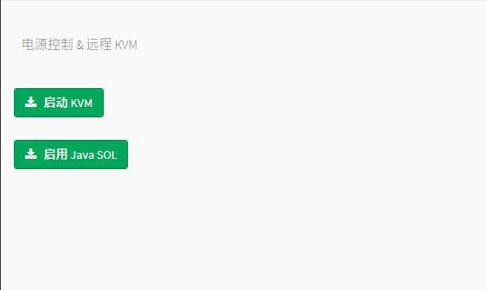
Figure 7-11 Start KVM

KVM page introduction
As shown in Figure 7-12, it is the KVM interface after starting KVM.
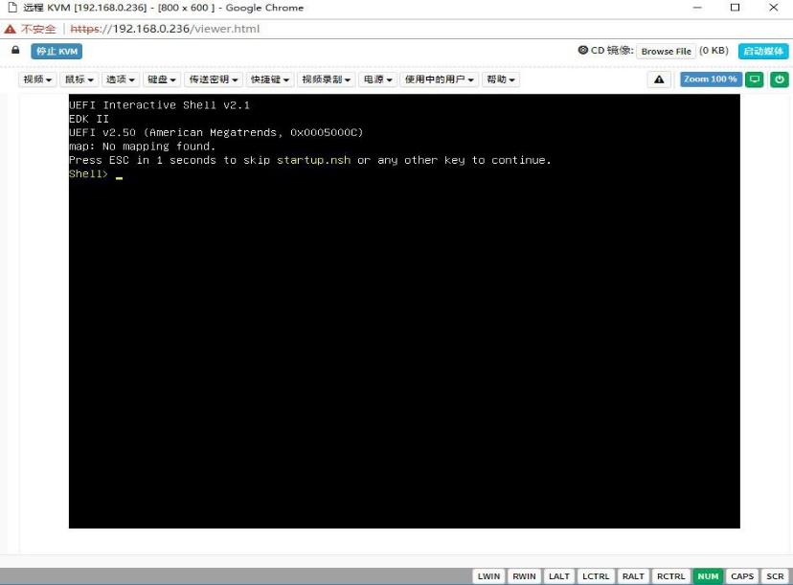
Figure 7-12 KVM interface
As shown in Figure 7-13, the KVM interface consists of two parts: one part is the menu and shortcut buttons, and the other part is the remote desktop window, which is the server desktop information sent back remotely.
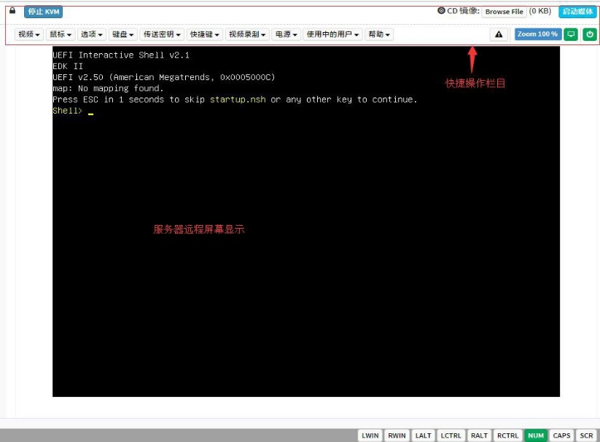
Figure 7-13 KVM interface composition

Remote control quick operation
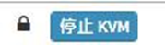 | Stop KVM
 | Hang on the CD image, generally used to remotely install the operating system, the host display unlocks, the server turns on and off
Table 1- 28

Introduction to SOL
Click Activate Java SOL on the page shown in Figure 7-14 to open the interface shown in Figure 3-7 below.
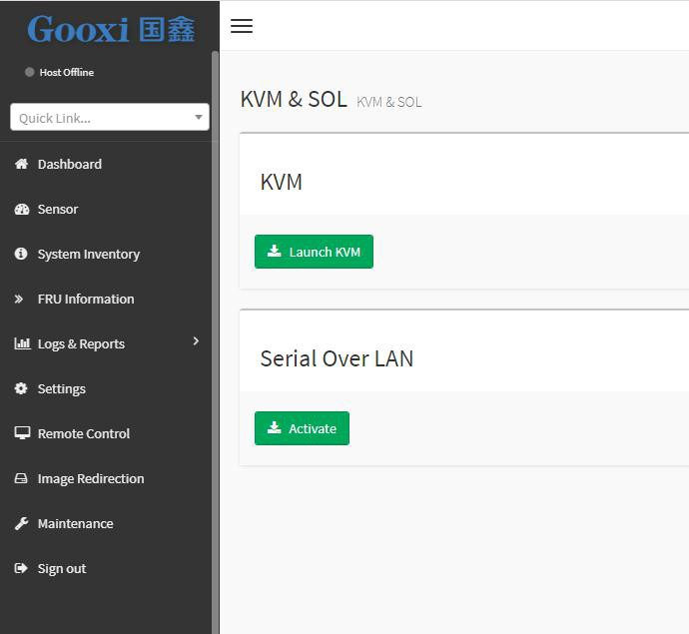
Figure 7-14 Enable Java SOL
- After clicking Activate, the SOL interface shown in Figure 7-15 will appear.
- Press Enter to activate the screen.

Figure 7-15 SOL operation interface
Note: The SOL interface operation function has only tested the BIOS screen synchronization, and other interfaces have not been tested. This time is an operation demonstration and will not be described in detail.

Other ways to connect to IPMI
The AST2500 firmware complies with the IPMI 2.0 specification, so users can use the standard IPMI driver assigned by the operating system.

IPMI driver
AST2500 supports the drivers cited by Intel and can be obtained from the following websites: https://www.intel.com/content/www/us/en/servers/ipmi/ipmi-technical-reso urces.html With Windows Server 2003 R2, Microsoft also provides an IPMI driver package, and you can also use the Open IPMI driver in the system.
AST2500 supports the Open IPMI driver of the Linux kernel. Use the following command to load the IPMI driver: "modprobe ipmi_devintf" "modprobe ipmi_si" If you are using an older version of the Linux kernel, you need to replace the "ipmi_si" component with "ipmi_kcs".

IPMI tools and other open source software
AST2500 supports open source IPMI tools, you can also use other software, such as: Open IPMI, IPMI Utility, etc.
The above documents are designed to help you quickly understand and deploy the IPMI functions of the system. Regarding the detailed function operation manual of IPMI, we will provide other help files.

Product Technical Specifications

Technical specifications

Features | Technical specifications
model | 2U
size | 2U cabinet type, maximum depth: 748 mm
processor | Support 1 or 2 Intel Xeon Scalable series processors (up to TDP 165W, optional TDP 205W)
chipset | Intel® C621/C622 series server dedicated chipset
RAM  Storage controller | Support DDR4 ECC RDIMM/LRDIMM server memory, memory frequency support 1866/2133/2400/2666MHz Support 12 DDR4  Channel, each Channel supports 2 DIMMs, a total of 24 DDR4 slots; supports Intel Optane 2933MHz memory  Internal storage controller: PCH supports RAID 0\1\10&5 External HBA (non-RAID): 12 Gbps SAS HBA Internal storage: 2 PCIe  3.0 x4 M.2 slot, 2 Mini SSD slots (SATA DOM)
driver | Support 8/12/25 hot-plug SAS/SATA(HDD/SSD)
power supply | Platinum level 500W, 800W, 1200W, 1600W hot-swappable redundant power supply, optional support 240V and 336V high voltage DC power supply, -48V high voltage DC power supply

External port&PCIE | Front port: VGA, 2 USB3.0  Rear: VGA, 2 USB3.0, 1 management network port, 2 RJ45 network ports  PCIE expansion board: up to 10 PCIE expansion slots OCP slot: 1 OCP 3.0 (X8)
System fan | Standard 4 8038 N+1 hot-swappable redundant fans,  optional 4 8056 N+1 hot-swappable redundant fans
network | Onboard 2 1GbE or 10GbE (RJ45)
Security | TPM/TCM (optional)  Chassis opening intrusion detection  Lock the upper cover of the chassis  The onboard iBMC management module supports management features such as IPMI, SOL, KVM Over IP, and virtual media
management | Microsoft Windows Server, Red Hat Enterprise Linux, SUSE Linux Enterprise Server, CentOS, Ubuntu  Citrix Xen Server, Vmware ESXi, Linux KVM, Windows Hyper-V
Operating | Standard operating temperature: 10ºC-40ºC (without direct sunlight) Extended operating temperature: 5ºC-40ºC (limited configuration meets)  Transportation storage temperature: 10ºC-40ºC Working humidity: 30%-80% (non-condensing) Storage humidity: 5%-95% (non-condensing)
Table 1- 29

